Republic of Malawi
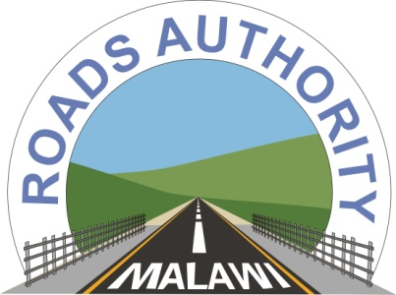
Accelerating Malawi’s Economic Growth

The Roads Authority
CORRIGENDUM NO. 1

Phase I Road and Bridge Maintenance for the Roads Authority: 2023-2024 Financial Year

- The Roads Authority with funding from the Roads Fund Administration, invited bids from eligible bidders for the execution of various Civil Works contracts for the 2023-2024 Financial Year.

- In pursuant with clause 10.3 of the instructions to bidders, the Roads Authority is informing all prospective bidders that the deadline for submission of the bids (ITB 20.1 and 20.3) has been revised from 5th June 2023 to Monday, 12th June 2023 at 10.00 hours local time. The bids will be opened on Monday, 12th June 2023, at 10.30 hours local time.

- The bid opening place remains the same as in the bid documents.

Northern Region | Central Region | Southern Region
Regional Manager  The Roads Authority  Northern Region Office  P O Box 20050  Mzuzu 2  Tel: (265) 1 311 065  (265) 888 861 640 | Regional Manager  The Roads Authority  Central Region Office  ARET Premises  along Mchinji Road  P O Box 624  Lilongwe  Tel: (265) 1 759 896  (265) 888209334 | Regional Manager  The Roads Authority  Southern Region Office  Lonhro Building  P O Box 373  Blantyre  Tel: (265) 1 847 354  (265) 888 844 343

