 |  | 
Roads Authority | Government of the Republic of Malawi | World Bank

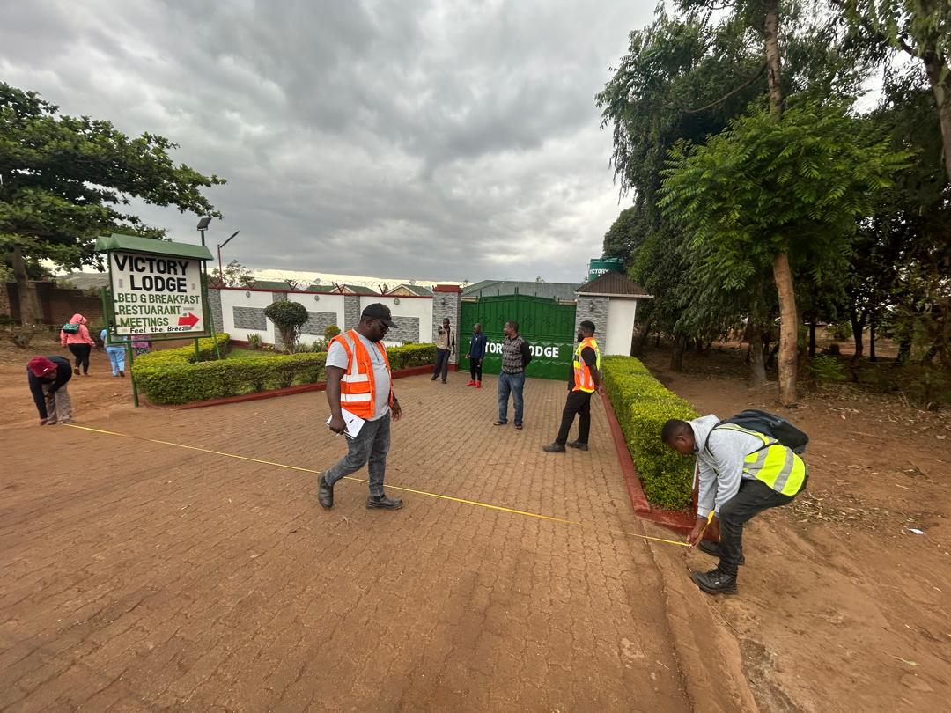
Southern Africa Trade and Connectivity Project
(SATCP)

RESETTLEMENT ACTION PLAN FOR LIWONDE-MATAWALE ROAD REHABILITATION PROJECT

October 2025

List of Abbreviations and Acronyms

4WD | Four-Wheel Drive
AGRCs | Area Grievance Redress Committees
AEDCs | Agricultural Extension Development Coordinators
CBR | California Bearing Ratio
CGRCs | Community Grievance Redress Committees
CDAs | Community Development Assistants
CSR | Corporate Social Responsibility
CSOs | Civil Society Organizations
DESC | District Environmental Sub-committee
DGRCs | District Grievance Redress Committees
EIA | Environmental Impact Assessments
ESCOM | Electricity Supply Corporation of Malawi
ESF | Environmental and Social Framework
ESIA | Environmental and Social Impact Assessment
ESS | Environmental and Social Standards
ESS 1 | Assessment and Management of Environmental and Social Risks and Impacts
ESS 5 | Land Acquisition, Restrictions on Land Use, and Involuntary Resettlement
ESS 10 | Stakeholder Engagement and Information Disclosure
FGD's | Focus Group Discussions
GIS | Geographic Information System
GoM | Government of Malawi
GMCs | Grievance Management Committees
GRM | Grievance Redress Mechanism
GVH | Group Village Head
IVSC | International Valuation Standards Committee
LHS | Left-Hand Side
LMP | Labor Management Procedures
LPA | Land Parcel Assessment
LRP | Livelihood Restoration Plan
MEPA | Malawi Environment Protection Authority
M&E | Monitoring and Evaluation
MOI | Net Operating Income
MWA | Malawi Water Supply and Sanitation Authority
MWK | Malawi Kwacha
NGOs | Non-Governmental Organizations
NGRD | National Grievance Redress Committee
NMT | Non-Motorized Transport
PAPs | Project Affected Persons
PIU | Project Implementation Unit
Q.A/Q.C | Quality Control and Quality Assurance
RA  RCs | Roads Authority  Resettlement Committees
RCC | Resettlement Compensation Committees
RoW  RR | Right of way  Road Reserve
SADC | Southern African Development Community
SATCC | Southern Africa Transport and Communication Commission
SATCP | Southern Africa Trade and Connectivity Project
SEP | Stakeholder Engagement Plan
SIM | Surveyors Institute of Malawi
SRWB | Southern Region Water Board
STIs | Sexually Transmitted Infections
TCS | Traffic Control System
TEVETA | Technical, Entrepreneurial, Vocational Education and Training Authority
TMP | Traffic Management Plan
VS and L | Village Savings and Loans
WB | World Bank
WGRC | Workers Grievance Redress Committees

Table of Contents
List of Abbreviations and Acronyms i
Table of Contents iii
List of Tables vii
List of Figures viii
EXECUTIVE SUMMARY ix
CHAPTER 1: INTRODUCTION 1
1.1 Background Information 1
1.2 Scope and Objective of the Resettlement Action Plan (RAP) 2
1.2.1 Scope 2
1.2.2 Objective 2
1.2.3 Principles Governing the RAP 3
1.3 Project Description 4
1.3.1 Project Location 4
1.3.2 Nature and Scope of the Proposed Project 5
1.3.3 Existing land use and land requirements for the project 8
1.3.4 Compensation for the PAPs 9
CHAPTER 2: RESETTLEMENT PLANNING AND DESIGN 10
2.1 Introduction 10
2.2 Methodology for preparation of the RAP 10
2.2.1 Site visits 10
2.2.2 Literature review 10
2.2.3 Consultation with Stakeholders 10
2.2.4 Household, Community and Asset Surveys 11
2.3 Determination and Negotiation of Entitlements and Compensation 12
2.3.1 Asset Evaluation 12
2.3.2 Resettlement Planning, Scheduling, Budget and Responsibilities 13
2.3.3 Initiation of Resettlement and Compensation 13
2.4 Monitoring and Evaluation 13
CHAPTER 3: STAKEHOLDER ENGAGEMENT 14
3.1 Overview 14
3.2 Aims and Objectives of Stakeholder Consultation 14
3.3 Stakeholder Mapping 15
3.4 Consultations 21
3.5 Census of Project Affected Persons/Social Economic Survey 25
CHAPTER 4: POLICY AND LEGAL FRAMEWORK 27
4.1 Introduction 27
4.2 National Policy Framework 27
4.2.1 Malawi 2063 27
4.2.2 National Land Policy, 2002 28
4.2.3 National Gender Policy, 2015 29
4.2.4 National Decentralization Policy, 1998 29
4.3 Legal framework 30
4.3.1 Constitution of the Republic of Malawi, 1995 30
4.3.2 Public Roads (Amendment) Act of, 2014 30
4.3.3 Land Act (Amendment), 2022 31
4.3.4 Customary Land (Amendment) Act, 2022 31
4.3.5 Physical Planning (Amendment) Act, 2022 32
4.3.6 Land Acquisition and Compensation (Amendment Act), 2022 32
4.3.7 Local Government (Amendment) Act, 2017 33
4.3.8 Environment Management Act, 2017 34
4.3.9 Monuments and Relics Act, 1991 34
4.3.10 Forestry (Amendment) Act, 2017 35
4.3.11 Electricity Act, 2004 36
4.3.12 Water Resources Act, 2013 36
4.3.13 Water Works Act, 1995 37
4.3.14 Mines and Minerals Act, 2019 38
4.4 World Bank Environmental and Social Framework (ESF) 41
4.4.1 ESS1: Assessment and Management of Environmental and Social Risks and Impacts 41
4.4.2 ESS5: Land Acquisition, Restrictions on Land Use, and Involuntary Resettlement 41
4.4.3 ESS10: Stakeholder Engagement and Information Disclosure 42
4.5 SATCP Resettlement Policy Framework 42
CHAPTER 5: SOCIO-ECONOMIC CHARACTERISTICS OF PROJECT AFFECTED PERSONS 46
5.2.1 Population Size 46
5.2.2 Population Structure 49
5.1.2. Household Size and Structure 52
5.3.1 Education and Skills Distribution Amongst PAPs 55
5.4.1 Elderly PAP’s 56
5.4.2 Chronic Illness among PAPs 57
5.4.3 Disability Status among PAPs 59
5.5 Economic Activities and Livelihoods 60
5.5.1 Property Use Among PAPs 60
5.5.2 Expected Property Loss Among PAPs (number of utilities and services affected will be updated once the service providers consulted provides the data) 72
CHAPTER 6: IMPACTS, LAND ACQUISITION AND RESETTLEMENT 79
6.1 Resettlement Impacts and Mitigation 79
6.2 Potential Resettlement Impacts 79
6.3 Resettlement Mitigation 82
6.4 Eligibility Criteria for Compensation 84
6.5 Valuation of Affected Assets and Compensation Process 92
6.5.1 Valuation Methods 92
6.5.2 Approach to the valuation of affected properties 94
6.6 Utility and Service Infrastructure 95
CHAPTER 7: GRIEVANCE REDRESS MECHANISM 97
7.1 Introduction 97
7.2 Grievance Redress Principles 97
7.3 Procedure Negotiations and Resolution of Conflicts 98
7.4 Grievance Redress Process 99
7.5 Summary of Grievances Received 101
CHAPTER 8: RESETTLEMENT PLANNING, SCHEDULING, BUDGET & RESPONSIBILITIES 108
8.1 Introduction 108
8.2 Resettlement Planning 108
8.3 Scheduling 108
8.4 Budget 109
8.5 Asset Inventory and Budget Assumptions 110
8.5.1 Utility and Service 110
8.5.2 Properties for Government Agencies – Forestry Department and Police 110
8.5.3 Details of the PAPs by type of loss per District 111
8.5.4 Budget Assumptions (public facilities relocation cost will be updated once service providers make provide the invoice) 116
8.6 Roles and Responsibilities 116
8.6.1 Roads Authority (Proponent) 116
8.6.2 Institutional Responsibilities for Implementation of the RAP 117
8.6.3 Resettlement and Compensation Committee 118
CHAPTER 9: MONITORING, EVALUATION AND REPORTING 121
9.1 Introduction 121
9.2 Indicators 121
9.3 Suggested Monitoring Periods 127
9.4 Key Considerations 127
9.5 Monitoring Program 127
9.6 Reporting 128
CHAPTER 10: CONCLUSION 129
10.1 Introduction 129
APPENDICES 130
1.4 130
Appendix 2: COMPENSATION SUMMARY FOR RELOCATION 131
Appendix 3: RAP Implementation Schedule - 12 Months (August 2025 – July 2026) 132
Phase 2: Construction & Active Monitoring (Months 6-10: Jan - Apr 2026) 134
1.5 Appendix 4: PAP CENSUS QUESTIONNAIRE 137
1.6 Appendix 5: MULTI-CRITERIA SCREENING FOR SOCIAL AND ENVIRONMENTAL IMPACT MITIGATION 144
ANNEXES 147
Annex A: LIVELIHOOD RESTORATION PLAN 147
1.7 Annex B: REPORT FROM MINISTRY OF LANDS, HOUSING AND URBAN DEVELOPMENT. THE SCHEDULE IS SHARED SEPERATELY 156
1.8 Annex C: PROCEDURES FOR UNPLANNED ACTIVITIES AND ASSOCIATED COMPENSATIONS 158
C.1 Management Procedures for Land Acquisition for Ancillary Works 158
C.2 Management Procedures for Damaged Structures (Cracks) 160
C.3 Chance Find Procedure for Rehabilitation of Liwonde-Matawale Road Projects 162
1.9 Annex D: CONSULTATIONS WITH PROJECT AFFECTED PERSONS (PAPS) FOR THE ROAD PROJECT 166
Annex E: STAKEHOLDER CONSULTATIONS WITH GOVERNMENT DEPARTMENTS, AGENCIES AND UTILITY AND SERVICE COMPANIES 179
Shared separately. 179

List of Tables
Table 1: Stakeholder Matrix 33
Table 2: Details of FGDs conducted along the road. 40
Table 3: Stakeholder Issues and Project Commitments and Feedback 41
Table 4: Details of key legislation on resettlement 56
Table 5: Comparison of National and WB ESS, Mitigation measures and projects commitment 61
Table 6: Population of Project Affected Persons 66
Table 7: Gender Distribution among PAPs 67
Table 8: Age Group Distribution 68
Table 9: Marital Status 68
Table 10: Gender Distribution Among PAPs Household Members 69
Table 11: Age Groups Among PAPs Household Members 70
Table 12: Highest Level of Education Among PAPs 71
Table 13: Distribution of Elderly PAPs by gender 72
Table 14: Distribution of Elderly PAPs and PAP's Household Members 72
Table 15: Chronic Disease Among PAPs 73
Table 16: Chronic Illness among PAPs Household Members 73
Table 17: Disability Status Among PAPs 74
Table 18: Disability Status among PAPs Household Members 74
Table 19: Asset Use Distribution among PAP with Chronical illness in Machinga 76
Table 20: Asset Classification Distribution among PAPs with Chronic illness in Zomba 77
Table 21: Main Source of Income Among PAPs 79
Table 22: Source of income among PAPs in Zomba 80
Table 23: Source of income for PAPs in Machinga 82
Table 24: Average Income for Zomba District 84
Table 25: Average Income for Machinga District 85
Table 26: Expected Property Loss among PAPs with Chronic Disease in Machinga 87
Table 27: Expected Property Loss among PAPs with Chronic Disease in Zomba 88
Table 28: Expected Property Loss among PAPs with Disability in Machinga 89
Table 29: Expected Property loss among PAPs with Disability in Zomba 90
Table 30: Summary of Asset Inventory Findings 93
Table 31: Category of loss and Social and Economic Impacts 93
Table 32: Entitlement Matrix 99
Table 33: Budget for RAP Implementations 121
Table 34: Summary of Impacts per Traditional Authority 123
Table 35: Summary of Project-Affected Persons (PAPs) by Type of Structure Lost 124
Table 36: Estimated Compensation Amount and Budget 125
Table 37: Summary of institutions’ Responsible for Resettlement Activities 129
Table 38: Indicators and Variables to be monitored 131
Table 39: Multi-Criteria Screening for Social and Environmental Impact Mitigation 153
Table 41: Summary of Potential Courses under LRP 162
Table 42: Appendix D: Stakeholder Identification and Analysis Matrix 174

List of Figures

Figure 1: Location of the Proposed Project 23
Figure 2: Property Use Among PAPs 75
Figure 3: Types of property loss amongst PAPs 86
Figure 4: Cross-Sectional View in Rural Section 92
Figure 5: Cross-Sectional View in Urban Section 92
Figure 6: Implementation Arrangement Chart 129

EXECUTIVE SUMMARY

1.0 Background Information
This document presents the Resettlement Action Plan (RAP) for the rehabilitation of the Liwonde-Matawale (M003) Road, which spans 47.9 kilometers across Machinga District, Zomba District and Zomba City in Malawi. The rehabilitation project aims to improve road infrastructure to enhance regional connectivity, promote socio-economic development, and facilitate trade in the Southern African region. The project implementation unit (PIU) developed a Resettlement Action Plan (RAP) based on requirements included in the project safeguards instruments namely: the Resettlement Policy Framework; Stakeholder Engagement Plan; and Grievance Redress Manual; and aligned it to national legislation and the World Bank’s Environmental and Social Framework (WB ESF), particularly Environmental and Social Standard 5 (ESS5) on Land Acquisition, Restrictions on Land Use, and Involuntary Resettlement. The RAP addresses social impacts related to losses and limitations with regard to land-based rights, legal and policy context, eligibility criteria and entitlement matrix, institutional arrangements, stakeholder engagement process including grievance redress mechanisms, budget (including compensations for project-affected persons {PAPs}) and monitoring and evaluation frameworks to ensure compliance with international and national resettlement standards.

2.0 Scope of RAP
The RAP has been developed to align with the World Bank’s Environmental and Social Framework (WB ESF), and Malawi legal and policy frameworks. The project activities covered under this RAP include:
- Identifying and assessing the land required for the sub-project and proposing measures to minimize social risks and impacts associated with the land acquisition process;
- Verifying and securing the Road Reserve (RR);
- Identifying properties within the road reserve, assessing their ownership status, and evaluating the implications of their relocation;
- Carrying out detailed surveys, valuations, and socio-economic assessments of the impacted households and businesses;
- Establishing procedures and processes for securing the road reserve;
- Determining the costs for relocating utility and service infrastructure with minimal disruption to services; and
- Facilitating the meaningful stakeholder engagement to ensure deliberative dialogue and effective conflict resolution.

3.0 Objective of the RAP
The primary objective of the RAP is to identify and assess individuals, institutions and assets to be affected by the Liwonde-Matawale project. This ensures that the project implementation minimizes adverse social and economic impacts while providing fair and adequate compensation to PAPs. To that end, the RAP provides procedures and processes that will guide resettlement and relocation activities under the Liwonde-Matawale Road Rehabilitation Project based on the requirements of the project safeguards instruments as presented in the background information above. Specifically, the RAP aims to:
- Mitigate risks associated with involuntary resettlement;
- Restore or enhance livelihoods of displaced persons to pre-project levels or better; and
- Provide a clear framework for resettlement and relocation, ensuring compliance with the SATCP Resettlement Policy Framework (RPF), National legislation and policies, the World Bank’s Environmental and Social Framework and international best practices.

4.0 Environmental and Social-economic Concerns
The RAP highlights the project’s primary impacts associated with the loss of land-based rights namely:
- Economic and physical displacement of PAPs due to clearing of the Right of Way (RoW);
- Loss of structures, crops, and trees within the RoW;
- Loss of access to certain services and facilities due to service interruption/disruption and blocked access roads; and
- Impacts on livelihoods, particularly for those relying on roadside businesses and subsistence farming.

Efforts have been made to minimize displacement and property loss by aligning road rehabilitation activities with the existing road corridor.

5.0 Socio-Economic Profile of PAPs
A socio-economic baseline survey was conducted across affected areas in Machinga, Zomba District and Zomba City. Key findings include:
- A total of 1,745 PAPs, including 842 households, 769 businesses, and 134 institutions will be impacted by the project where the 3,409 assets will be affected consisting of: 13 dwelling units; 2 dwelling and business structures; 216 businesses; 553 temporary movable business (Hawkers, Kiosk, Shade); 38 auxiliary facilities; 8 public facilities; 20 fences and walls; 7 incomplete structures; 222 sign posts; and 2,311 crops and trees. Livelihoods are predominantly agro-based, with a significant number of PAPs engaged in small-scale farming and informal trading. Average household income in project area is MK 39,819.67 for females and 32,750.54 for males; and
- Vulnerable groups, such as: disabled (2%); chronically ill (21%); Child PAPs (0.22%); women-headed households (11.4); and the elderly (9.28%); require special consideration in livelihood restoration and compensation measures.

6.0 Legal and Policy Framework
The RAP aligns with the SATCP Resettlement Policy Framework (RPF) that is based on National legal and policy frameworks and the World Bank’s Environmental and Social Framework (WB ESF), Key guiding legal and policy framework include:
- SATCP Resettlement Policy Framework;
- The Public Roads Act, 2014 which establishes the road reserve and gives mandate to the Roads Authority (RA) to maintain the RR;
- The Land Act (of Malawi), 2016 and Land Act Amendment (of Malawi), 2022 which outlines compensation mechanisms for land acquisition; and
- The World Bank ESS 1 and ESS5, which provide for the assessment of impacts and adherence to international standards for involuntary resettlement and livelihood restoration.

The RAP also identifies and addresses gaps between national legislation and the World Bank requirements which largely demonstrate the former’s shortcomings particularly the absence of provision for livelihood restoration, support for vulnerable groups, inclusion of informal occupants, in-kind compensation, deliberate and meaningful stakeholder engagement, a grievance redress mechanism, continuous monitoring, communal resources management, cultural heritage reservation, and environmental and social integration. To close these gaps, the project will implement a Livelihood Restoration Plan (through training, business support, temporary employment); conduct deliberate and meaningful inclusive and culturally appropriate consultations; provide full replacement-cost compensation for all affected assets (including informal occupants and crop producers); establish an accessible and efficient grievance mechanism; protect or restore communal resources and cultural heritage; and deploy a robust monitoring and evaluation framework focused on vulnerable populations

7.0 Institutional and Organizational Framework
Key stakeholders in RAP implementation include:
- Roads Authority: Leads overall project coordination and implementation. It is responsible for maintaining meaningful stakeholder engagement, overseeing compensation, facilitating grievance redress, and ensuring effective communication.
- Councils (Zomba City, Zomba District and Machinga District): Provide local-level coordination, community mobilization, and support. They have already been engaged and are working closely with the RA, especially in infrastructure relocation and public communication.
- Line Ministries, Departments and Agencies:
  - Ministry of Lands: Oversees land acquisition, valuation, and approval processes. Engage in guiding compensation procedures.
  - Malawi Environment Protection Authority (MEPA): Provides oversight on environmental compliance so as to avoid or reduce the impacts on the environment and human health.
- Traditional Leaders, Local Communities and Resettlement and Compensation Committees: Facilitate the identification of PAPs and help mediate between the project and affected populations. They have been consulted, established Resettlement and Compensation Committees and are actively involved in grievance redress and information dissemination.
- Development Partners (World Bank): Ensure compliance with ESS5, provide funding, and monitor implementation of the safeguards. They have been actively involved throughout the planning and appraisal stages.
- Utility and Service Providers (e.g., ESCOM, SRWB, OCL and Airtel): Responsible for relocating affected infrastructure (electricity, water, telecom). Engagements are ongoing, with relocation plans and coordination mechanisms in place.
- Police: Ensure security and safety during relocations and implementation of project activities. They expect formal coordination and have been partially engaged through project briefings.

8.0 Eligibility for Compensation
PAPs eligible for compensation include individuals who:
- Own or use assets within the RoW as of the cut-off date and auxiliary sites;
- Are engaged in economic activities within the RoW and auxiliary sites (soil and gravel hauling sites, quarry sites, access roads, campsites);
- Own assets that are not within the project area (RoW, RR or auxiliary sites) but are damaged during project works (will be compensated by the contractor); and
- Are vulnerable and affected by the project’s resettlement and relocation exercise and require additional support to cope with project impacts.

9.0 Compensation Entitlement and Rates
Compensation will be provided for structures (both temporary and permanent), perennial crops, and trees within the RoW. Valuation rates for compensation have been established in line with the national legal framework and verified by the Ministry of Lands – Valuation Department. A disturbance allowance was also factored in and it includes relocation costs to account for transitional costs. The values were disclosed and negotiated with PAPs from 9th through 22nd June 2025 where PAPs signed against the values that were based on current market value to indicate acceptance. Currently, all PAPs have accepted the values presented to them although it is worth noting that initially 5 percent of the PAPs expressed dissatisfaction with the values and request RA to reconsider and RA, through Ministry of Lands justified the values and where the PAPs were still not satisfied the asserts were reassessed.97% of the PAPs physically signed against the offered values while the remaining 3% indicated their acceptance over the phone. The Ministry of Lands reassessed and revised the values (see Annex B - 2). RA has also reached agreements with ESCOM, OCL and SRWB, however it could not manage to get feedback from Airtel despite adequate engagement and thus it is no longer necessary to provide them with such support and they have been excluded from any relocation assistance (see Annex E).

10.0 Stakeholder Engagement
Comprehensive consultations were conducted with government agencies, councils, PAPs, community leaders, utility and service providers and other stakeholders to ensure transparency and inclusivity as per the Project Stakeholder Engagement Plan. Key topics discussed include: the project’s resettlement and relocation related impacts, national legislation guiding relocation and resettlement, compensation mechanisms, affected assets, entitlement and eligibility criteria, the cut-off date, property assessment and valuation process, grievance redress procedures, and livelihood restoration strategies.
During the consultations, stakeholders raised concerns that included the need for prompt and fair compensation, livelihood restoration, preservation of social networks, and support for vulnerable groups. Local communities sought transparency on project changes, clarity on valuation, measures for dust control, need for prioritization of local labor, timely implementation, and compensation disbursement. Traditional leaders emphasized respect for local customs and timely relocation support. Local governments requested early communication, advance notice before construction, and safe handling of displaced infrastructure. Utility and service providers highlighted accurate infrastructure mapping, coordinated relocations, emergency response readiness and clear communication. The police requested formal notifications, logistical support, and structured coordination during relocations.

In response, the project has committed to using full replacement cost compensation, culturally appropriate consultations, continuous engagement with stakeholders including Resettlement and Compensation Committees, coordination with local authorities and utilities and service providers, maintaining accessible grievance mechanisms, issuance of advance notices and maintaining transparency on project activities impacting communities.

11.0 Grievance Redress Mechanism
A 3-tier grievance redress mechanism (GRM) was operationalized for SATCP where a National GRC was set up, District GRCs were adopted and RCCs were established at 16 GVH to address complaints and disputes for the Liwonde-Matawale Road. This is a structured system designed to address and resolve complaints or grievances effectively, fairly, and transparently at different levels of an organization or project. Each tier provides a progressively higher level of review and authority, ensuring unresolved issues can escalate appropriately. Specifically for RAP implementation, RCCs are critical for verification of ownership, receipt of grievances, investigation of ownership or omission related grievances and also serve as a channel for communication between the PIU and PAPs. Unresolved issues at RCC level are escalated to the formal judicial system or wherever the grievant wishes as the RCC already consists of representatives from RA, Council and Ministry of Lands. The mechanism incorporates traditional dispute resolution practices, guarantees confidentiality, and includes special procedures for sensitive cases—such as Gender-Based Violence (GBV), which are referred to and handled confidentially by a designated GBV service provider.

12.0 Implementation Arrangements and Schedule
The RAP implementation is scheduled to span 12 months, with key milestones including stakeholder engagement, establishment of the grievance redress mechanism, asset assessment and valuation, disclosure and negotiation, compensation payment, relocation and resettlement, and livelihood restoration activities.

13.0 Institutional Arrangement
The Roads Authority is the RAP Implementation entity and it will be supported by the following institutions:
- The World Bank will provide the technical support;
- Ministry of Lands will support with the assert assessment and valuation, disclosure and negotiation and grievance resolution;
- Department of Treasury and Roads Fund Administration will financially support and support the disbursement of compensations;
- District Councils will support in stakeholder identification and engagement, awareness and grievance redress, disclosure and negotiation, PAP and asset identification, identification of relocation spaces and monitor RAP implementation and
- Resettlement and Compensation Committees will support in stakeholder engagement, awareness and grievance redress, PAP and asset identification, identification of relocation spaces and RAP Implementation and monitoring;

Local leaders and Civil Society Organizations will advocate for rights and monitor RAP implementation).

14.0 Budget.
The total estimated budget for RAP implementation is MWK 10,716,678,785.10 covering compensation, livelihood restoration, grievance management, sensitizations, handling of damages during works (compactions), relocation of utility service and monuments/relics, and monitoring activities. This RAP provides a comprehensive framework for addressing social and economic impacts, ensuring equitable treatment of all PAPs, and fostering sustainable development outcomes for the Liwonde-Matawale Road Rehabilitation Project.

15.0 RAP Budget
Allocation | Item | Total Compensation (MWK)
Property Assessment |  | 55,000,000.00
Stakeholder Engagement | Consultations | 35,000,000.00
Stakeholder Engagement | Awareness Raising/Sensitizations | 60,000,000.00
Stakeholder Engagement | Disclosure | 40,000,000.00
Stakeholder Engagement | Grievance Management | 30,000,000.00
Compensations Payment | Verification | 25,000,000.00
Compensations Payment | Payment Facilitation | 25,000,000.00
Compensations Payment | Compensations | 1,764,339,286.56
Compensations Payment | Livelihood Restoration | 60,000,000.00
Utility and Services Relocation |  | 6,625,926,329.34
Cracks Repair/Compensations |  | 882,169,643.28
Chance Find procedure |  | 100,000,000.00
Monitoring |  | 40,000,0000.00
Total |  | 9,742,435,259.18
Contingency (10% of Total Compensation) 1933 |  | 974,243,525.92
Grand Total Compensation |  | 10,716,678,785.10

16.0 Monitoring and Evaluation
A comprehensive Monitoring and Evaluation (M&E) system, along with periodic audits, is proposed to assess the progress, compliance, and overall effectiveness of the RAP implementation for the road project. The M&E system will provide critical insights into the efficiency and fairness of the resettlement process. Specifically, the M&E framework will address the following key aspects:
- Compensation Tracking: Tracking payments to ensure timely disbursement, identify outstanding payments, and determine the reasons for delays;
- Compliance with Eligibility Criteria: Verification of adherence to the eligibility criteria outlined in the RAP to ensure that all PAPs are treated equitably; and
- Verification of Receipt: Monitoring the actual receipt of compensation packages by PAPs to ensure that funds reach the intended beneficiaries. The compensations will be paid in form of cheques; cash will be paid only for amounts less than MK 100,000.00, in line with RFA provisions.

The Roads Authority will establish an internal monitoring mechanism to track the progress of compensation payments, maintain a detailed record of grievances received and resolved, and document cases where PAPs have sought legal redress. This system will ensure transparency, accountability, and continuous improvement in RAP implementation for RA.

17.0 Disclosure
In compliance with Malawi regulations and the World Bank's Environmental and Social Framework (ESS10) on stakeholder engagement and information disclosure, the RAP report will be made publicly accessible in October2025 upon receipt of clearance from the WB. This ensures transparency and fosters trust among stakeholders. The disclosure process will involve the following:
- Physical Access: The RAP report will be made available at the offices of Zomba District Council, Machinga District Council and Zomba City Council and other accessible public locations within the affected areas;
- Digital Access: Copies of the RAP report will be uploaded on the Roads Authority website, SATCP website, World Bank website, LinkedIn and other relevant online platforms including email list for broader accessibility;
- Sensitization Campaigns: Community meetings with PAPs and sensitization campaigns with communities will be used to inform PAPs and other community members about: the road project; its implication arrangement; RAP findings and implementation procedures; and their rights under the RAP, RA personnel, with assistance from Councils and local community leaders, will facilitate these campaigns, ensuring information is effectively communicated in local languages; and
- Translation Support: Community leadership will assist in translating and disseminating information to ensure all stakeholders, particularly vulnerable groups, understand the project’s scope and implementation process.

This disclosure and M&E framework ensure that the implementation of the RAP remains transparent, participatory, and aligned with both local and international standards, promoting accountability and inclusivity throughout the process.

CHAPTER 1: INTRODUCTION

Background Information
The Government of Malawi has secured financing from the World Bank under the Southern Africa Trade and Connectivity Project (SATCP, P164847). The project’s development objective is to reduce trade costs and transit times, enhance road safety, and promote value chain development along critical trade corridors in Malawi and Mozambique. The SATCP is structured around four components: reducing trade costs, improving regional coordination and project implementation, strengthen value chains for integration, and strengthening transport infrastructure to improve market access. As part of Component 4, the Government of Malawi, through the Roads Authority (RA), is utilizing World Bank financing to rehabilitate the Liwonde-Matawale (M003) Road. This 47.9-kilometer road section, located along the M003 corridor, serves as a critical link between Blantyre, Malawi’s commercial hub, and the Nacala Corridor, passing through Zomba City and the Districts of Machinga and Zomba.

The Liwonde-Matawale Road, although currently paved, is in poor condition and requires urgent rehabilitation to accommodate increasing traffic demands and improve safety for both local and transit users. The rehabilitation is critical due to its poor condition, which leads to high transport costs, road safety concerns, and inefficient connectivity. This rehabilitation project directly supports Malawi’s long-term development vision, Malawi 2063 (MW2063), which prioritizes improved infrastructure as a key enabler for economic growth and regional connectivity. As part of the M003 corridor, the road plays a critical role in facilitating and integrating the regional trade. Its improvement will reduce transport costs, enhance road safety, and improve access to markets and social services for communities along the route.

The project aligns with Malawi 2063 by supporting economic growth through industrialization, urbanization, and agricultural commercialization while fostering regional connectivity and sustainable development. By reducing transport costs, it will foster economic efficiency and enhance access to markets and essential social services, thereby improving livelihoods and economic opportunities for communities along the corridor. Furthermore, the project will facilitate regional economic integration, strengthening Malawi’s position within trade networks and value chains across the region. By improving road infrastructure, this project addresses immediate concerns of safety and accessibility while contributing to the broader vision of sustainable growth, enhanced connectivity, and inclusive development as envisioned in MW 2063.

Considering the scope and nature of works that will be undertaken prior to, during and post construction, the road project was classified as high risk according to the findings of screening report. As per that classification, there is need to carry out an Environmental and Social Impact Assessment (ESIA) and develop a Resettlement Action Plan (RAP) as required by the Environment Management Act (2017) and the World Bank’s Environmental and Social Safeguard policies (specifically ESS 1, ESS 5 and ESS 10) and in line with the Roads Authority’s Environmental and Social Management Guidelines for the Road sector.
The Resettlement Action Plan (RAP) for this project will ensure that any potential displacement or resettlement/relocation impact on communities, businesses, and utility and service infrastructures are effectively addressed in line with the Resettlement Policy Framework, Stakeholder Engagement Plan and Grievance Redress Manual, and further complies with national legislation and the World Bank’s Environmental and Social Framework (ESF), particularly ESS5 on Land Acquisition, Restrictions on Land Use, and Involuntary Resettlement.

Scope and Objective of the Resettlement Action Plan (RAP)

Scope
This RAP clarifies the principles for mitigating social impacts related to compensation for loss of property and livelihood, and the relocation or resettlement of Project Affected Persons (PAPs). This RAP clarifies the principles for social impact mitigation with regards to compensation for loss of property, livelihood and relocation or resettlement affected people. It provides the procedures and processes that will guide resettlement and relocation activities for the Liwonde-Matawale Project, ensuring alignment with Malawi legal and policy frameworks and the World Bank’s Environmental and Social Framework.

Objective
The primary objective of the RAP is to identify and assess individuals, institutions and assets to be affected by the Liwonde-Matawale project. This seeks to ensure that the project implementation minimizes adverse social and economic impacts while providing fair and adequate compensation to PAPs. To that end, the RAP provides procedures and processes that will guide resettlement and relocation activities under Liwonde-Matawale road in alignment with the Malawi legal and policy frameworks and World Bank’s Environmental and Social Framework. Specifically, the RAP aims to:
- Identify and Quantify PAPs: Classify and quantify different categories of PAPs requiring assistance, compensation, rehabilitation, or relocation to ensure their specific needs are addressed effectively;
- Assess Resettlement Impacts: Identify and assess the extent of involuntary resettlement, including the social, economic, and environmental impacts of the project on individuals, households, and businesses;
- Develop and Implement Mitigation Strategies: Formulate fair and transparent strategies to mitigate adverse impacts on PAPs, including compensation, livelihood restoration, and resettlement measures in compliance with national laws and World Bank standards;
- Ensure Compliance: Ensure the RAP aligns with the Government of Malawi legislation and policies and World Bank’s Environmental and Social Framework (ESF) mainly ESS1, ESS5 and ESS10 thus adheres to international and national standards;
- Provide Guidelines for Stakeholder engagement: Offer clear guidelines to stakeholders involved in mitigating the adverse social impacts of the project, ensuring through meaningful consultations and the provision of platforms for negotiations and provide feedback;
- Raise Awareness of the project and Engage Stakeholders: Increase public awareness of the project and its potential impacts, particularly among Project Affected Persons (PAPs);
- Establish Grievance Redress Mechanisms: Create accessible, inclusive, and transparent mechanisms for resolving complaints and disputes related to resettlement and compensation;
- Estimate Costs and Plan Resources: Estimate the costs required for implementing resettlement and compensation measures to ensure adequate financial resources are allocated for the process; and
- Monitor and Evaluate Resettlement Activities: Develop a robust monitoring and evaluation framework to oversee the implementation of the RAP, ensuring compliance, effectiveness, and timely resolution of emerging challenges

The preliminary RAP is based on different international and national laws, policies and procedures related to involuntary resettlement. The resettlement scoping included the following sub activities:
- A socio-economic baseline survey of affected persons and their assets; and
- Consultations with persons potentially affected by the project, to inform them of project activities, the likely time frame, and the type of compensation likely to be affected

Principles Governing the RAP
The core principle of resettlement is that no one defined as project-affected, should be worse off after resettlement. International best practice goes further than this and stipulates that resettled people should be project beneficiaries. To ensure, that the core principle is borne in mind, the following are sub-principles that the RA will adopt with respect to the resettlement process:

Principle 1: Resettlement Must Be Avoided or Minimized
Action: To comply with the principle, the RA will demonstrate that the proposed resettlement is both necessary and viable, and that its scope and extent cannot be lessened. Land acquisition including resettlement of people shall be avoided or at least minimised wherever feasible by exploring alternative project designs. In particular, acquisition of sites of spiritual or cultural/historical significance such as graves and graveyards shall be avoided. When unavoidable, the project shall take all measures to minimize the impacts of physical and economic displacement of people arising from implementation of the project. The final design has taken the location of trading centre infrastructure into account, in order to avoid all structures and exclude these from resettlement impact wherever possible.

Principle 2: Genuine Consultation and Participation Must Take Place
Action: Given its focus on resettlement, the primary concern of the resettlement planning will be to take seriously the rights and interests of the displaced and ‘to-be-resettled’ people. Structure and procedures need to be put in place for this to occur, which will be facilitated through the formation of a local level consultative forum. This consultative body will be given official recognition within the RA implementing agencies institutional framework. Project boundaries (RoW and for ancillary works) should be made known to all interested and affected parties and should not be changed without adequate consultation and notice.

Principle 3: Pre-Resettlement Data Baseline Will Be Established
Action: A Pre-Resettlement Data Baseline will be established to support the successful re-establishment of affected homesteads. The following activities will be undertaken prior to displacement or property acquisition:
- An inventory of landholdings and immovable/non-retrievable improvements (buildings and structures) to determine fair and reasonable levels of compensation or mitigation.
- A census detailing household composition and demography, and other relevant socio-economic characteristics as appropriate. The asset inventories will be used to determine and negotiate entitlements, while the census information is required to monitor homestead re-establishment. The information obtained from the inventories and census will be entered into a computerised database to facilitate resettlement planning, implementation and monitoring.

Principle 4: Assistance with Relocation to be made available
Action: Provision of resettlement assistance for affected households to relocate from the impacted area to new relocations. Special attention will be made to groups such as the elderly living alone, disabled/chronically ill, female-headed households, and child headed households must be given additional support to mitigate resettlement risks.

Project Description

Project Location
The project is located in Machinga District, Zomba District, and Zomba City in a section of the M3 road (otherwise referred as Liwonde - Matawale road). The road to be rehabilitated starts just after Liwonde Barrage in Liwonde Township, traversing Machinga Hill and Liwonde Forest Reserve passing through major Trading Centres like Machinga Boma, Malosa, Namwera Turn-Off, Domasi, Songani and ends right within Zomba City at Matawale. The total length of the road is 47.9 km. Figure 1 presents location of the proposed project.
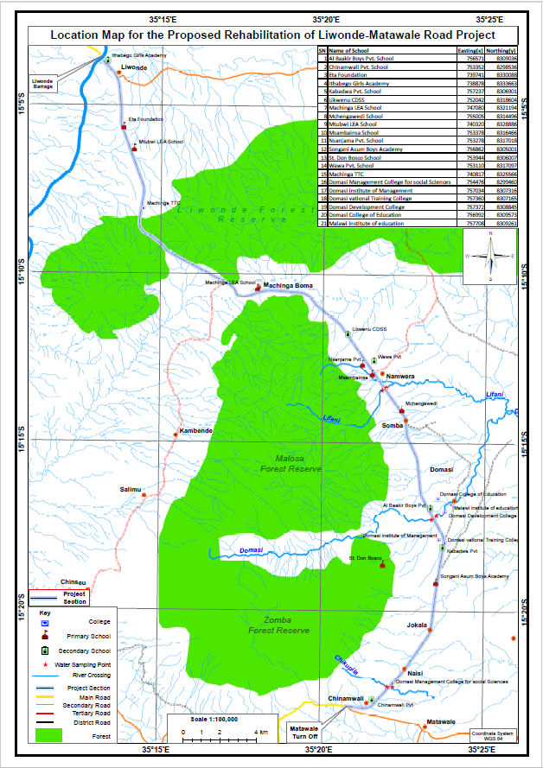
Figure 1: Location of the Proposed Project

Nature and Scope of the Proposed Project
The Liwonde-Matawale Road Rehabilitation Project is phased into four main stages: planning, construction, demobilization, and operation and maintenance. Each phase has significant implications for displacement, relocation, and resettlement, as well as for addressing the environmental and social impacts. Below is an outline of how these phases intersect with the development and implementation of the Resettlement Action Plan (RAP).

  - Planning Phase
The planning phase involves critical activities such as engineering design, feasibility studies, and the preparation of the Environmental and Social Impact Assessment (ESIA) and RAP.
- Design and Extent of Works: The road design and earthworks determine the amount of land required for road widening and construction material, which includes road alignment, shoulder widening, and the needs for infrastructure like bridges. Based on these designs, the scope of work has been clearly defined, including the spatial requirements and the quantities of materials needed—such as gravel, quarry stone, and water. All road works will be carried out within the Road Reserve (RR), which was demarcated using marker posts. Site clearing will be strictly limited to the areas where construction activities will occur, as defined by the coordinates provided by the supervising consultant and this sets the project’s Right of Way (RoW).
- Environmental and Social Impact Assessment (ESIA): The ESIA predicts and evaluates the potential impacts of the project, including displacement of people, loss of assets, and effects on public utilities and forests such as the Liwonde Forest Reserve. It also considers risks to livelihoods for those relying on land for farming, business, or housing. The ESIA informs the RAP development, ensuring that any displacement or loss of income is addressed through appropriate measures among them compensation and resettlement plans.
- RAP Development: The RAP is developed based on the ESIA findings and aims to mitigate the social and economic impacts of displacement. The RAP established procedures and processes for identification of affected properties and Project Affected Persons (PAPs); outlines compensation strategies; and proposes measures for livelihood restoration in order to ensure that affected individuals are not left worse off after the project.
- Reclaiming Road Reserve: The road widening requires claiming land within the Road Reserve (RR) and that will displace individuals, households, and businesses that are currently existing with the RR. Trading centers such as Malosa, Somba, Songani, and Matawale will be directly affected, as the Road Reserve in these areas is densely occupied. Additionally, the road works will impact forested areas, including sections of the Liwonde Forest Reserve, through which the road alignment passes.
- Resettlement and Compensations Payment: PAPs displaced by the road widening and other works like diversions will need to be resettled. The RAP ensures that resettlement is done in a smooth way and the impact on resettled households and individuals is well managed. Compensation will be provided for lost assets and livelihoods, ensuring that PAPs are not worse off after displacement. This may include monetary compensation for lost structures or land and assistance in re-establishing businesses or farming activities. The RAP also focuses on creating alternative livelihoods for those who depend on informal markets or other income sources.

  - Construction Phase
The construction phase involves the physical work necessary to rehabilitate the road, and this is where the greatest impact on communities occur, especially through claiming land within the Road Reserve (RR) and displacement.
- Civil Works (Road, Bridges and Drains): Undertaking of bush clearing and actual construction of the road, bridges, the site camp and drainages. This phase will also involve clearing of the compensated trees and structures that were still standing following lapse of resettlement period to create room for the works. Trading centers such as Malosa, Somba, Songani, and Matawale will be directly affected, as the Road Reserve in these areas is densely occupied.
- Relocation Utility and Services: Infrastructures such as electricity lines, water pipes, optical cables, boreholes, police road block and streetlights within the Road Reserve (RR) will be relocated during construction thereby temporarily disrupting the services obtained from such infrastructure. The RAP provides procedure to ensure proper communication among the stakeholders and to ensure timely repair of the relocated infrastructure. The RAP ensures costs and resources are provided for the relocation of such utility and service infrastructures and outlines measures to minimize service disruptions.
- Ancillary Works Land Acquisition: Land acquisition for ancillary activities, such as quarry, gravel and soil hauling sites, water extraction sites, diversions, river training and campsites, will also lead to displacement and resettlement. The RAP addresses the acquisition of land for these purposes and ensures compensation and livelihood restoration for affected people.
- Temporary Diversions: During construction, temporary diversions will be necessary to maintain traffic flow. This may impact businesses and settlements along the road, requiring temporary relocations. The RAP includes provisions for managing these relocations to minimize disruption.

  - Demobilization Phase
The demobilization phase will take place after construction is completed, focusing on removing temporary infrastructure and restoring impacted areas.
- Demolition and Rehabilitation: Temporary structures elected, such as worker camps and construction-related infrastructure, will be removed and those temporarily relocated will be restored. Areas disturbed by the construction such as burrow pits, quarry sites, diversions, and access points will be rehabilitated as per the World Bank’s Environmental and Social Framework (ESF) and MEPA guidelines. The RAP will ensure that affected landowners are properly compensated and that contractors facilitate the restoration and hand over of land to its rightful owners.

  - Operation and Maintenance Phase
Once the road is rehabilitated, the operation and maintenance phase begin, involving the monitoring and maintenance of the road.
- Monitoring and Evaluation: The RAP will continue to be monitored during the operation phase, particularly focusing on the success of resettlement and livelihood restoration efforts. This includes assessing the effectiveness of compensation measures and ensuring that PAPs have successfully integrated into their new communities and maintain their livelihoods.
- Grievance Redress Mechanism: Throughout the operation phase, a grievance redress mechanism managed by the RA will be in place to address ongoing issues related to compensation, resettlement, or livelihood restoration, ensuring that any unforeseen challenges are managed effectively.

The RAP is therefore developed for managing impacts of the Liwonde-Matawale Road Rehabilitation Project, particularly in addressing displacement, relocation, and resettlement. The RAP ensures that affected communities are not left worse off by identifying PAPs, outlining compensation strategies, and providing for livelihood restoration. The RAP also addresses land acquisition for ancillary works such as quarry sites, soil and gravel hauling sites, water extraction, access roads, and campsites. It aims to mitigate social and economic risks associated with land acquisition and displacement by ensuring that PAPs are adequately compensated and supported throughout the project lifecycle.

Existing land use and land requirements for the project
The Liwonde-Matawale (M003) Road is gazetted as a primary road under the Roads Act No 7 of 2023, with a road reserve of 60 meters. This reserve is designated as public land for road infrastructure purposes. Beacons marking the RR boundaries exist in some areas but are inconsistently placed. However, the existing RR is encroached upon by infrastructure (both permanent and temporary), informal vending, and small-scale farming. Specific infrastructure includes structures (residential, commercial/shops, fences, toilets, mixed-use properties), utilities (electricity lines and water pipes), service facilities (optical fiber, wells, boreholes and street lights), bill boards and drainage system. Local authorities generally tolerate these encroachments, recognizing their informal nature.

The project will require approximately 24 meters’ width of land over the 47.9 km stretch translating to 1,149,600 m², within the gazette road reserve. Thus, no additional land acquisition, outside the RR, will be required for the road construction. The road width will be widened from the existing average of 6.0 m (i.e. a range of 5.6 - 6.4 m) to 12.4 m (i.e. 6.2 meters each side) in rural areas and 23.4 m (11.7 m each side) in urban areas. In rural areas the 6.2 m on each side will accommodate a carriage way of 3.7 m, 2 m for paved shoulder width and a 0.5 m for shoulder roll over to limit future damage of the shoulder. In urban sections which include trading centers such as Malosa, Somba, Songani and Matawale the 11.7 m on each side will make accommodation for carriage way of 3.7 m, 2.0 m for walkway, 0.3 m for spacing between the road and drainage, 1.7 m for construction of drainage systems and provision for utilities, 2.0 m for cyclists and 2.0 m for emergency shoulder. The project will also create 11 bus bays and lay-by systems.

Even though the project will be carried out within the road reserve as stipulated above, the road will pass through Liwonde forest reserve, agricultural fields, trading centers and settlement areas thus structures, markets, utility and service infrastructure and trees will have to be cleared to make way for the road works. These will result in the displacement, resettlement, and relocation of people and utility and service infrastructure, disrupting livelihoods as well as social and economic activities. As a result, a Resettlement Action Plan (RAP) has been developed to ensure proper management of resettlement and relocation, guaranteeing that PAPs receive fair compensation and are not left worse off after the project. The proposed road project will also require extra temporary acquisition of land for ancillary works such as: Contractor campsites (approximately 2 hectares but prone to change upon contractors’ requirements); quarry site, sand mining – loading/turning/pumping bay, soil and gravel hauling sites, water abstraction sites and access road to these sites. Location of these sites and required sizes will be determined by the contractor during construction and is outside the scope of this RAP. However, land acquisition procedures for ancillary works outside RR are included to this RAP as Annex C. Post-construction, the RR will remain public land, with strict controls enforced by the Roads Authority and local councils to prevent encroachment and ensure road safety while the ancillary sites will be rehabilitated as per project specifications that align with World Bank ESF standards and MEPA guidelines, and will subsequently be returned to their respective owners.

Compensation for the PAPs
The Resettlement Action Plan (RAP) outlines compensation for relocating infrastructure for utility and service companies and 1,745 Project Affected Persons (PAPs) whose structures, livelihoods, trees, and other assets such as utility and service infrastructure within the 60-meter road reserve are impacted. The valuation of these assets was prepared, disclosed, negotiated and approved by the Regional Commissioner for Lands. Once the compensation has been disclosed and accepted by the PAP’s, it will be provided in accordance with Malawi laws and World Bank’s Environmental and Social Framework (ESF) standards before construction begins.

Although the RAP primarily addresses utility and service infrastructures and PAPs within the road reserve, it will also cover relocation and resettlement procedures for ancillary areas. At present, the assets impacted by soil and gravel hauling, quarry sites, campsites, sand mining, and water extraction sites are yet to be identified and confirmed. Once these sites are identified, they will be assessed and compensated by the contractor in liaison with respective Councils following all Malawi laws and World Bank standards, ensuring full replacement costs and fairness. The contractor will also be responsible in identifying any damages caused during construction and RA will facilitate their assessment, valuation and compensation after the damages are reviewed by the supervising engineer. In that view, the RAP set procedures for management of those activities, relocation and resettlement (see Annex C-1).

CHAPTER 2: RESETTLEMENT PLANNING AND DESIGN

Introduction
This section provides information on the approach and methods used to develop this RAP.

Methodology for preparation of the RAP
The Resettlement Action Plan (RAP) was prepared using a combination of primary and secondary data collection methods to ensure a comprehensive understanding of the impacts and needs of the affected population. The approach focused on inclusive stakeholder consultations, accurate socio-economic data collection, and compliance with compensation principles, including payment at full replacement cost

Site visits
The visits were conducted to understand the project impact areas and to obtain verifiable information about the area. The visits further provided an opportunity for the team to interact with members of the communities and staff from relevant ministries and departments of Zomba City Council and Machinga and Zomba District Councils as well as utility and service companies. During the visits, information was collected through personal observations, focus group discussions and key informant discussions made in the area to be affected by the proposed road project. The method was also used to identify the type and density of the existing trees and protects forests (whose impact was later assessed separately by Department of Forestry).

Literature review
The desktop study reviewed: Liwonde-Matawale road designs, material specifications and ESIA; SATCP safeguards instruments (RPF, ESMF,SEP and GRM Manual); the Constitution of the Republic of Malawi; National Policies (the Malawi Vision 2063, the National Land Policy, National Environmental Policy, Forest Policy); National legislations (the Environment Management Act, the Water Resources Act, the Land Act, Land Acquisition Act, Town and Country Planning Act, Public Roads Act, Forestry Act, Relics and monuments Act and other pieces of legislation relevant to the activities of the proposed project); World Bank Resettlement Policies; and Environmental and Social Guidelines for Roads Sector. Additional documents such as the socio-economic profile, health surveys and research data for Zomba City, Machinga and Zomba District Councils were also reviewed. The intention of reviewing the policies, legislations and guidelines was to ensure that the resettlement and compensation of the PAPs was done according to legal requirements.

Consultation with Stakeholders
Successful resettlement requires stakeholder participation during all stages of the resettlement process. Consultation with affected people and stakeholders is seen to be mandatory and is regarded as the single most critical component in the resettlement process. The RAP team aimed to achieve effective consultation through undertaking the following activities:
- Information exchange: Promoting awareness-building of the Project and resettlement in the local communities;
- Capacity Building and Education: Informing affected people of their options and rights pertaining to resettlement and compensation and training the Resettlement and Compensation Committees on grievance management;
- Participation Promotion: Allowing all stakeholders to openly voice their concerns, any issues and possible disputes without fear of recrimination; and
- Discussion and Negotiation: Consulting with affected people and offering them choices among technically and economically feasible resettlement and compensation alternatives;
- Focus group discussions (FGDs): Organized with targeted groups, including women and business owners, to gather input on resettlement and compensation concerns; and
- The stakeholder consultation process undertaken by RA during project initiation (awareness and screening) and those for the ESIA phase have initiated stakeholder consultation for this RAP (refer to Chapter 4 for details on stakeholder consultation undertaken to date). Further consultation will be undertaken with PAPs, traditional leaders and the relevant District Commissioner(s) following the development and clearance of this RAP by the World Bank. It is anticipated that these consultations will be conducted by the RA, the Ministry of Lands, a Valuation Office and the office of the relevant District Commissioner.

Household, Community and Asset Surveys
An important aspect in undertaking a resettlement programme is to determine the existing socio-economic context of potentially affected households and communities. This is accomplished by undertaking a number of socio-economic studies, including those listed below:
- Mapping: Depending on data availability, the resettlement process may be supported by a Geographic Information Systems (GIS) interface and field mapping. Maps may include both socio-economic, spatial patterns and natural features of the resettlement site and host site;
- Census: A census of directly affected PAPs, i.e. those either physically or economically displaced, was undertaken during the asset inventory process to provide socio-economic and demographic baseline information. This census is important as it provides a register of affected PAPs and allows for the determination of PAPs that are eligible for compensation and for protection under the auspices of this RAP;
- Asset Inventory: The asset inventory records all permanent and temporary losses likely to be incurred by households, enterprises and communities as a result of the road rehabilitation project. An asset inventory was jointly undertaken by representatives from the Ministry of Lands and the RA in the second quarter of 2024. The survey data are summarised in Annex B – 1 and Annex C, and include all structures located within the 24 m RoW that need to be removed and or relocated. For the forestry reserve section, the RA involved Department of Forest to carry out a census of the trees and other forest products available in their protected areas. Utility and service companies were shared with the KMZ file (coordinates) indicating extent of road works (which included the diversions) and requested them to identify and share coordinates of their respective infrastructure falling within the RoW for RA’s consideration.

This inventory focussed on individual, households and community losses of physical structures and loss of access to natural resources (mainly trees). The inventory included information relating to losses of the following aspects, as appropriate and relevant:
- Homesteads and ancillary structures;
- Trees and natural resources;
- Community resources including schools, churches and health facilities;
- Community land and natural resources;
- Sites of cultural or historical importance including graveyards; and
- Other assets owned by PAPs;

A moratorium on development is currently in place and as such stakeholders in the project area were prohibited from developing their homesteads or other assets unless only where structural integrity of the said structure was threatened and the Councils and RCCs were notified and have verified and documented the case.

Determination and Negotiation of Entitlements and Compensation
The RAP identifies households, individuals, communities, and utility and service companies that are deemed to be entitled to or eligible for compensation. The eligibility criteria was defined early in the resettlement process and was agreed upon with all stakeholders as affected households, individuals and communities are entitled to compensation based on agreed values which were also disclosed during asset verification and value disclosure and negotiation. Multiple compensation options were discussed with affected parties via the consultative forums in order to obtain agreement on the adequacy and acceptability of the compensation package.
Compensation valuations focused on the following:
- Compensation options in terms of replacement of homesteads, structures and replacement land for physical resettlement. These were based on initial census results and consultations with PAPs where they preferred cash as it gives them more flexibility and timely replacement of assets unlike if RA replaces them; and
- For communal asset, such as boreholes, relocation and replacement of such structures was preferred by stakeholders.

Asset Evaluation
The estimated extent of compensation required for assets that will be lost was subjected to an asset evaluation process that recognizes three main parameters, i.e.:
- Land to be acquired under the proposed Project (no land is to be acquired by the Developer);
- Structures falling within the road reserve (key parameter of relevance to this RAP);
- Forestry products within the protected areas under the Department of Forestry were jointly assessed with the subject Department and Machinga District Council. RA was advised to undertake restoration exercise for the affected products using an independent service provider with expertise in forest ecology and native species restoration be engaged to lead the reforestation and ecosystem rehabilitation activities; and
- Trees and perennial crops falling within the road reserve. Annex B – 1 and Annex E – B (b - iii) indicates that compensation rates have been included for trees. As stated earlier in this report, field owners were notified not to plant crops in road reserve in advance of road construction activities and no compensation is envisaged for this parameter. Replacement of trees that fall under customary land will be replaced based on engagements with community members, traditional leaders and district council.

Resettlement Planning, Scheduling, Budget and Responsibilities
Information in terms of resettlement planning, schedules, budget and responsibilities are provided. These various components have been developed based on the outcomes of the previous tasks and were negotiated and discussed with the communities and relevant authorities. Key factors that will need to be defined include:
- Resettlement Planning: Define overall strategy in terms of resettlement, likely phasing and means of compensation. Further consideration will be needed in terms of construction of any resettlement structures, labour and other issues.
- Scheduling: Define timing for resettlement in terms of the physical resettlement, payment of any cash compensation and ensure it aligns with any civil engineering required by the Project.
- Budget: Resettlement costs are often underestimated and thus detailed budgeting/costs for the implementation of the resettlement should be provided.
- Role and Responsibilities: Organisational structures and responsibilities must be clarified prior to resettlement. This includes all actions that must be adopted by relevant stakeholders including, amongst others, the proponent (RA) and the relevant government departments.

Initiation of Resettlement and Compensation
The physical resettlement and compensation should be initiated in line with the RAP (this document). Overall responsibility for the implementation of the RAP lies with the proponent (RA) with close co-operation from local authorities.

Monitoring and Evaluation
Monitoring and evaluation are an important part of a resettlement project and the requirements for this task are set out in Chapter 9. The purpose of performance monitoring is to ensure that the RAP is implemented as described in the plan and incompliance with World Bank’s ESS 5 requirement.

CHAPTER 3: STAKEHOLDER ENGAGEMENT

Overview
Participation of and consultation with the affected community and authorities is vital to the success of the resettlement and compensation programme. The process was aligned to the principles and requirements of SATCP’s stakeholder engagement plan. Consultation and participation of the public allow the project management to design resettlement such that it is able to benefit affected peoples. Effective consultation can also assist in reducing the costs of implementing the RAPs by avoiding implementation that is contrary to the needs of PAPs and which does not breed antagonism towards the project by withholding information. Consultation is an ongoing aspect of the resettlement process that takes place through every stage of resettlement planning and implementation and thereafter, once the road upgrade project has started.

Broadly defined, stakeholders include any individual or group that feel that it is going to be affected by the project, the affected community and any individuals or groups that may have any significant role to play in shaping or affecting the project, be it in a positive or negative manner. In a narrower vein, PAPs are those individuals and groups who are directly affected by the project through the loss of assets and or land, or for whom the project disrupts or affects their livelihoods. Every effort has been made to undertake meaningful stakeholder engagement and deliberative consultations where stakeholders were informed of the Project and its resettlement components. In this regard the ESIA had a consultative process that has been followed.

Aims and Objectives of Stakeholder Consultation
The aim of the stakeholder consultation process undertaken during the ESIA was to:
- Achieve continued, optimum stakeholder input and support for the current project;
- Understand stakeholder’s viewpoints;
- Build trust by, e.g. providing feedback to stakeholders;
- Implement experiences and lessons learnt from stakeholders and community experience;
- Inform decision making and facilitate sustainable development;
- Empower and build capacity amongst stakeholders;
- Disseminate concepts of the proposed project activities with a view to generating project interest amongst the communities;
- Manage stakeholder expectations; and
- Promote a sense of ownership for the project and resettlement activities

From the onset of the project, RA has facilitated meaningful engagement and deliberative consultations with various stakeholders, namely: councils, utility and service providers, communities, project affected persons and government agencies. Initially, in 2022 the Roads Authority conducted preliminary stakeholder engagements and the Design Consultant and Individual RAP Consultant later undertook in-depth engagement. In addition, targeted consultations were held with Project-Affected Persons (PAPs) and other stakeholders to discuss resettlement, compensation, and livelihood restoration measures as part of the RAP development process.

These consultations aimed to foster collaboration, address concerns and ensure transparency in the RAP preparation process. The objectives of the consultations included:
- Discuss land requirements of the project, impacts and implication on various stakeholders;
- Discussing compensation principles, including applying World Bank’s full replacement cost policy
- Exploring livelihood restoration measures tailored to the needs of affected groups, particularly vulnerable populations;
- Identifying preferences and challenges related to resettlement for physically displaced households and businesses; and
- Gathering opinions on key project impacts and strategies to mitigate them.
- Informing PAPs about grievance redress mechanisms to address disputes related to compensation and resettlement

Stakeholder Mapping
During the reconnaissance of the proposed approach for the road project, the RAP team identified key stakeholders to initiate the stakeholder engagement process. A comprehensive stakeholder identification matrix was employed to categorize, analyze, and assess stakeholders' roles and significance in the project. The analysis considered responsibilities, influence, proximity to the project, dependency, representation, and strategic alignment with the project's objectives. Table 1 below outlines the categories of stakeholders, their mandates or interests, their level of influence on the project, and their expectations.

Table 1: Stakeholder Matrix
Stakeholder Category | Stakeholders | Mandate/Interest | Influence on the Project | Expectations
Project Affected Persons (people within the RR) | Directly Affected Persons (Households, Farmers, Business Community) | Sustainability of their livelihoods | Can influence level of acceptability and public interest in the project | Prompt and fair compensation for all property
Project Affected Persons (people within the RR) |  | Fair compensation for their properties | Can influence the mode of compensation | Restoration of livelihoods
Project Affected Persons (people within the RR) |  | Preservation of social networks |  | Vulnerability support
Communities | Local communities, PAPs, traditional leaders, grievance committees | - Transparency and engagement of projects actions and changes | High: Impacts on land, livelihoods, environment, and trust | - Expect transparency in project scope changes, especially for those previously identified as affected but now excluded.  - Expect continuous involvement of grievance committees in decision-making processes.  - Expect clear explanation of the tree valuation and counting process.  - Expect dust management measures during construction to prevent health risks.  - Expect local labour to be prioritized for employment opportunities.  - Expect timely project implementation to reduce uncertainty and community frustration.  - Expect prompt compensation disbursement to prevent reoccupation or new structures on assessed land.
Traditional Leaders | Traditional leaders, community leaders | Represent the interests of landowners and local communities, particularly in the rural and traditional landholding areas. | Medium: Help in PAP identification | Fair compensation, consideration of local customs in land acquisition processes, and timely relocation support.
Traditional Leaders | Traditional leaders, community leaders |  | Helps mediate and facilitate communication between the project and local communities, especially those directly affected by land acquisition.
Local Governments | Local Councils  Zomba District Council (ZDC) | Monitoring project activities within their jurisdiction  Community mobilization and support | Medium: Impacts on municipal infrastructure and public communication | - Expect timely and improved communication from RA to avoid community frustration.  - Expect early commencement of disclosure activities to avoid PAP uncertainty.  - Expect at least two (2) months' advance notice before construction starts to prepare for the removal of infrastructure.  - Expect project support in removing and storing city street poles.  - Expect that clients will be notified to remove billboards, and that space will be made available post-construction for reinstallation where feasible.  - Expect the contractor to coordinate removal and safe storage of unclaimed billboards at council premises if clients do not comply.
Development Partners | World Bank (WB) | Ensuring compliance with international best practices and standards | Can influence adherence to international standards | Full compliance with international standards
Development Partners | World Bank (WB) | Providing financial support and monitoring | Can influence budgetary allocations and implementation | Effective project implementation and reporting
Central Government Agencies | Ministry of Labour, Ministry of Lands, Ministry of Gender and Social Welfare, MEPA, Ministry of Transport and Public Works | Protection of human rights and security of livelihoods | Can influence preparation of mitigation plans | Prompt and fair compensation
Central Government Agencies |  | Ensuring compliance with national laws and guidelines | Can affect the pace of implementation | Restoration of livelihoods with special focus on vulnerable groups
Central Government Agencies |  | Approvals for operations | Can enforce local content laws
Utility/ Service Companies | Southern Region Water Board (SRWB) | Provides water supply and sanitation services. | Medium: assist in water law compliance and relocation  Can influence water extraction mechanism and processes | - Accurate mapping and reporting of water pipe locations and depths.  - Early relocation of infrastructure before construction begins, with clearances for PAPs.  - 12-week relocation timeline in Zomba, contingent on compensation and space availability.  - Avoid excessive crossings and include service ducts where necessary.  - Timely payment for relocation activities and post-intervention invoicing for emergencies.  - Assistance with excavation and trenching during the relocation process.  - Emergency response for any infrastructure missed in plans, with a 1-2-hour response.  - Daily on-site presence to monitor activities and address concerns.  - Clear communication throughout the project, with regular updates and use of a WhatsApp group for rapid coordination.  - No construction water from the SRWB dam—only domestic water use permitted in Zomba.
 | Electricity Supply Corporation of Malawi (ESCOM) | Provides electricity distribution and generation services. | Medium: assist in electricity law compliance and relocation | - Submit completed relocation forms and payment proof to Machinga ESCOM.  - Coordinate site visits for pole verification and asset mapping.  - Assist in identifying all ESCOM assets, including underground cables.  - Plan and book outages in areas needing power disconnection.  - Keep ESCOM informed on construction progress and schedules.  - Report any infrastructure damage or emergencies immediately.  - Support ESCOM during emergencies (e.g. transport, access).  - Avoid damaging ESCOM infrastructure during construction.  - Sensitize PAPs on disconnection fees and asset ownership.  - Maintain regular communication with ESCOM, RA, and contractors.  - Payment of Capital Contribution Fee part of the overall relocation expense.
 | Open Connect Limited (OCL) | Provides telecommunication services. | Medium: Potential impact on telecommunication infrastructure such as optical fibre lines and poles. | - Accurate mapping and communication of construction zones.  - Support during trenching to avoid damage to buried cables.  - Timely payment to enable relocation and mobilization.  - Early reporting of any incidents or cable exposure.  - Coordination during relocation, especially around bridges.  - On-site assistance when exposing cables.  - Clear communication from project start to finish.  - Emergency access and quick reporting of any infrastructure impact.  - Regular updates from RA and contractors during all phases.
 | Camusat (Airtel Contractor) for Optic Fibre Line | Provides telecommunication services. | Medium: Potential impact on telecommunication communication and infrastructure such as optical fibre lines and poles | - Trenching Support: Assistance from road contractor in critical areas.  - Emergency Response: Must be notified quickly; committed to 2-hour response time and post-intervention invoicing.  - Monitoring: Personnel to remain on-site throughout construction.  - Budget: Expectation to submit detailed relocation budget for approval.  - Gap: Lack of coordination or trenching support could delay relocation or cause service disruptions.
 | Police | Provides security and road safety | Medium: Temporary relocation may affect enforcement, public safety, and accessibility | - Formal Communication: RA must issue a formal relocation request.  - Logistical Support: RA to provide site clearance, infrastructure movement, and basic facilities (toilets, shelter, water).  - Coordination: Police expect structured liaison with RA’s supervising consultant and contractor’s social officer.  - Gap: Lack of timely formal communication or inadequate support could delay or compromise relocation.

Consultations
Community consultations were done from 11th June to 6th July 2023. In 2024, the project narrowed down to PAPs within the villages along the road and consultations were jointly made by officials from Department of Valuations under the Ministry of Lands and Councils. RA together with Individual RAP Review Consultant, facilitated consultations and field visits with utility and service providers in 2024 in order for the companies to identify their infrastructure and agree on measures to protect the infrastructure that might potentially obstruct the works including relocation as well as establish procedures to cover events where such infrastructure is damaged especially during construction phase.

FGDs were used, and it involved a small group of respondents (usually 6-15 respondents) who were interviewed together in a common location. Three different groups were interviewed at each location: men only, women only, and a mixed youth group. The social expert and field assistants were the interviewers who led the discussions and ensured that every person had an opportunity to respond. A total of 449 PAPs were consulted through 48 FDGs where 246 adults (176 males, 70 females) and 203 youths (95 males and 108 females) as presented in Table 2 below.

Table 2: Details of FGDs conducted along the road.
Group Village Head | Number of FGDs | Males FGD (Number of Participants) | Female FGD (Number of Participants) | Youth Group
 |  |  |  | Males | Female
Machinga District
Chibwana | 3 | 9 | 16 | 9 | 7
Malindima | 3 | 6 | 8 | 4 | 8
Mliwo | 3 | 7 | 13 | 5 | 6
Kalanje | 3 | 8 | 11 | 6 | 5
Chabwera | 3 | 9 | 12 | 7 | 6
Mlangala | 3 | 9 | 15 | 7 | 8
Chingoli | 3 | 14 | 11 | 6 | 5
Ndaje | 3 | 7 | 12 | 8 | 9
Lipongo | 3 | 9 | 11 | 5 | 6
Nkalo | 3 | 7 | 13 | 6 | 8
Zomba District
Minama | 3 | 10 | 9 | 4 | 8
Mtogolo | 3 | 6 | 13 | 5 | 6
Mwambaka | 3 | 9 | 10 | 6 | 5
Kapyepye | 3 | 8 | 9 | 4 | 8
Chopi | 3 | 14 | 5 | 5 | 6
Chinamwali | 3 | 13 | 8 | 8 | 7
Total | 48 | 176 | 70 | 95 | 108
These topics aimed to inform, engage, and address concerns, ensuring transparency and participation in the project process. Following that, the major issues and concerns raised as well as the project feedback and commitment is outlined in the Table 3 below.

Table 3: Stakeholder Issues and Project Commitments and Feedback
Concerns from Participants | Issue/Concern | Response/Proposed Mitigation
Crops | Shall we continue growing our crops in the road reserve? | Those with crops will be allowed to harvest them, including commercial trees. A minimum of seven-day notice will be given to the PAPs prior to commencement of works as required in the Land Act 206 section 45 subsection 2 (provision of notice to an illegal occupant to vacate land).
Structures | There are people who have their houses built within the reserve. What is the plan for such structures? | Compensation for structures will be based on the materials used and valuation. Structures built after the cut-off date will not be compensated.
Markets | There are several markets along the road, especially in high-density areas. What will happen to these? | Markets within the RR will be demolished to pave way for the works. The Livelihood Restoration Plan (LRP) will include mitigation measures. Local authorities will work with RA to identify suitable locations for relocation.
Loss of Livelihood | What happens to people who derive their livelihood along the road reserve? | A detailed Livelihood Restoration Plan will be implemented to support those impacted economically. Priority will be given to restoring livelihoods through compensation and other measures.
Employment | Will our people gain employment in the road construction works? How will the project benefit the locals? | Local content is prioritized to maximize direct and indirect employment for locals. Contractors will ensure fair hiring practices and training opportunities. Labor laws will be enforced to safeguard workers' rights.
Project Start | When is the project likely to start? | The project will commence after the compensation process is complete. Construction is expected to begin by November 2024.
Dust Impact | What about dust from construction affecting nearby businesses? | Contractors will mitigate dust impacts by employing water sprinkling and other measures. A grievance mechanism is in place to address concerns.
Disclosure and Awareness Raising | The community wanted to know if it was possible to access the legislations that talk about land issues since most of them were not aware about these laws | The Acts are enacted by the National Assembly and printed by the Government Printers’ Offices. They can be accessed from the DCs office. However, the Ministry of Transport, through RA as custodian of the Public Roads Act has the responsibility to raise awareness about the contents of the Public Roads Act. RA has done that through awareness campaigns such as sensitizations and will also make available the RAP once it is finalized
Eligibility for Compensation | Who qualifies for compensation? What about tenants or new property owners? | Compensation is based on assets documented before the cut-off date. Tenants and new property owners are eligible if they meet assessment criteria.
Cut-off Date Awareness | How will people know about the cut-off date? | Public announcements via local radio, loudspeakers, and community meetings will ensure awareness. Committee members will assist in spreading information.
Grievance Redress Mechanism | What measures has the GoM put in place to ensure that no disputes arise when resettling people and relocating property outside the road reserve? | The RAP will have a Grievance Redress Mechanism in place where grievances can be raised without any fear of recrimination.
Relocation Period | Will people be given notice before the demolition of their structures? | Indeed, people will be given notice before demolition of their structures. A notice of about 2 to 3 months will be given to those people whose structure will be affected.
Occupying the RR | How will those that have properties in the road reserve be differentiated in-terms of establishment of structures before and after placing of beacons? | They will all be compensated. However, a time will come when a letter through the DC`s office will entail the closing period when anyone who constructs in the road reserve will not be considered anymore. It is important to note that the law does not differentiate people on the basis of ignorance.
Property Assessment | Who is responsible for determining the value of the properties to be compensated? The owner or property evaluators? | Government registered property evaluators will be engaged for that purpose.
Property Assessment | How will the estimates of items per house be calculated? | A property evaluator will estimate and calculate all the costs per house depending on the current prices of the items.
Compensation Payment | What will start between compensation and road construction | The people will first be compensated then the construction can take place.
Road Reserve | How will those that built their structures knowingly and unknowingly in front of a beacon be differentiated? | With respect to the laws, they are all wrong doers. However, both will be compensated.  Shortly Government will enforce regulations that prohibit settlement within road reserves.
Cultivation within the RR | How will those that have farms near the road be considered? | Those that have crops will be asked to reap/harvest their produce before construction starts. They will be warned not to plant within the road reserve. They will also be compensated for the loss of crops based on an assessment of crops in the field if the crop is lost.
Relocation of Vendors with items that ineligible for compensations | Zomba City Council should arrange for a place where the displaced people will be plying their businesses. | This request made by the vendors has been noted. It will be communicated to relevant authorities and included in the RAP as one of the mitigation measures for loss of business by the vendors.
Damaged Properties | Will those affected during construction due to operations of machinery be compensated? | These will be considered, even if they are just cracks on houses. Contractors will be required to undertake dilapidation surveys prior to starting construction and establish a baseline. If it is seen that construction activities damage structures, the Contractor will be required to compensate the affected party.
Damaged Properties | If road construction causes cracks in houses outside the reserve, will there be compensation? | It will depend on where, if these are due to the actual road works and it is deemed not contractor’s fault for instance cracks due to compaction of the road, the project will address through a contingency fund. However, if this is due to contractor’s negligence or on ancillary works, the contractor will be responsible. Complaints should be reported through the grievance committee.

During the consultations, speculative behaviors (e.g., erecting new structures within the RR to claim compensation) were observed. To mitigate this, the project established a cut-off date (31st July 2023), which was communicated clearly to all stakeholders. Structures or activities initiated after this date are ineligible for compensation, as outlined in the RAP. Community leaders were engaged to monitor and discourage speculative activities. From the discussions, it was observed that impacts from the rehabilitation of the proposed road are likely going to come from: compensations, employment, livelihood impacts from reliance of business along the road and probable damages of structures close to the road reserve, for mitigation all houses surrounding the road will have to be screened and pictures taken prior to project commencement to ensure legitimate claims on any damages that may occur. Evidence of stakeholder consultations and a summary of the consultation process is provided in Annex D and E. Recommendations outlined in Annex D and E are integrated into the RAP implementation framework. These measures are part of the final RAP and will guide the construction phase. No revised RAP is required, as this document encompasses all relevant feedback and commitments.

Census of Project Affected Persons/Social Economic Survey
A census of PAPs was conducted to identify and document individuals, households, and businesses directly impacted by the project. The census served as the basis for determining eligibility for compensation and resettlement assistance in compliance with World Bank ESS5 and Malawi laws. Affected persons were identified through consultations with Community Grievance Redress Committees (CGRCs)- community leaders, local authorities, and mapping of the RR, which was pre-set in GIS for accuracy.

The census team began by briefing CGRCs and local leaders on the objectives and methodology of the census process, to ensure stakeholder participation and clarity. Enumerators, accompanied by CGRC members and local leaders, conducted household visits and interviews with PAPs to document demographic details, affected assets, and the extent of project impacts. The active involvement of CGRCs and community leaders provided oversight, ensured transparency, and minimized grievances. The census documented:
- The total number of PAPs categorized into households, businesses, institutions and public facilities.
- Types and quantities of affected assets, including land, structures, trees, and crops.
- Vulnerable groups, such as women-headed households, the elderly, and persons with disabilities, require special assistance during resettlement.

The census data formed the foundation for the valuation of affected assets, which included land, buildings, trees, and crops. Compensation amounts were calculated based on full replacement cost, adhering to World Bank ESS5 standards. The detailed findings, including quantitative data on PAPs, affected assets, and their valuation, are presented in Chapter 4 of this RAP. This participatory and transparent approach ensured that all affected persons were adequately accounted for and provided a robust framework for implementing the RAP.

Purposive sampling was used to select participants with relevant information for this study. The sample at the district level included members of the District Environment Sub-Committee (DESC), which the Director of Natural Resources and Environment chairs. Other members of the DESC include the District Environment Office, District Community Development Office, District Land Office, District Forestry Office, District Social Welfare Office, District Environmental Health Officer, and District Water Development Officer. The DESC members were first consulted through a consultative meeting on 03rd June 2023 for Machinga DESC and 04th June 2023 for Zomba DESC. After the consultative meeting, key informant interviews were conducted from 14th to 25th June 2023 with individual DESC officers to gather specific information from their sectors. Additionally, other stakeholder consultations were carried out with service and utility companies during field verification exercise of affected utilities and services. The stakeholders consulted included Southern Region Water Board (SRWB) in Liwonde and Zomba on 24th and 25th March 2025 respectively, Machinga and Zomba Electricity Supply Corporation of Malawi (ESCOM), Machinga Police, Camusat (Airtel Contractor) for Optic Fiber Line and Open Connect Limited (OCL) on 24th March 2025. Further Stakeholder consultations with communities’ representatives and CGRCs were conducted from 24th to 25th March 2025 along the Liwonde-Matawale road

It is anticipated that further consultation will be undertaken with PAPs, traditional leaders and the relevant District Commissioners following the development and clearance by the World Bank. These consultations will be conducted by the RA (or appointed representative), the Ministry of Lands, Valuation Officer and the office of the relevant District Commissioners. The objectives of these consultation meetings will be as follows:
- Discuss the contents of the RAP for validation and final input by RCC, PAPs and Councils;
- Re-orient the District Councils and Resettlement and Compensation Committees about the grievance management;
- Sensitize the Council and PAPs about the need to have GRM;
- Re-orient the PAPs about the RCC and GRM;
- Discuss on modalities on compensations payment process – verification, payment and resettlement;
- Orient the PAPs and communities about the impending Project, Migrant Workers and the influx of migrant workers and the dangers of HIV/AIDS and other Sexually Transmitted Infections (STIs); and
- Discuss any other social impacts of the Project

CHAPTER 4: POLICY AND LEGAL FRAMEWORK

Introduction
This Chapter provides background information on Government policy and legal framework related to the proposed project. The chapter provides the basis for the project’s resettlement activities and presents the policy and legal framework context in Malawi. The chapter has been subdivided into four main sections as follows: The first Section is the introduction; second section provides an outline of the most important related policies; the third section reviews the related legislations while the fourth section reviews the World Bank Environmental and Social Framework (ESF).

National Policy Framework
.

Malawi 2063
Malawi 2063 (MW2063) outlines the vision for the country’s long-term development, influencing the way resettlement, land acquisition, and compensation should be managed, especially in relation to infrastructure and other development projects. Section 2.3 of MW2063 emphasizes the goal of inclusive development, ensuring that no one is left behind. In the context of resettlement, this means that relocation should be fair, equitable, and voluntary. Project affected persons (PAPs) should be consulted and compensated adequately, with particular attention to vulnerable groups who must be specifically protected. Section 4.1, under the goal of land tenure security, ensures that all citizens have secure land rights. These policies guarantee that the projects resettlement processes do not undermine land security for those displaced.

In Section 5.2, the goal of environmental sustainability is highlighted. MW2063 calls for sustainable land use and environmental conservation, ensuring that the resettlement processes consider the ecological impact of development. Relocation should avoid environmental degradation, and appropriate land restoration measures must be put in place. Section 6.4 focuses on strengthening institutional capacity and governance. Effective land management requires robust and accountable governance structures. The implementation of Resettlement Action Plans (RAPs) must be managed by institutions capable of ensuring fair compensation and reliable grievance address mechanisms.

Economic empowerment and livelihood restoration are central to MW2063's goals, as outlined in Section 7.2. Resettlement should involve strategies that empower communities economically. Compensation must not only be monetary but also include non-monetary support, such as skills development programs and opportunities for economic integration. The project will comply through compensation and livelihood restoration. Finally, in Section 8.1, MW2063 stresses the importance of community participation and social inclusion. Therefore, the resettlement process must be participatory, with affected communities having representation in decision-making bodies. This ensures that the resettlement process is socially harmonious, inclusive, and aligned with the broader goals of development.
The Liwonde-Matawale road project will align its resettlement activities with aspirations and tenets of MW2063 thereby recognizing the land rights of citizens; ensuring that there is meaningful engagement with stakeholders; ensuring all quarters of communities particularly the vulnerable are incorporated, avoid tampering with ecological resource areas and that construction works are done in a sustainable way. In aligning with section 8.1, the project established RCC that consists of community members representing various groups and influences.

National Land Policy, 2002
The National Land Policy, 2002 is aimed at ensuring tenure security and equitable access to land in accordance with section 28 of the Constitution of the Republic of Malawi and to facilitate the attainment of social harmony and broad based social and economic development through optimum and ecologically balanced use of land and land-based resources. The policy provides clear definitions and categories of land tenure and outlines proposals to reform the land tenure system.

Section 4.11 of the Land Policy ensures that security of land tenure can be guaranteed on an equitable basis to all citizens in accordance with the statement that “Any citizen or group of citizens of Malawi can have access to land in any part of Malawi provided that:”
- Land is available where it is being sought;
- The person agrees with the land owner and the laws governing disposal of land; and
- The proposed land use is compatible with land use plans, environmental regulations and community land management duties and obligations.

Section 5.0 specifically provides for land administration and resettlement. The definition of ‘land administration’ in the policy is broad and includes the delivery of land rights, the planning of land uses, demarcation and survey of land parcels and the registration and maintenance of land information. It also includes conveyance, policies to facilitate decisions on mortgages and investment, development management, property valuation for assessment purposes and monitoring the environmental impact of all land-based activities.

Sections 5.19 to 5.22 of the policy deal with Land Retransmission and Resettlements. This part focuses on the acquisition of land for retransmission to the landless and for promoting a strategy to encourage the resettlement of landless and land-short households in carefully selected areas throughout the country in order to relieve land pressure and poverty in some of the most congested agricultural districts in the nation. The policy further guides that relocation and resettlement should to take into consideration the following factors:
- the principles of fairness, equity and human rights;
- the fact that people cannot be forced to relocate to any location without their consent and that individuals and household’s readiness to resettle in a different traditional area, district or region is a matter of personal choice;
- the fact that the potential disruption of social, cultural and economic existence may be traumatic enough to make the prospect of relocation untenable to some, and the prospect of leaving valuable immovable property is always a cause for resisting relocation; and
- how much will respondents demand to be successfully resettled.

Despite the fact that the provisions of the Policy focus on re-transmission of land to the landless and land poor, the principles and factors are applicable to issues of relocation and land settlement in general which will be applicable in the project as it will require relocation and resettlement.

The project’s resettlement activities will adhere to the principles set forth by the National Land Policy. For the soil and gravel hauling sites and other ancillary works, the project will encourage leasing as opposed to purchase and where private land will be acquired, adequate compensations will be paid in order to facilitate purchase of land.

National Gender Policy, 2015
The National Gender Policy (2015) calls for integration of gender responsiveness in planning and implementation of development projects and programs. It is understood that consideration of gender needs and benefits enhance poverty reduction in both rural and urban environments. Section 1.3 provides the purpose of the Policy as. “To strengthen gender mainstreaming and women empowerment at all levels in order to facilitate attainment of gender equality and equity in Malawi). Section 3.7 discourages Gender Based Violence (GBV), especially violence against women, girls and the vulnerable groups which was recognized by the Malawi Government as a severe impediment to social well-being and poverty reduction. Section 2.3 provides the Policy Objectives and number (ii) is, “To ensure women, men, boys and girls sexual and reproductive health rights, and HIV AIDS status are improved”.

In line with the National Gender Policy, all the teams and committees will have to ensure that men, women, including the vulnerable groups are given equal treatment without discrimination on the basis of gender. The project should also put in place all the measures for improving the sexual and reproductive health rights, and HIV AIDS status of workers.

National Decentralization Policy, 1998
The National Decentralization Policy (1998) seeks to create the democratic environment and institutions. As such, the Policy (a) devolves administration and political authority to the council level; (b) integrates governmental agencies at the council and local levels into one administrative unit, through the process of institutional integration, manpower absorption, composite budgeting; and makes provision of funds allocations to the decentralized services. In brief, the Policy makes full recognition of the council as a local government and stand-alone entity.

The implication is that the project should make full recognition of Machinga District Council, Zomba District Council and Zomba City Council. All the resettlement/relocation and compensation matters should be done in consultation and with full guidance and engagement of these Councils.

Legal framework

Constitution of the Republic of Malawi, 1995
The Malawi Constitution undersection 207 vests land in the ‘Public’ thus establishes government’s ‘eminent domain’. Section 44 specifies the limitation of expropriation of property where it shall only be permissible when done for public use and adequate notification and appropriate compensation, if there shall always be a right to appeal to a court of law.

Under Section 28, the constitution providers the basis for legislation providing for issues pertaining to title, claim or specific responsibility over land is outlined below: “Section 28 of the Constitution provides that every person shall be able to acquire property alone or in association with others and that no person shall be arbitrarily deprived of property.”

In line with the Constitution, the Liwonde-Matawale road rehabilitation designs have only utilized the RR for the actual road works. However, if necessary, the government may be requested to exercise its powers of eminent domain. In such cases, there will be thorough consultations and engagements with relevant stakeholders, including property owners, and the provision of adequate compensation in accordance with legal and policy requirements. .RA further recognize rights of property ownership as stipulated under Section 28 and in view with other policy frameworks particularly the World Bank ESS, RA will facilitate payment of compensations for the structures that are put up within the RR and make sure that the properties (including land), acquired outside the RR either by itself or the contractor are adequately compensated for. The project will further undertake protection and rectification measures for the properties that might be damaged due to works including cracking or falling due to compaction, swaying vehicles or any other means of damage. The contractor will be tasked with creating a data base (of picture, owners, village/chainage and commentary on structure integrity) for all existing structure within the road reserve, near quarry/burrow sites and along access to road to ancillary sites to save as a baseline for determination of structural impact caused by the project.

Public Roads (Amendment) Act of, 2014
This Act provides for road standards, safety and classification. The Public Roads Act of 1962 as amended was enacted to consolidate and amend the law relating to Public Roads. In this Act, the highway authority is assigned responsibilities for the construction, care and maintenance of any road or class of road in accordance with the Act. The Public Roads Act provides for various instances when compensation may or may not be paid. Sections 44-50 of the Act provide for issues relating to compensation including assessment of compensation generally and for surface rights, compensation for land which becomes public land, matters to be taken into consideration in assessing compensation for alienated land and claims for compensation.
Section 44 provides assessment of compensations which can be paid under this act. The compensations cover surface and land rights of the owner or occupier of land. Section 45 provides for compensation for conversion of land into public use and the section states specifically that in case of customary land compensation is in respect to disturbance to people, section 49 and section 50 provide opportunities for land owners or occupiers to appeal to the High Court on grievances related to resettlement and compensations provided for in this act. The part also provides for procedures to be followed before a Land Tribunal and the right to apply to the High Court for judicial review if the claimant is unhappy with a decision of the Land Tribunal.

The proposed road project will reclaim the road reserve and will fully comply with the provisions of the Act by ensuring that appropriate infrastructure for public safety and road durability are considered. Such infrastructure includes road signage, packing bays, bridges, road markings, road shoulders, drainage systems, road crossings and junctions, road reserves, vertical and horizontal alignments and others.

Land Act (Amendment), 2022
The Land Act (Amendment) of 2022 which is the principal legislation dealing with land tenure and land use, was enacted after the Land Act of 2016. The 2016 Land Act created a lot of discomfort among stakeholders ranging from rural people to other farming communities, traditional leaders, the academia, professional bodies and civil society. The major issues that have been addressed in the amended Land laws are the following: status of freehold land; sale of vacant freehold or leasehold land; concentration of land by few people; ownership of land by non-citizens; the role of traditional leaders in the administration of customary land; the role of customary law in the administration of customary land; and payment of fees for registration of customary land by rural land owners. Under this Act, it is illegal to enter on someone’s land and developing it without prior permission from the owner. Section 20 of the Act stipulates that encroachment of public land attracts a fine of K500,000.00 and imprisonment to 3 years upon conviction. Section 7 of the Act categorize land as public land, customary land and private land. Section 9A guarantees access to land by all, subject to availability and a person’s means; prohibits concentration of land in a few individuals; and mandates the Minister to prescribe land ceilings. Section 39 (1) provides that where a lease is granted by the Minister and in accordance with this Act expires, it shall become public land. Where the land in question was created out of customary land, the Minister may convert the public land to customary. The Minister may reallocate the land giving priority to people of surrounding communities.

To that end and in view of other policies governing the project, RA will compensate all PAPs with properties that will be affected due to the project works. The project recognizes Council as the delegated land authority in their respective jurisdictions and all land related matters will be done in line with their authority. The project will comply with the provisions for Land Act and other related laws when acquiring land outside the RR.

Customary Land (Amendment) Act, 2022
Section 3 provides that Customary Land shall be held by the Traditional Authority on trust for the people; be administered in accordance with prevailing customary law, subject to this Act and other written law; Surveyor General to produce and issue a map for every traditional land management area (TLMA) according to agreed boundaries; Alterations of TLMA in accordance with Chiefs Act: Surveyor General to carry out subdivision and produce new maps showing revised TLMAs; Reference to boundaries of TLMA shall be to general boundaries. Section 14.1 provides for a Land committee in consultation with relevant village headmen, identify a portion of customary land to be set aside as communal land and determine intended use.

The project recognizes the role local leaders play as custodians of customary land and as such they will be very much involved in the processes. Land acquisition for ancillary works will be done in line with the Act whereby the local leaders will be involved for site assessment (consultations), ownership verification and act as witness for both parties. The chiefs will annotate the lease agreements forms before being sending them to the councils for further annotation and only sites whose lease agreements have been anointed by both local leaders and councils will be approved for works. During rehabilitation and handover, the local leaders and councils will also have to certify that the rehabilitation works have been carried to their satisfaction.

Physical Planning (Amendment) Act, 2022
This Act directly impacts the project by establishing clear legal requirements for land use and development. The Act mandates that no development can proceed without proper planning permission which includes reinforcement of the notion of road reserve citing that no development and structure should be elected within the road reserve boundaries (Section 43A), which ensures that any changes, such as the resettlement of displaced individuals, the relocation of utilities, and other infrastructure works, are conducted in accordance with approved physical plans and that construction within road reserve are unlawful. This means the project is not obligated to compensate for land within the RR and also ensures that the project contributes to sustainable development, avoids land misuse, and prevents the negative impacts of uncontrolled expansion.

Furthermore, Section 45 of the Act, which outlines regulations for land subdivision and changes, ensures that the relocation and resettlement of people within the road reserve are done with due consideration to proper land planning and development standards. This helps ensure that affected communities are resettled in well-planned areas with access to necessary services, infrastructure, and resources.

By enforcing these regulations, the Act contributes to the protection of vulnerable groups during the resettlement process, ensuring their needs are met and that the process is fair and equitable. In accordance with the Act, Roads Authority engaged the 3 Councils informing them about the project and possible impacts as well as agree on mitigation measures and management of environmental and social issues including resettlement, relocation and community engagement. The project design and safeguards instruments will be presented to the councils for planning/development permission and disclosure purposes, and resettlement activities will be implemented together with three councils.

Land Acquisition and Compensation (Amendment Act), 2022
The Lands Acquisition (Amendment) Act of 2022 has amended some provisions of the Lands Acquisition and Compensation Act. New Section 10 of the Lands Acquisition and Compensation (Amendment) Act of 2022 provides for appropriate compensation of any acquisition of land by Government shall be assessed by a valuer appointed by the Minister; Where a party is not satisfied with the appointment of a valuer by the Minister, the party shall be free to appoint any licensed valuer, provided that:

Section 3 of the Act read with the Amendment Act Empowers the Minister responsible for lands whenever he is of the opinion that it is desirable or expedient in the interests of Malawi, to acquire land for public utility, either compulsorily or by agreement, and pay compensation as may be agreed or determined under the Act. Sections 5-7 of the Act provide for the issuing of notices upon the persons who are possessed of an interest in the land. According to section 12 of the Amended Act when a notice to acquire land has been issued and published, the land shall revert to the Government as public land within 2 months of the publication of the notice.
Section 9 as amended provides for the payment of compensation. It provides that where any land is acquired by the Minister under this Act the Minister shall pay in respect thereof appropriate compensation agreed or determined in accordance with the provisions of this Act. The Amendment Act further provides that compensation shall be paid in one lump sum; therefore, the assumption is that compensation shall only be monetary.

Amended provisions relating to assessment of appropriate compensation provide that an assessment is to be done by an independent valuer appointed by the Minister, unless the parties agree otherwise. The Amendment to the Act also provides information on the grounds on which compensation can be calculated which include; loss of occupational rights, loss of land, costs of professional advice and disturbances which are a natural and reasonable consequence of the disposition of land. The Amendment has inserted substantive provisions on matters to be taken into consideration in assessing compensation for alienated land under section 10A. Section 11 of the Act deals with the effect of payment of the compensation and states that a person who has been paid compensation for land cannot make further claims in respect of the land. However, this does not prevent any subsequent proceedings against the person to whom the same was awarded by any person claiming to have a better right to the compensation or the right to a share thereof.

To that end and in view of other policies governing the project, RA will compensate all PAPs with properties that will be affected due to the project works and the PAPs will sign an MOU agreeing on conditions set forth in the Act under section 11. The project recognizes Council as the delegated land authority in their respective jurisdictions and all land related matters will be done in line with their authority. The project will comply with the provisions for Land Act and other related laws when acquiring land outside the RR.

Local Government (Amendment) Act, 2017
The Local Government (Amendment) Act of 2017 significantly impacts the road rehabilitation project by enhancing the role of local government authorities in land acquisition, planning, and community engagement. It empowers local councils to oversee and approve development projects within their jurisdictions. Section 3 of the Act strengthens the authority of local councils in managing land, including acquiring land for public use. The project must collaborate with local authorities to obtain the necessary permits and approvals for land acquisition, resettlement, and roadworks. Section 4 mandates transparency and accountability in local governance, requiring the project to ensure open communication and consultation with affected communities and local leadership throughout the implementation process. This is crucial to avoid conflicts and ensure fair compensation and resettlement plans.

Moreover, the Act consolidates provisions related to land acquisition. Section 34 allows local councils to acquire land for public purposes, such as development and improvements in their area. This includes acquiring land through purchase, lease, exchange, or gift. The project must comply with the Land Acquisition Act and other related laws when acquiring land through the council. Additionally, the Amendment Act gives councils the authority to dispose of land according to the Land Act and the Registered Land Act.

The ministry responsible for local government also has the power to issue eviction orders for encroachers on public land, which could be relevant in areas where the road works intersect with public land. The Project jointly facilitated awareness raising meetings with communities along the Liwonde-Matawale road where they were informed about the illegal nature of encroaching the RR and that anyone who will settle in the RR after 31st July 2023 will not be entitled to compensations and will be evicted. This date was set as the cut-off date for the RAP.

Environment Management Act, 2017
By adhering to these provisions, the road rehabilitation project will ensure that local councils are properly engaged, land acquisition is conducted legally, and the rights of affected communities are respected. This collaboration with local authorities helps ensure the smooth and efficient implementation of the project. The Environment Management Act of 2017 (EMA) was enacted to make provision for the protection and management of the environment and the conservation and sustainable utilization of natural resources. The Act provides for Environmental Impact Assessment to be done in certain circumstances. Malawi has developed Guidelines for Environmental Impact Assessment (EIA) in Malawi. The purpose of the Guidelines is to facilitate compliance with Malawi's EIA requirements by Government, project developers, donors and the general public. The guidelines help to integrate environmental concerns in national development and will be applicable to all types of projects, in the public and private sectors, for which EIA studies may be or are required. As the project has been graded type 1 this act guides the project in carrying out an ESIA and mitigation measures of the impacts.

Monuments and Relics Act, 1991
This act make provision for the conservation, preservation and study of cultural heritage including places of distinctive natural beauty and of sites, buildings and objectives of archaeological, geological anthropological, ethnological, historical, per historical and other interests; and provide for the declaration of protected monuments and relics and acquisition thereof by the governments and relics and the acquisition by government for rights and trusteeship over monuments and relics and for the preservation thereof by agreement with the owners; and to provide for the listing of monuments and registration of monuments and relics; and to provide for the procedure to be followed in relation to the discovery, excavation, removal, sale, exportation and importation of monuments, relics and collections of cultural heritage; and to establish an advisory council to advise the Minister on matters aforesaid; and to provide for matters connected therewith or incidental thereto.

According to section 18 of the Act, if the Minister apprehends that a monument or relic is in danger of being destroyed, injured or allowed to fall into disrepair or decay, or that a monument or relics is threatened by any proposed change of use or use or development of land, he may make a report in that behalf to the Minister Responsible for Land Matters and it shall be lawful for the Minister to acquire the monument or relic under the provision of the Land Act and Land Acquisition and Compensation Act as if the conservation or preservation of such monument or relic were for public purpose within the meaning of that Act. The act has provided guidance in terms of what would be regarded as monument or relic within the project area. The field survey that was conducted during the development of this RAP revealed that there will be no form of a monument or relic whose removal or destruction would trigger the application of the act. In this circumstance the provisions of the Land Act 2022 and Land Acquisition and Compensation Act of 2022 would apply in other aspects but not in terms of relics and monuments.

The project’s designs have made considerable effort to avoid cultural and heritage facilities and places in view of the Act. However, for the artifacts and other cultural, heritage and religious materials unknown and undiscovered, particularly those buried underground, the project has chance find procedure that will guide management of such materials in an event they have been discovered.

Forestry (Amendment) Act, 2017
This is an Act that provides for participatory forest management, forestry research, forestry education, forest industries, protection and rehabilitation of environmentally fragile areas and international cooperation in forestry and for matters incidental thereto or connected therewith. Section 3 of the Act outlines the purposes of the Act which aim at identifying, promoting and controlling all human activities relating to sustainable use of forestry products and biodiversity. It also seeks to protect fragile areas like steep slopes, riverbanks and water catchment by providing guidelines for planning and implementing forestry research and education.

Section 22 of the Act provides that the Minister may, after consultation with the Minister responsible for Land matters by order published in the Gazette, declares any public land nor already reserved for another public purpose to be a forest reserve. Section 23 continues to state that any area of land proposed for a forest reserve, and which is not public land shall first be acquired in accordance with the provisions of the Land Act and Land Acquisition and Compensation Act. On the other hand, the forestry Gazette of 2010 provides guidance of how forestry tree can be valued but now the Gazette has been updated in line with prevailing cost and value of money. The forestry Gazette provides that tree be assessed based on biomass (cubic meters) as opposed to size and type of the tree. This forms a premise on which the value estimation of trees in this RAP is based. The project area has trees (though not in forest reserve) that need to be assessed and the Forestry Act (Amendment) of 2017 and Forestry Gazette have provided such guidance. In accordance with the provisions of the Forestry Gazette, trees are classified as exotic and indigenous, whose approach of assessing the value estimate, is the same.

The project will used rates provided by the Forestry Department to assign values to the trees that will be affected for compensations. Furthermore, the project pass through two forests including the Liwonde forest that is being managed by Department of Forestry and some community-based organization. RA engaged Department of Forestry to facilitate assessment, compensations and replacement for the trees and other vegetation that might be affected by the project (See under Annex E – B (b - iii))

Electricity Act, 2004
The Electricity Act of 2004 plays a crucial role in the road rehabilitation project, especially in the relocation of electricity infrastructure. The Act governs the generation, distribution, and supply of electricity in Malawi, establishing standards for safe and efficient operation. Section 44 of the Electricity Act specifically addresses the rights and obligations concerning the diversion or relocation of electricity infrastructure. If any existing electrical infrastructure, such as poles, wires, or transformers, falls within the planned road alignment, the project must ensure that these utilities are relocated in accordance with the Act. This relocation process requires consultation with the Malawi Electricity Supply Corporation (ESCOM) or other relevant authorities.

Furthermore, Section 45 requires that the project must ensure the safety of electrical infrastructure during construction and relocation, preventing disruptions to power supply and ensuring compliance with safety standards. This includes obtaining the necessary permits and ensuring that electricity services are maintained throughout the relocation process.
Section 47 mandates that any utility relocation should not endanger public safety, and the project must implement adequate risk mitigation measures. This includes maintaining safe distances between electrical lines and workers and ensuring that electrical supply is restored promptly after relocation.

The project recognizes the role played by ESCOM and the value of utility infrastructure existing within the road reserve. To that end, RA facilitated engagement meetings with ESCOM to discuss on measures for protecting such infrastructure including possible relocation and it was agreed that the project will foot the cost of implementing the protective measures (See Minutes under Annex E – A (a)).

Water Resources Act, 2013
The Water Resources Act of 2013 is crucial for the road rehabilitation project, particularly in relation to the extraction of water and the potential relocation of water pipes within the road reserve. Section 15 of the Act mandates that any water extraction from rivers or other bodies of water requires prior authorization from the relevant authorities. For the road rehabilitation project, if water extraction is necessary, the project must obtain the appropriate permits from the Department of Water Resources to ensure that the extraction complies with environmental and sustainability standards. Section 27 of the Act governs the relocation of water pipelines. If the project involves moving existing water infrastructure within the road reserve, it must be coordinated with the relevant water utility provider, such as the Southern Region Water Board). The project must ensure that water services are not disrupted, and that the relocation is carried out with minimal environmental impact and in compliance with regulatory requirements.

The project recognizes the role played by SRWB and the value of utility infrastructure existing within the road reserve. To that end, RA facilitated engagement meetings with SRWB to discuss on measures for protecting such infrastructure including possible relocation and it was agreed that the project will foot the cost of implementing the protective measures (See Minutes under Annex E – A (a)).

Water Works Act, 1995
The Water Works Act (No. 17 of 1995) provides the legal framework for the establishment of Water Boards, designation of water areas, and the administration, development, operation, and maintenance of waterworks and water-borne sewerage and sanitation systems in Malawi.
Under Part IV – Services and Supply of Water, the Act stipulates that any person owning or occupying premises may, with the approval of the Water Board, construct or alter a water service connection. All such construction must comply with the standards set in the By-laws under the Act, and connections to the waterworks must be carried out by the Board upon payment of the applicable fees.

For the Liwonde–Matawale Road Rehabilitation Project, this legislation is particularly relevant in the context of utility relocation and ensuring continuity of water services during and after construction. While the Act establishes national provisions, in this case, the Southern Region Water Board (SRWB) is the responsible authority for water infrastructure in the project area.

Key implications for the project include:

Utility Relocation and Protection:
Any temporary or permanent relocation of SRWB water infrastructure (pipelines, valves, meters, etc.) must be conducted in compliance with SRWB’s technical standards and must be approved by the Board prior to implementation.

Service Continuity:
Measures must be in place to ensure uninterrupted water supply to affected communities and institutions during construction. Coordination with SRWB is essential to prevent service disruptions.

Legal Compliance and Oversight:
Sections 15 and 17 of the Act prohibit unauthorized interference with water infrastructure. SRWB has the legal authority to inspect works and access land as necessary for monitoring, protection, and maintenance of water services.
The project recognizes the role played by SRWB and the value of utility infrastructure existing within the road reserve. To that end, RA facilitated engagement meetings with SRWB to discuss on measures for protecting such infrastructure including possible relocation and it was agreed that the project will foot the cost of implementing the protective measures (See Minutes under Annex E – A (a)).

Mines and Minerals Act, 2019
The Mines and Minerals Act (No. 8 of 2019) provide the legal framework for the regulation, management, and sustainable development of Malawi’s mineral resources. It classifies materials such as gravel, sand, stones, and clay—commonly used in infrastructure projects—as construction minerals, which are subject to licensing and regulatory oversight. The Act requires that all extraction of these materials, whether for public or private use, be carried out under valid permits issued by the Ministry of Mining through the Department of Mines.

In the context of the Liwonde–Matawale Road Project, this Act is particularly relevant where burrow pits, quarry sites, and other sources of construction materials are involved. The project must ensure that all materials are sourced from legally recognized and licensed sites. Unauthorized extraction would constitute a violation of the Act and could result in environmental damage and legal penalties. The Act further emphasizes the importance of environmental sustainability, requiring environmental impact assessments for mining activities and mandating the rehabilitation of extraction sites upon completion of use. This is crucial for minimizing the long-term environmental footprint of the road project. Additionally, the Act protects the rights of landowners and communities by requiring consultation and fair compensation when mining activities affect private or customary land. This aligns with the principles of the Resettlement Action Plan (RAP), which seeks to ensure that all affected persons are adequately informed and compensated.

Overall, compliance with the Mines and Minerals Act is essential to ensure that the sourcing of construction materials for the Liwonde–Matawale Road Project is legal, environmentally responsible, and socially equitable. Table 4 below, summarizes key legislation on Resettlement and how they relate to the RAP study.

Table 4: Details of key legislation on resettlement
Legislation | Functional Relationship to Resettlement
Malawi 2063 | Outlines the long-term development vision for Malawi, emphasizing inclusive development, environmental sustainability, and economic empowerment. It advocates for secure land tenure, equitable resettlement, and community participation in development, guiding the framework for land acquisition, compensation, and resettlement in alignment with national development goals.
The Constitution of the Republic of Malawi, 1994 | Provides the legal basis for land ownership, expropriation, and compensation. Guarantees that property cannot be arbitrarily taken and must be acquired for public utility with compensation. Section 44 ensures that any land expropriation is accompanied by adequate compensation.
The Malawi National Land Policy, 2002 | Establishes policy objectives for land administration, including equitable access, tenure security, and fair resettlement. It provides a foundation for resettlement by promoting fair, voluntary relocation and ensuring that land acquisition respects land tenure rights.
The Public Roads (Amendment) Act, 2014 | Governs the construction and maintenance of public roads, including compensation for land that is affected by road construction projects. It provides for compensation of landowners and occupiers, including for surface rights and disruptions caused by roadworks.
The Land Act (Amendment), 2022 | Principal legislation on land tenure and use. It governs land administration, acquisition, and compensation processes during resettlement. It ensures that land acquired for public purposes is fairly compensated, particularly for customary and public land.
The Customary Land (Amendment) Act, 2022 | Regulates the management and administration of customary land. Ensures that customary land rights are respected during resettlement and land acquisition processes and provides clarity on land tenure for affected communities.
The Lands Acquisition and Compensation (Amendment) Act, 2022 | Empowers the government to acquire land for public purposes and outlines the procedures for compensation. It ensures that adequate compensation is provided to affected persons (PAPs), whether through monetary or non-monetary means.
The Registered Land (Amendment) Act, 2022 | Governs the registration of land titles and the processes for verifying ownership. During resettlement, this act ensures secure and formal land tenure, which is essential to prevent land disputes and clarify ownership for affected persons.
The Physical Planning (Amendment) Act, 2022 | Requires planning and development permission before land development, ensuring that land use for resettlement follows proper planning protocols and respects zoning laws. Ensures that resettlement areas are well-planned and developed in accordance with national standards.
The Land Survey (Amendment) Act, 2022 | Regulates the conduct of land surveys and boundary demarcation, which are critical for accurate land allocation and determining compensation during resettlement. This act ensures that land boundaries are clearly defined, and disputes are minimized.
The Local Government (Amendment) Act, 2017 | Authorizes local councils to acquire land for public functions and development projects. It also allows the disposal and management of land by local authorities. During resettlement, it provides a mechanism for local government involvement in land acquisition and compensation processes.
The Environment Management Act, 2017 | Provides the framework for environmental management in Malawi, including sustainable land use and rehabilitation during resettlement projects. Ensures that land acquisition and resettlement projects incorporate environmental safeguards and mitigate adverse ecological impacts.
Environmental Impact Assessment (EIA) Guidelines, 1997 | Mandates that resettlement and development projects undergo environmental impact assessments to assess potential harm to the environment. These assessments require public consultations, ensuring that the concerns of affected communities are addressed.
The Forestry Act (Amendment), 2017 | Regulates forest management and conservation, ensuring that resettlement and land acquisition projects do not lead to the destruction of forests or other critical environmental resources. It sets guidelines for managing land that includes forests or other biodiversity-rich areas. It also explains how to survey and compensate trees as well as public forests
The Monuments and Relics Act, 1991 | Protects cultural heritage sites, such as monuments and relics, from being disturbed during land acquisition and resettlement. The Act mandates that any proposed development affecting such sites must ensure their preservation, and government can acquire them, if necessary, for public purposes. It also explains procedures of relocating, compensating or dealing with any cultural heritage sites or artefacts identified or discovered during the project
The Mining and Minerals Act, 2019 | Regulates mining activities, including the acquisition of land for mining projects. It ensures that affected communities are compensated for land taken for mining purposes such as sand mining and quarry sites. Additionally, the act requires that proper resettlement and rehabilitation strategies are in place for people displaced by mining projects, ensuring that communities' livelihood and land tenure rights are safeguarded.
The Water Resources Act, 2013 | Governs the use and management of water resources in Malawi such as water extraction points or relocation of pipelines. The act ensures that resettlement and land acquisition processes involving water resources take into consideration the needs and rights of affected communities, providing for equitable access to water and ensuring that water resources are not depleted or contaminated by development activities.
The National Water Policy, 2005 | Provides a framework for the sustainable management and use of water resources in Malawi. In the context of resettlement, the policy ensures that water resources are properly managed, with clear guidelines on the relocation and compensation of communities affected by water development projects.
The Electricity Act, 2016 | Regulates the generation, transmission, distribution, and supply of electricity including relocation of electricity poles. It impacts resettlement in cases where land is required for electricity infrastructure such as power lines, substations, or plants. The Act ensures that compensation for land affected by electricity infrastructure projects is provided fairly and that resettlement processes consider the needs of communities displaced by such projects.

World Bank Environmental and Social Framework (ESF)
The proponent is committed to complying with the World Bank Environmental and Social Framework (ESF) and its Environmental and Social Standards (ESSs), which set the global benchmark for managing environmental and social risks in development projects. The ESF provides comprehensive guidelines to ensure sustainable development while protecting communities and the environment. The standards most relevant to the Liwonde-Matawale Road Rehabilitation Project are summarized below.

ESS1: Assessment and Management of Environmental and Social Risks and Impacts
ESS1 is the cornerstone of the ESF, establishing the framework for identifying, assessing, and managing environmental and social risks throughout the project lifecycle. It emphasizes meaningful engagement with affected communities and stakeholders. Key requirements include:
- Conducting a comprehensive Environmental and Social Impact Assessment (ESIA) to identify potential risks and impacts.
- Engaging affected communities through an inclusive and culturally appropriate consultation process.
- Addressing the needs of disadvantaged or vulnerable groups.
- Establishing and maintaining an accessible and effective grievance redress mechanism.

For the Liwonde-Matawale Road Project, ESS1 ensures that all environmental and social risks are managed responsibly, fostering transparency and participation.

ESS5: Land Acquisition, Restrictions on Land Use, and Involuntary Resettlement
ESS5 governs the management of physical and economic displacement caused by project-related land acquisition. The primary objectives of ESS5 are:
- Avoiding or minimizing involuntary resettlement wherever feasible by exploring alternative project designs.
- Mitigating impacts by compensating for loss of assets at full replacement cost and ensuring effective implementation of livelihood restoration measures.
- Improving or at least restoring livelihoods and standards of living for displaced persons.
- Providing secure housing and improved living conditions for physically displaced individuals, ensuring resettlement sites have adequate amenities and security of tenure.

ESS5 also highlights the importance of negotiated settlements to prevent forced evictions and requires proponents to align domestic legal frameworks with World Bank standards to "bridge the gap" in policy and practice. For the Liwonde-Matawale Road Project, displacement is limited to economic activities within the Road Reserve (RR), affecting vending stalls, small-scale farming, and other businesses. Compensation and livelihood restoration measures are implemented to ensure that affected persons experience minimal disruption and are not left worse off.

ESS10: Stakeholder Engagement and Information Disclosure
ESS10 outlines requirements for engaging stakeholders in a transparent, inclusive, and culturally appropriate manner throughout the project lifecycle. Objectives include:
- Establishing a stakeholder engagement plan (SEP) to guide communication and participation.
- Ensuring affected communities are informed about project risks, impacts, and benefits.
- Providing timely and accessible information to stakeholders, particularly disadvantaged or vulnerable groups.
- Establishing a grievance redress mechanism to address and resolve stakeholder concerns effectively.

The Liwonde-Matawale Road Project has implemented an extensive consultation process involving local leaders, community grievance redress committees (CGRCs), and other stakeholders to ensure that all concerns are addressed and participation is inclusive.

SATCP Resettlement Policy Framework
The Resettlement policy framework provides a consensus between the national legislation and World Banks’ ESS to guide management of resettlement and relocation activities are the SATCP. It highlights the gap between two and compares Malawi's laws and practices with the World Bank’s Environmental and Social Framework (ESF) standards, specifically Environmental and Social Standard 5 (ESS5), and identifies measures adopted in the Liwonde-Matawale Road Rehabilitation Project to align with international requirements. A summary is presented in Table 5, followed by the measures required to address gaps and the project’s commitments.

Table 5: Comparison of National and WB ESS, Mitigation measures and projects commitment
Aspect | Malawi Legislation | World Bank ESS5 | Gap | Mitigation Measures | Project Commitment
Consultation | Requires consultations under EMA (2017), limited emphasis on livelihood restoration. | Requires inclusive, culturally appropriate consultation with all PAPs, particularly vulnerable groups, throughout the project lifecycle. | Malawi laws do not require livelihood-specific consultations or participation of vulnerable groups. | Ensure inclusive, culturally sensitive consultations; engage vulnerable groups directly in the consultation process. | The Proponent has committed to inclusive consultations, involving vulnerable groups in decision-making.
Livelihoods | Focus on fair compensation for lost assets; no mandate for livelihood restoration. | Requires livelihood restoration or improvement, with monitoring of outcomes. | No legal provision for livelihood restoration. | Develop and implement a Livelihood Restoration Plan (LRP) to improve and monitor the livelihoods of affected persons. | The RAP includes livelihood restoration programs, such as skills training, business support, and temporary employment opportunities.
Vulnerable Groups | Protects vulnerable groups in general terms under the Constitution. | Requires targeted assistance and engagement to improve or restore livelihoods for vulnerable groups. | No explicit requirement for targeted assistance to vulnerable groups in resettlement or compensation. | Implement targeted assistance for vulnerable groups, including women, elderly, and persons with disabilities. | Vulnerable groups identified during consultations are provided with additional support, including priority access to livelihood restoration programs.
Grievances | Affected parties can access judicial or administrative remedies. | Requires a project-specific grievance mechanism that is accessible, culturally appropriate, and free of charge. | No requirement for a specific grievance redress mechanism in Malawi laws. | Establish a grievance mechanism that is culturally appropriate and accessible to all affected persons. | A grievance mechanism was established for PAPs, ensuring it is culturally appropriate, accessible, and free of charge.
Eligibility | Only legal or customary landowners are eligible for compensation. | All persons affected before the cut-off date, including informal occupants and squatters, are eligible for compensation or resettlement assistance. | Informal occupants and squatters are excluded under national laws. | Include informal occupants, vendors, and squatters in the eligibility criteria for compensation or resettlement assistance. | All affected persons, including informal occupants, vendors, and squatters, are eligible for compensation based on the cut-off date and in line with both national law and ESS5.
Entitlements | Compensation typically provided as cash payments. | Prefers in-kind compensation over cash and requires compensation at full replacement cost. | In-kind compensation is not prioritized under Malawi laws. | Prioritize in-kind compensation (e.g., land-for-land) and ensure compensation is at full replacement cost. | Compensation for assets was calculated at full replacement cost, with provisions for in-kind compensation where necessary.
Gender Considerations | Equal rights to land ownership under the Constitution but no explicit gender considerations in land allocation or compensation. | Requires gender-sensitive measures in resettlement planning, ensuring equal access to compensation and benefits, and joint titling of land where applicable. | Limited integration of gender considerations in resettlement planning. | Implement gender-sensitive resettlement measures, ensuring equal access to compensation, joint titling, and addressing the unique needs of women and other marginalized groups. | Continuous consultations ensure that both men and women are equally considered for eligibility, with joint titling of compensation agreements and gender-sensitive livelihood restoration.
Crop Compensation | Compensation for crops is not explicitly mandated; PAPs may harvest crops before vacating. | Requires compensation for crops at full replacement cost, even for those without legal claims to the land. | No explicit provision for crop compensation at full replacement cost in national laws. | Ensure compensation for crops at full replacement cost, even for informal land users. | Full compensation for crops, including those planted by informal land users, is provided to affected persons.
Communal Resources | Communal resources are generally considered public land, with limited or no compensation provided. | Requires compensation or restoration of access to communal resources to maintain or improve livelihoods. | No provision for compensating loss of communal resources. | Provide compensation or restore access to communal resources (e.g., grazing land, forests) to ensure livelihoods are maintained or improved. | Affected communities will receive compensation or restoration of access to communal resources to maintain their livelihoods.
Impact on Cultural Heritage | The Monuments and Relics Act protects cultural heritage but may not fully address resettlement impacts. | Requires protection of cultural heritage during resettlement activities, including restoration when necessary. | Malawi laws may not fully address cultural heritage impacts during resettlement. | Implement measures to protect cultural heritage during the project and provide compensation or restoration where required. | Cultural heritage impacts are managed through assessments and mitigation measures to protect and restore any affected sites.
Environmental Management | EMA (2017) requires assessments but lacks specific focus on resettlement impacts. | Requires environmental and social assessments addressing resettlement-related impacts. | Environmental and resettlement management are not fully integrated. | Integrate environmental and social assessments that address resettlement impacts, ensuring comprehensive management of both aspects. | The project has prepared Environmental and Social Impact Assessments (ESIA) to address all resettlement-related impacts, ensuring environmental and social considerations are properly integrated.
Monitoring & Evaluation | No explicit requirement for monitoring and evaluation of resettlement or livelihood restoration outcomes. | Requires robust monitoring and evaluation of resettlement progress, with special attention to vulnerable groups. | No requirement for monitoring and evaluation of resettlement outcomes in national laws. | Implement a monitoring and evaluation framework to track resettlement and livelihood restoration outcomes, focusing on vulnerable groups. | A comprehensive monitoring and evaluation framework will be implemented to track resettlement and livelihood restoration progress, with attention to vulnerable groups.

CHAPTER 5: SOCIO-ECONOMIC CHARACTERISTICS OF PROJECT AFFECTED PERSONS

  - Introduction
The understanding of characteristics of the project area and the project affected persons is critical for assessing the potential effects of the project on the affected population and for designing appropriate mitigation and livelihood restoration measures. By examining the socio-economic profiles of PAPs, the project ensures that vulnerable groups, such as women, children, the elderly, and persons with disabilities, are identified and supported. This assessment also helps ensure that the project aligns with both national laws and World Bank’s Environmental and Social Framework (ESF), particularly in terms of fair compensation, stakeholder engagement, and restoration of livelihoods. In summary, understanding the socio-economic characteristics of PAPs is essential for fostering inclusive development, minimizing negative impacts, and ensuring that displaced individuals and communities are not left worse off, but rather benefit from the project.

  - Demographic Information of the PAP’s

Population Size
The total number of Project-Affected Persons (PAPs) (Table 6) identified is 1,745, with the total affected population reaching 7,993 individuals when household members are considered. The majority of these impacts occur in Zomba District, which houses a significant portion of the project’s corridor, leading to a higher concentration of affected persons compared to Machinga District and Zomba City. PAPs are categorized based on the nature of the impact: physical, economic, and social, Table 6 presents PAPs population per Group Village and classifies affected assets.
- Physical impacts: The largest portion of affected individuals has experienced physical losses, including the loss of land, structures, residential areas, and businesses. Among these, 53.98% (942) of PAPs have lost structures, and 40.97% (715) have lost trees, while 5.04% (88) are affected by both types of assets. These impacts require direct compensation and rehabilitation measures, such as monetary compensation, reconstruction support, or land replacement in some cases. In addition, physical loss is the main category of loss for public infrastructure, involving the displacement or removal of fixed assets such as poles, cables, water mains, and ducts. This is followed by the reinstallation or reconstruction of these assets in a new location to accommodate road or construction works.
- Economic impacts: PAPs who have lost income sources or livelihoods are also significantly impacted. This includes those who have lost access to natural resources such as water, forests, and grazing land, which have economic value. Vendors whose businesses may have been disrupted due to the project’s encroachment, especially along the wayleave, will require tailored mitigation measures. The projects Livelihood restoration programs will address income disruptions and support PAPs in regaining financial independence. In addition, public facilities may incur economic loss due to temporary service disruptions affecting revenue, emergency repair costs for unforeseen damages, and post-intervention expenses, which will be invoiced separately after restoration.
- Social impacts: Beyond physical and economic losses, the project has also caused social disruption in local communities. This includes impacts on community networks, social ties, and vulnerable groups, such as women, children, and elderly persons, who may be more susceptible to displacement. The project will address these social impacts by fostering community cohesion, offering targeted support in livelihood restoration to vulnerable groups, and ensuring the maintenance of social networks in relocated areas.
Table 6: Population of Project Affected Persons
 | Structure |  |  |  |  |  |  |  |  |  |  | Crops and Trees
District | GVH |  | Temporary Movable-Business (Hawkers, Kiosk, Shade) | Auxiliary | Business and Dwelling | Business | Community/  Public | Dwelling | Fences and Walls | Incomplete structures | Sign posts | Crops and Trees | Grand Total
Machinga | Chabwera | 41 | 5 | 1 |  | 1 |  |  |  |  | 7 | 145 | 159
Machinga | Lipongo | 68 | 17 | 1 |  | 27 |  |  | 1 | 1 | 3 | 35 | 85
Machinga | Malindima | 16 |  | 1 |  |  |  |  |  |  | 1 | 20 | 22
Machinga | Mlangala | 57 | 7 | 1 |  | 2 |  |  |  |  | 64 | 86 | 156
Machinga | Ndaje | 35 | 2 |  |  | 9 |  |  |  |  | 3 | 90 | 104
Machinga | Mkalo | 49 | 8 |  |  | 2 | 1 |  |  |  | 4 | 192 | 208
Machinga | Mliwo | 97 | 19 |  |  | 3 |  |  |  |  | 2 | 78 | 102
Machinga | Kalanje | 23 |  |  |  | 1 |  |  |  |  | 3 | 66 | 70
Machinga | Chibwana | 29 | 2 | 1 |  | 2 | 2 |  | 1 |  | 13 | 73 | 94
Machinga | Chingoli | 161 | 32 | 1 | 1 | 18 |  | 6 |  |  | 15 | 278 | 352
Zomba | Chopi | 294 | 106 | 17 | 1 | 64 | 1 | 7 | 12 | 4 | 50 | 236 | 498
Zomba | Kapyepye | 45 | 57 | 2 |  | 7 | 1 |  | 2 | 2 | 8 | 114 | 193
Zomba | Masambuka | 57 | 78 |  |  | 19 |  |  |  |  | 4 | 5 | 106
Zomba | Minama | 398 | 158 | 5 |  | 49 | 1 |  | 2 |  | 25 | 471 | 711
Zomba | Mtogolo | 375 | 85 | 8 |  | 14 | 2 |  | 2 |  | 20 | 418 | 549
Grand Total |  | 1,745 | 553 | 38 | 2 | 216 | 8 | 13 | 20 | 7 | 222 | 2311 | 3409

Population Structure

Gender Distribution of the PAPs
The 2018 Census for Zomba city, Zomba Rural?? and Machinga districts reveal that the total population of Zomba city is 105,013, Zomba is 746,724 and Machinga is 735,438, respectively. With 1,745 PAPs, this represents only 0.20% of the combined population. Zomba District has a larger share of the PAPs, accounting for 66%, due to the significant portion of the project corridor passing through the district. Table 7 shows the gender distribution among the PAPs 53% are male and 47% are female, which deviates slightly from the general population distribution in both districts, where females constitute 52% and males 48%.

Table 7: Gender Distribution among PAPs
District | T/A | GVH | Gender of PAP |  | Total
District | T/A | GVH | Female | Male | Total
Machinga | Sitola | Mulanga | 27 | 30 | 57
Machinga | Sitola | Chabwera | 21 | 20 | 41
Machinga | Sitola | Malindima | 9 | 7 | 16
Machinga | Sitola | Chibwana | 14 | 15 | 29
Machinga | Sitola | Chingoli | 104 | 57 | 161
Machinga | Nkula | Mkalo | 24 | 25 | 49
Machinga | Nkula | Kumpalira | 1 | 0 | 1
Machinga | Chikwewo | Kalanje | 16 | 7 | 23
Machinga | Chikwewo | Limpongo | 36 | 32 | 68
Machinga | Chikwewo | Ndanje | 17 | 18 | 35
Machinga | Chikwewo | Mliwo | 53 | 44 | 97
Zomba | Chikowi | Matawale-Chinamwali | 39 | 68 | 107
Zomba | Malemia | Minama | 177 | 221 | 398
Zomba | Malemia | Kapyepye | 17 | 28 | 45
Zomba | Mwambo | Chopi | 91 | 96 | 187
Zomba | Mwambo | Mtongolo | 159 | 216 | 375
Zomba | Kuntumanje | Masambuka | 15 | 41 | 56
Total |  |  | 820 | 925 | 1745

Age Group Distribution
The age distribution as shown in, indicates that there are 4 minor PAPs (1 male and 3 females), representing 0.23% of the total PAP population (Table 8). Meanwhile, the elderly (65+ years) make up 9.3% of the total PAPs, with 162 individuals in this age group—57.4% (93) of them male and 42.6% (69) female. The majority of the PAPs fall within the working-age population (18-64 years), representing 90.5% (1579) of the PAPs, with 52.6% male (831) and 47.4% (748) female. Minor PAPs will require a custodian to represent their interests in the project as they are not legally qualified to make decisions for themselves. The elderly may face challenges with mobility, necessitating consultations at their location, and for those prone to illnesses, a household member will need to represent their interests, especially during livelihoods restoration.
Table 8: Age Group Distribution
District | Gender of the PAP | Age Groups |  |  |  |  |  |  | TOTAL
Machinga |  | 0-17 | 18-24 | 25-34 | 35-44 | 45-54 | 55-64 | 65+ | TOTAL
Machinga | Female | 3 | 23 | 63 | 89 | 69 | 47 | 29 | 322
Machinga | Male | 0 | 15 | 33 | 66 | 60 | 45 | 36 | 255
Machinga | Total | 3 | 38 | 96 | 155 | 129 | 92 | 65 | 578
Zomba | Female | 0 | 57 | 105 | 152 | 87 | 56 | 40 | 497
Zomba | Male | 1 | 81 | 184 | 170 | 122 | 55 | 57 | 670
Zomba | Total | 1 | 138 | 289 | 322 | 209 | 111 | 97 | 1167
Total | Female | 3 | 80 | 168 | 241 | 156 | 103 | 69 | 820
Total | Male | 1 | 96 | 217 | 236 | 182 | 100 | 93 | 925
Total | Total | 4 | 176 | 385 | 477 | 338 | 203 | 162 | 1745

Marital Status
There are 171 divorced PAPs along the corridor, representing 9.8% of the total. Among them, 86.5% (148) are female and 13.5% (23) are male. 59.1% (101) of the divorced PAPs have non-commercial properties impacted, while 38% (65) will lose commercial properties, highlighting the need to address the livelihoods of those relying on commercial activities. Married PAPs make up 73.1% (1276) of the total, with 62.9% (108) male and 37.1% female (473). A significant number of married PAPs will be affected: 743 will lose commercial properties and 485 will lose non-commercial ones (Table 9). Zomba District has the highest proportion of married PAPs 845 translating to 66.2%, underscoring the importance of involving both spouses in the resettlement process to ensure proper compensation and avoid conflicts. Widowed PAPs account for 9.2% of the total, with 86.9% being female. Many rely on commercial properties, with 44 losing these and 109 affected in non-commercial categories. Given the high percentage of women, especially in Zomba District (60.6%), careful consideration of their economic and social needs during resettlement is crucial. Never-married PAPs represent 7.9% (137) of the total, with 56.9% (78) male and 43.1% (59) female. The majority will lose commercial properties (108), while only 25 will have residential properties affected. This indicates that many are engaged in business activities, necessitating adequate compensation and support to ensure their livelihoods continue post-relocation
Table 9: Marital Status
District | Gender of PAP | Marital Status |  |  |  | Total
District | Gender of PAP | Divorced | Married | Never married | Widower/widow | Total
Machinga | Female | 57 | 200 | 19 | 47 | 322
Machinga | Male | 10 | 231 | 8 | 6 | 255
Machinga | Total | 67 | 431 | 27 | 53 | 578
Zomba | Female | 91 | 273 | 40 | 93 | 497
Zomba | Male | 13 | 572 | 70 | 15 | 670
Zomba | Total | 104 | 845 | 110 | 108 | 1167
Total | Female | 148 | 473 | 59 | 140 | 820
Total | Male | 23 | 803 | 78 | 21 | 925
Total | Total | 171 | 1276 | 137 | 161 | 1745

5.1.2. Household Size and Structure

Gender Distribution of PAPs Household
The gender distribution of PAH members follows the same trend as at district where the gender split between men and women is slight and the females are slightly more than the males There is an almost equal distribution of male and female household members in both Machinga and Zomba with females slightly higher at 52% and males at 48% of the total population of the household members for the whole corridor. The distribution of household members based on property use follows a trend similar to gender distributions observed at district levels, where the gender split between men and women is minimal, with females slightly outnumbering males. Inroad project, although there is no data specifically addressing economic or physical displacement, the property use data of PAPs provides insight into the gender dynamics. In Machinga, 54% of the affected properties are associated with female household members, while 45% are tied to males, reflecting a minor female predominance. A similar pattern is seen in Zomba, where 53% of affected properties are used by females, compared to 47% by males. This near-equal distribution of property use between genders suggests that both male and female household members will be impacted by the project, though the slight predominance of females aligns with broader demographic trends observed in the area (Table 10)
Table 10: Gender Distribution Among PAPs Household Members
District | Property Use | Total | Female | % female | Male | % Male
Machinga | Commercial | 381 | 208 | 54 | 171 | 45
Machinga | Commercial and residential | 171 | 95 | 56 | 75 | 44
Machinga | Residential | 18 | 8 | 44 | 10 | 56
Machinga | Auxiliary Structures | 8 | 7 | 75 | 2 | 25
Machinga | Sub-total Machinga | 578 | 312 | 54 | 263 | 46
Zomba | Commercial | 338 | 180 | 53 | 158 | 47
Zomba | Commercial and residential | 789 | 403 | 51 | 381 | 48
Zomba | Residential | 18 | 11 | 61 | 7 | 39
Zomba | Auxiliary Structures | 9 | 4 | 44 | 5 | 56
Zomba | Sub-total Zomba | 1167 | 602 | 52 | 560 | 48
Total | Overall Total | 1745 | 915 | 52 | 823 | 47

The Age Distribution Among PAPs Household
Table 11 shows the age distribution of household members affected by the road project reveals a significant presence of dependents and economically active individuals. Minors (aged 0-14 years) constitute approximately 42.5% of the total members, with the majority residing in Machinga, totaling 2,913 minors across both districts. This group is particularly prominent in the commercial sector, especially in Zomba, where 72 minors are linked to affected commercial properties. Conversely, the elderly (65+ years) account for about 2% of the total population, with 74% residing in Machinga and 8.3% in Zomba, indicating a smaller and more concentrated elderly population. Given their numbers, the impact on this group is likely to be economic rather than physical. The working-age population (15-64 years) makes up approximately 47% of those affected, with 32% in the 18-34 age group. This indicates a substantial number of economically active individuals, particularly in Zomba’s commercial sector, where 216 members are in the 18-34 age range. The project can effectively target this economically active population for livelihood restoration programs and employment opportunities during the construction phase. With about 45% of the total population classified as dependents (either below 14 years or over 65 years), there is a clear need to address the vulnerabilities of these groups. By leveraging the active working population, the project can support income restoration while ensuring adequate assistance for the elderly and young dependents. This distribution highlights the opportunity to balance support between livelihood restoration for the economically active individuals and care for vulnerable populations, promoting a holistic approach to resettlement and compensation.

Table 11: Age Groups Among PAPs Household Members
Property Use | Age Group | Machinga (Female) | Machinga (Male) | Zomba (Female) | Zomba (Male) | Total (Female) | Total (Male)
No Use | 0-14 | 2619 | 138 | 156 | 72 | 2913 | 450
Commercial | 15-17 | 618 | 40 | 39 | 23 | 697 | 111
Commercial and Residential | 18-34 | 2068 | 137 | 95 | 46 | 2300 | 262
Auxiliary Structures | 35-64 | 811 | 53 | 38 | 28 | 902 | 114
Residential only | 65+ | 124 | 12 | 10 | 2 | 146 | 22
Total | Total | 6240 | 380 | 338 | 171 | 6958 | 959

Dependency Ratio
The districts of Machinga and Zomba present a noteworthy dependency ratio, with a significant proportion of dependents compared to the working-age population. The dependency ratio in these districts indicates that, on average, each working-age individual supports a substantial number of dependents, reflecting the economic pressures faced by households. Specifically, Machinga has a dependency ratio of 2.5, meaning that each economically active member of the household is responsible for supporting approximately 1.5 dependents. This ratio highlights the economic burden on the workforce and the need for sustainable livelihoods.

The age distribution data reveals that around 45% of the total affected population are dependents, emphasizing the challenges posed by this demographic. The higher dependency ratio implies that those of working age are tasked with supporting both children and the elderly, which can strain household resources and limit economic productivity. Given these dynamics, it is crucial for project implementation to include targeted livelihood restoration interventions that focus on assisting dependents, particularly the young and elderly populations. By tailoring support programs to address the needs of these vulnerable groups, the project can foster a more balanced approach to resettlement and compensation, ultimately enhancing the overall economic stability of the community.
  - Social Activities

Education and Skills Distribution Amongst PAPs
The educational distribution among the 1,745 Project-Affected Persons (PAPs) shows significant gender and educational disparities. The population of PAPs is divided into 820 females (47%) and 925 males (53%). Illiteracy is notably higher among females, with 76% of illiterate PAPs being female (71 females compared to 22 males). In terms of literacy without formal education, the gender distribution is more balanced, with 43% females and 57% males. The highest educational level among PAPs is primary education, with 708 individuals (41% of the total). This category is almost evenly distributed, with 52% females and 48% males. Secondary education represents another 41% of the total, with males making up a larger share (58%) compared to females (42%). Tertiary education is pursued by 12% of the PAPs, where males outnumber females at a ratio of 65% to 35%. Finally, vocational training is minimal, accounting for only 1% of PAPs, with 73% of those trained being male. Table 12 presents level of education for PAPs.

Table 12: Highest Level of Education Among PAPs
Education Status | Female | % Female | Male | % Male | Total | % of Total
Non-Illiterate | 71 | 76% | 22 | 24% | 93 | 4%
Non-Literate | 10 | 43% | 13 | 57% | 23 | 1%
Primary | 365 | 52% | 343 | 48% | 708 | 41%
Secondary | 301 | 42% | 409 | 58% | 710 | 41%
Tertiary | 70 | 35% | 130 | 65% | 200 | 12%
Vocational | 3 | 27% | 8 | 73% | 11 | 1%
Total | 820 | 47% | 925 | 53% | 1,745 | 100%

Furthermore, the analysis of education levels amongst total PAP’s including members of their household reveals notable gender and district disparities between Machinga and Zomba. Of the total population, 50% (4,023 people) are currently attending school, with slightly more females (51% or 2,064) than males (48% or 1,941) attending. Machinga accounts for the majority of school attendees, comprising 77% (3,107) of the total, compared to only 8% (306) in Zomba. Among those not attending school, 36% of the total population (2,844) is divided into 55% females (1,557) and 45% males (1,278). Educational attainment shows that 65% of those in school are in primary education, with 32% in Machinga and just 2% in Zomba. However, tertiary education is pursued by only 3% (243 people), with slightly more males (122) than females (121), and Machinga has a higher share (189, or 2%) than Zomba (31, or 0.4%). Among those no longer attending school, 15% have attained secondary education, and 3% have tertiary qualifications, highlighting the educational gap, especially in vocational training, which remains under 0.2%. The gender gap in educational attainment is narrow, but Machinga leads in almost every category, indicating more educational engagement than Zomba.

The education gaps highlighted by the PAPs’ distribution, especially in vocational training and secondary education, have important implications for the Resettlement Action Plan (RAP). Since a substantial proportion of PAPs have low education levels, especially females and those in Zomba, interventions will need to focus on skills training, particularly in vocational education, to improve livelihood restoration. This will ensure that PAPs are equipped to generate income and restore their livelihoods post-resettlement. The RAP has accounted for the gender disparities in these districts and for instance, will intensify interventions for female PAPs in Zomba such as further engagement on resettlement impacts, mitigation measures and closer follow up on their cases.

  - Vulnerable groups

Elderly PAP’s

Elderly PAP Households
The elderly population among PAPs is significant, particularly in terms of gender and district disparities. Machinga has a higher proportion of elderly PAPs, with 3.72% (65 individuals) of the total PAP population, while Zomba has 5.21% (97 individuals). Of the total 162 elderly PAPs, females account for 3.95% and males for 5.33%. The gender gap is evident, with more elderly males in both districts. Table 13 presents Elderly headed PAP households’ percentages.

Table 13: Distribution of Elderly PAPs by gender
District | Female | Male | Total | Total %
Machinga | 29 | 36 | 65 | 3.72
Zomba | 40 | 57 | 97 | 5.21
Total | 69 | 93 | 162 | 9.28
Total % | 3.95 | 5.33

Elderly PAP Household Members (Total elderly PAP)
The elderly population among PAP household members is concentrated in Machinga, with 7.79% of the total household members being elderly (136 individuals), compared to only 0.69% (10 individuals) in Zomba. The gender disparity among elderly household members is also notable: 7.11% of elderly household members in Machinga are female, while in Zomba, only 0.57% are female. The overall elderly population across both districts is 11.63% female and 6.13% male. The data is presented in Table 14 below.

Table 14: Distribution of Elderly PAPs and PAP's Household Members
District | PAP’s Female | PAP’s Male | Household Members Female | Household Members Male | Total Female | Total Male | Total PAP’s | Total %
Machinga | 29 | 36 | 124 | 12 | 153 | 48 | 201 | 11.52
Zomba | 40 | 57 | 10 | 2 | 50 | 59 | 109 | 6.25
Total | 69 | 93 | 134 | 14 | 203 | 107 | 310 | 17.77

Project Implication and mitigation measures
Elderly PAPs, may face increased vulnerabilities related to mobility, health, and social integration. To mitigate these challenges, these individuals will be provided with transportation of their l? property factored in their compensations and ensure their lost assets are replaced by following up on them. They will also be linked to District Councils and partners involved in social protection programs like the Social Cash Transfer Programme (SCTP). These elderly individuals, identified through the LRP (Livelihood Restoration Plan), can access financial and social support from the SCTP and similar government programs, improving their livelihoods and healthcare.

Chronic Illness among PAPs

Chronically Ill PAPs
A significant portion of PAPs (79%) report no chronic illness, with a higher proportion of males (43%) compared to females (36%). Among the 21% (369 individuals) who report chronic illness, pressure/heart disease is the most prevalent, affecting 10% (156 individuals), followed by HIV/AIDS (6%, or 106 individuals) and diabetes (3%, or 43 individuals). The "other" category of chronic diseases affects 6% of the population. Males are more affected by most chronic conditions, except for heart/pressure disease, which is more common among females. Information of chronically ill PAPs is presented in Table 15 below.
Table 15: Chronic Disease Among PAPs
Chronic Illness | Female | Male | Total
HIV and AIDS | 60 | 46 | 106
Cancer | 2 | 1 | 3
Diabetes | 18 | 25 | 43
Heart Disease | 89 | 67 | 156
Mental Illness | 2 | 2 | 4
Chronic Disease (Other) | 45 | 65 | 110
No Chronic Disease | 629 | 747 | 1376
Total | 818 | 926 | 1745

Chronic Ill PAP Household Members
The analysis of chronic illnesses among PAP household members reveals that HIV/AIDS is the most commonly reported illness (22% of cases), followed by pressure/heart disease (16%) and mental illness (14%). The "other" category of chronic illnesses comprises 42% of cases, indicating a variety of unspecified conditions that require further investigation. Information of chronically ill PAP led households is presented in Table 16 below

Table 16: Chronic Illness among PAPs Household Members
Type | Frequency (N) | Percent of Cases (%)
HIV and AIDS | 137 | 22
Cancer | 2 | 0
Diabetes | 32 | 6
Pressure Heart Disease | 99 | 16
Mental Illness | 87 | 14
Other | 259 | 42
Total Chronic Illnesses | 616 | 100

Project Implication and mitigation measures
Chronic illnesses such as HIV/AIDS, cancer, diabetes, and mental illness can have profound implications on a Resettlement Action Plan (RAP) and the overall project implementation. Individuals with these conditions may face heightened vulnerabilities during displacement, including the risk of health deterioration due to disrupted access to medications, specialized care, or mental health support. HIV/AIDS and cancer patients, for example, may require continuous treatment and support that can be interrupted during resettlement, exacerbating their conditions. People with diabetes may face challenges in maintaining proper diets and access to essential medications, leading to potential health crises. Additionally, those with mental illnesses may struggle with the stress of displacement, increasing their risk of accidents or self-harm. These health challenges can also increase the demand on local healthcare services, potentially overwhelming resources and further marginalizing these individuals. To mitigate these risks, the RAP through LRP will connect the chronically ill to the Government’s Social Cash Transfer Programme, implemented through the Ministry of Gender. Alternatively, the client may establish a dedicated fund to finance a similar intervention for 3-4 years, modeled on the Government's program, ensuring long-term support for vulnerable groups.

Disability Status among PAPs

PAPs with disabilities
98% of PAPs report no disability. Vision impairment is the most common disability (39%), and it disproportionately affects females (78% of the cases). Other impairments include deafness or hearing loss (26%), speech impairment (17%), and physical impairments affecting the arms (22%). Males experience higher prevalence of most impairments, except for vision-related issues, which predominantly affect females. Table 17 presents disability status among PAPs.

Table 17: Disability Status Among PAPs
Type of Impairment | Female | Male | Total | Percentage
Vision Impairment | 7 | 2 | 9 | 39%
Deaf or Hard of Hearing | 2 | 4 | 6 | 26%
Speech Impairment | 0 | 4 | 4 | 17%
Physically Impaired (Arms) | 1 | 4 | 5 | 22%
Albinism | 0 | 1 | 1 | 4%
Mental Health Condition | 0 | 1 | 1 | 4%
Total | 10 | 13 | 23 | 100%

Disability Status among PAP Household Members
Among the household members of PAPs, 30% experience physical disabilities, particularly those classified as lame. Other common impairments include deaf/dumb (22%) and "other" disabilities (24%) as presented in Table 18. The high percentage of "other" disabilities suggests the presence of various fewer common conditions that could benefit from targeted health and social support programs.

Table 18: Disability Status among PAPs Household Members
Type | Frequency (N) | Percent of Cases (%)
Crippled (Legs) | 27 | 16
Blind | 13 | 8
Deaf/Dumb | 37 | 22
Crippled (hands) | 50 | 30
Other | 39 | 24
Total Disabilities | 166 | 100

Project Implication and mitigation measures
The RAP should ensure the inclusion of household members with disabilities in support programs, with linkages to District Councils and social protection programs like the Social Cash Transfer Programme. The focus should be on providing specialized support for those with mobility impairments, hearing and speech disabilities, and other less common conditions. A dedicated fund, as proposed, could assist with long-term support for individuals with disabilities, providing both financial and social aid.

Economic Activities and Livelihoods

Property Use Among PAPs
The property uses data reveals that 55% (960 cases) of the properties in the area are used exclusively for commercial income purposes, making commercial properties the predominant land use. Additionally, 41% (719 cases) of the properties have no specific use as they are just trees, which accounts for a large portion of the total. Residential-only properties are rare, comprising only 1% (21 cases), and properties used for both commercial and residential purposes make up just 1% (17 cases). The "Other" category, which includes various unclassified uses such as drains, curvets and concrete slabs represents 2% (28 cases). See Figure 2 below outlining the property use amongst PAPs.

Figure 2: Property Use Among PAPs

This distribution suggests that the project’s primary concern will be the relocation and compensation of commercial entities as they will lose income and wages due to the displacement and resettlement. Since most properties are commercially used, the RAP will ensure that business owners and those with mixed-use properties receive cash compensation at full replacement cost for their structures and or compensated for lost income and wages. They will also be provided with relocation allowances for households and businesses to facilitate resettlement on suitable alternative commercial spaces and minimize economic disruption. The small percentage of residential-only properties indicates minimal residential displacement which will receive cash compensate and relocation allowance. The 41% of properties with no specific use will need clear communication regarding their rights and compensation options. Overall, the RAP will need to focus on ensuring fair compensation for displaced businesses, providing relocation options, and addressing the needs of mixed-use property owners, while minimizing broader economic and social impacts.

Property use and gender distribution among PAPs with chronic diseases in Machinga District
The property use data among the 369 Persons Affected by the Project (PAPs) with chronic illnesses in Machinga District shows notable gender differences in property ownership. Overall, females account for 62% (229 cases) of property use, while males contribute 38% (140 cases). In GVH Chabwera, females dominate non-commercial property use with 75% (3 cases), and commercial property use is evenly split at 50% (2 cases) between genders. In GVH Chingoli, females lead in both non-commercial property use (69%, 9 cases) and commercial use (69%, 11 cases). Females exclusively occupy residential properties in this area (1 case). In GVH Kalanje, males dominate non-commercial properties (80%, 4 cases), but females lead in commercial property use (80%, 4 cases) and occupy combined commercial and residential properties (1 case). GVH Malindima shows females exclusively occupy all property types, with 100% (14 cases) of non-commercial and 100% (14 cases) of commercial properties. In GVH Mkalo, there is gender parity in non-commercial property use (50% each, 5 cases), but females dominate in commercial use (67%, 2 cases). In GVH Mlanga, females dominate non-commercial properties (56%, 10 cases), but males lead in commercial use (88%, 7 cases). Lastly, in GVH Mliwo, females hold 58% (14 cases) of non-commercial properties, with commercial property use evenly split (50% each, 1 case). Table 19 presents the data.

Table 19: Asset Use Distribution among PAP with Chronical illness in Machinga
GVH | Property Use | Female | Male
Chabwera | Trees | 3 | 1
Chabwera | Commercial | 2 | 2
Chabwera | Auxiliary Structures | 1 | 3
Chingoli | Trees | 9 | 4
Chingoli | Commercial | 2 | 5
Chingoli | Residence | 1 | 0
Kalanje | Trees | 1 | 4
Kalanje | Commercial | 11 | 6
Kalanje | Commercial and residence | 1 | 0
Malindima | Trees | 3 | 0
Malindima | Commercial | 1 | 0
Mkalo | Trees | 5 | 5
Mkalo | Commercial | 2 | 1
Mlanga | Trees | 10 | 8
Mlanga | commercial | 1 | 7
Mliwo | Trees | 14 | 10
Mliwo | Commercial | 1 | 1

The RAP will prioritize females, who represent the majority of property owners, especially in non-commercial sectors. Special attention will be given to female-headed households and those occupying both commercial and residential properties, as they may face unique barriers, such as limited financial resources, and cultural restrictions, which could make it harder for them to secure fair compensation and relocation options. The RAP will ensure gender-sensitive compensation, relocation support, and access to resources for women through the LRP, minimizing the impact of displacement on all affected individuals.

Property use and gender distribution among PAPs with chronical disease in Zomba district
In Zomba District, property use by gender among the Persons Affected by the Project (PAPs) with chronic illnesses shows a relatively balanced distribution, with females holding 51% (99 cases) of properties and males 49% (96 cases). Females dominate non-commercial and non-residential property use at 56%, while males lead in commercial property use at 57%, indicating distinct roles in property utilization. In GVH Chopi, females account for 71% (10 cases) of commercial property use and 53% (9 cases) of other property use such as auxiliary assets like curvets and drains. Kapyepye has an even distribution, with both genders representing 50% (3 cases each) for both property types. In GVH Masambuka, females are solely associated with non-commercial properties (100%, 1 case), while males dominate commercial property use (100%, 5 cases). In GVH Matawale-Chinamwali, males hold 100% (1 case) of other property uses, with a near balance in commercial property use (males 53%, 8 cases; females 47%, 7 cases). In Minama, females dominate non-commercial properties with 58% (26 cases), while males lead in commercial properties at 61% (27 cases). In GVH Mtongolo, females occupy 69% (22 cases) of other properties, while males hold 63% (26 cases) of commercial properties. Finally, in GVH Ndanje, males dominate both non-commercial (57%, 8 cases) and commercial properties. Table 20 presents property used distribution among PAPs with chronic illness in Zomba.

These gendered properties use patterns have clear implications for the Resettlement Action Plan (RAP). The RAP will address the fact that females predominantly hold non-commercial properties, which may include homes and community spaces, by ensuring they receive adequate compensation at full replacement cost and relocation allowance to continue their activities. For males, who mainly own commercial properties, the RAP ensures fair compensation at replacement cost, relocation allowance and compensation for income and wage lost for continuity of business. The RAP takes these gender roles into account to ensure that both male and female PAPs receive equitable compensation, relocation options, and support, minimizing the impact of displacement on all affected individuals. (Field verification will carry out gender analysis to review the RAP and LRP any inconsistencies will be updated).

Table 20: Asset Classification Distribution among PAPs with Chronic illness in Zomba
GVH | Asset Classification | Female | Male
Chopi | Trees | 9 | 8
Chopi | Commercial Structure | 10 | 4
Kapyepye | Trees | 3 | 3
Kapyepye | Commercial Structure | 3 | 3
Masambuka | Trees | 1 | 0
Masambuka | Commercial Structure | 0 | 5
Matawale-Chinamwali | Trees | 0 | 1
Matawale-Chinamwali | Commercial Structure | 7 | 8
Minama | Trees | 26 | 19
Minama | Commercial Structure | 17 | 27
Mtongolo | Trees | 22 | 10
Mtongolo | Commercial Structure | 15 | 26
Ndanje | Trees | 6 | 8

Income Source
As shown in the table, agriculture is the dominant livelihood source among Project Affected Persons (PAPs), with 743 individuals (42.6%) engaged in commercial and subsistence farming. Of these, 411 are women (55.3%), indicating that women play a central role in agricultural livelihoods. In Machinga, women are particularly active in commercial farming (121 out of 164), while in Zomba, they participate more in subsistence farming (127 out of 326). Trading and business follow as the second most common source of income, involving 402 individuals (23%), nearly evenly split between women (200) and men (202), suggesting a relatively balanced participation in informal commerce.
Salaried employment supports 163 people (9.3%), with men accounting for 60.7%, while property income benefits 372 individuals (21.3%), predominantly men (66.7%), reflecting unequal asset ownership. Casual labor is the least reported source, with only 5 individuals (0.3%), including 2 women, largely in Machinga.

The data highlights gendered patterns of livelihood: women are more involved in agriculture and informal sectors, while men dominate formal employment and property income. These trends suggest the importance of designing gender-responsive livelihood support, especially to improve women's access to formal and asset-based income opportunities.

Table 21: Main Source of Income Among PAPs
District | Gender | Casual Labor | Casual Labor (%) | Commercial Farming | Commercial Farming (%) | Other | Other (%) | Property Rent | Property Income/Rentals (%) | Salaried Employment | Salaried Employment (%) | Subsistence Farming | Subsistence Farming (%) | Trading\  Business | Trading/Business/Retail Shop (%) | Total
Machinga | Female | 2 | 0.6 | 121 | 37.6 | 19 | 5.9 | 66 | 20.5 | 6 | 1.9 | 36 | 11.2 | 72 | 22.4 | 322
Machinga | Male | 0 | 0.0 | 43 | 16.9 | 32 | 12.5 | 49 | 19.2 | 28 | 11.0 | 43 | 16.9 | 60 | 23.5 | 255
Machinga | Total | 2 | 0.3 | 164 | 28.4 | 51 | 8.80 | 115 | 19.90 | 34 | 5.90 | 79 | 13.70 | 132 | 22.90 | 577
Zomba | Female | 0 | 0.0 | 127 | 25.5 | 0 | 0.0 | 58 | 11.6 | 58 | 11.6 | 127 | 25.5 | 128 | 25.7 | 498
Zomba | Male | 3 | 0.4 | 47 | 7.0 | 9 | 1.3 | 199 | 29.7 | 129 | 19.3 | 199 | 29.7 | 84 | 12.5 | 670
Zomba | Total | 3 | 0.30 | 174 | 14.90 | 9 | 0.80 | 257 | 22.00 | 187 | 16.00 | 326 | 27.90 | 212 | 18.10 | 1168
Overall | Female | 2 | 0.20 | 248 | 30.20 | 19 | 2.30 | 124 | 15.10 | 64 | 7.80 | 163 | 19.90 | 200 | 24.40 | 820
Overall | Male | 3 | 0.30 | 90 | 9.70 | 41 | 4.40 | 248 | 26.80 | 99 | 10.70 | 242 | 26.20 | 202 | 21.80 | 925
Overall | Total | 5 | 0.30 | 338 | 19.40 | 60 | 3.40 | 372 | 21.30 | 163 | 9.30 | 405 | 23.30 | 402 | 23.00 | 1745

Sources of Income and Livelihood Diversification Among PAPs
The implementation of the road rehabilitation project in Zomba and Machinga Districts will have significant implications for the livelihoods of Persons Affected by the Project (PAPs). Small-scale commerce, especially retail shops, accounts for nearly half (49%) of the income for PAPs, meaning the disruption of businesses due to displacement or relocation could cause a major economic loss for many households. “Other” important sources of income include salaried employment (10%), casual labor (10%), subsistence farming (9%), and commercial farming (7%). These income sources, particularly trading, are heavily relied upon, and any disruption could severely affect economic stability.

Zomba
In Zomba District, gender roles in various occupations highlight that men dominate commercial farming (100% in GVH Kapyepye and 67% in Chopi), while women are more involved in subsistence farming (74% in Chopi). Women are also more engaged in casual labor (62% in Chopi). and trading businesses, with a relatively balanced gender participation (44% females in Chopi, 56% males in Kapyepye) as outlined in Error! Reference source not found.. The road project’s displacement and resettlement could impact these gendered livelihood roles.

The RAP will address these challenges by ensuring that both men and women are fairly compensated at replacement cost and supported with relocation allowances and LRP to maintain or transition their livelihoods. For women engaged in subsistence farming and casual labor, the RAP will provide compensation and LRP support, to alternative income opportunities. For men, particularly those engaged in commercial farming, the RAP will ensure compensation that supports the continuation of farming activities. The RAP will also ensure that small-scale traders are compensated for business disruptions. By considering the varied economic roles and gendered differences, the RAP will aim to minimize disruptions and provide equitable support for all PAPs during and after the resettlement process.

Table 22: Source of income among PAPs in Zomba
GVH | Source of income among PAPs in Zomba | Female | Male | Total
Chopi | Casual Labour Wages | 8 | 5 | 13
Chopi | Commercial Farming | 6 | 3 | 9
Chopi | Remittance, Social support services etc. | 6 | 16 | 22
Chopi | Property Income Rentals | 8 | 5 | 13
Chopi | Salaried Employment | 10 | 12 | 22
Chopi | Subsistence Farming | 14 | 5 | 19
Chopi | Trading Business Retail Shop | 39 | 50 | 89
Chopi | Total | 91 | 96 | 187
Kapyepye | Casual Labour Wages | 1 | 1 | 2
Kapyepye | Commercial Farming | 0 | 2 | 2
Kapyepye | Remittance, Social support services etc. | 2 | 5 | 7
Kapyepye | Property Income Rentals | 0 | 2 | 2
Kapyepye | Salaried Employment | 3 | 4 | 7
Kapyepye | Subsistence Farming | 1 | 6 | 7
Kapyepye | Trading Business Retail Shop | 10 | 8 | 18
Kapyepye | Total | 17 | 28 | 45
Masambuka | Casual Labour Wages | 1 | 0 | 1
Masambuka | Commercial Farming | 0 | 1 | 1
Masambuka | Remittance, Social support services etc. | 0 | 7 | 7
Masambuka | Property Income Rentals | 0 | 3 | 3
Masambuka | Salaried Employment | 1 | 0 | 0
Masambuka | Total | 2 | 11 | 12
Mtogolo | Trading Business Retail Shop | 1 | 0 | 1

Machinga
Subsistence farming is a key activity for 17% of the PAPs (96 out of 578), and casual labor plays a major role, involving 21% of the population (121 participants). Trading businesses, particularly retail shops, are the largest livelihood sector, with 53% of PAPs (306 participants) involved in small-scale commerce. Commercial farming, while less common, involves 16% of PAPs (94 participants), and salaried employment, which accounts for 9% (53 participants), is limited. Other income-generating activities, including property income and rentals, make up 10% (57 participants). This is summarized in Table 23.

The road rehabilitation project will disrupt these key livelihoods, particularly for those involved in small-scale trading and subsistence farming. The RAP will address these challenges by ensuring that affected PAPs, especially those reliant on agriculture and small businesses, receive appropriate compensation at replacement cost and support through LRP. For subsistence farmers and casual laborers, the RAP will offer alternative income opportunities through the LRP to minimize disruption to food security and household income. For small-scale traders, the RAP will ensure compensation for business disruptions and provide allowance for relocating or restoring their trading activities. By supporting these key livelihoods, the RAP will ensure that PAPs can maintain their income sources and continue their economic activities after resettlement.
Table 23: Source of income for PAPs in Machinga
GVH | Source of income for PAPs in Machinga | Female | Male | Total
Chabwera | Casual Labor Wages | 4 | 2 | 6
Chabwera | Commercial Farming | 2 | 0 | 2
Chabwera | Remittance, Social support services etc. | 4 | 3 | 7
Chabwera | Salaried Employment | 4 | 2 | 6
Chabwera | Subsistence Farming | 0 | 1 | 1
Chabwera | Trading Business Retail Shop | 7 | 12 | 19
Chibwana | Casual Labour Wages | 1 | 0 | 1
Chibwana | Commercial Farming | 1 | 2 | 3
Chibwana | Remittance, Social support services etc. | 1 | 0 | 1
Chibwana | Property Income Rentals | 0 | 2 | 2
Chibwana | Salaried Employment | 2 | 3 | 5
Chibwana | Trading Business Retail Shop | 9 | 8 | 17
Chingoli | Casual Labour Wages | 28 | 4 | 32
Chingoli | Commercial Farming | 15 | 9 | 24
Chingoli | Remittance, Social support services etc. | 8 | 6 | 14
Chingoli | Property Income Rentals | 1 | 5 | 6
Chingoli | Salaried Employment | 8 | 3 | 11
Chingoli | Subsistence Farming | 19 | 5 | 24
Chingoli | Trading Business Retail Shop | 25 | 25 | 50
Kalanje | Commercial Farming | 0 | 1 | 1
Kalanje | Remittance, Social support services etc. | 0 | 1 | 1
Kalanje | Property Income Rentals | 1 | 0 | 1
Kalanje | Subsistence Farming | 2 | 1 | 3
Kalanje | Trading Business Retail Shop | 13 | 4 | 17
Kumpalira | Commercial Farming | 1 | 0 | 1
Lipongo | Casual Labour Wages | 2 | 2 | 4
Lipongo | Commercial Farming | 1 | 2 | 3
Lipongo | Remittance, Social support services etc. | 3 | 1 | 4
Lipongo | Property Income Rentals | 1 | 1 | 2
Lipongo | Salaried Employment | 0 | 4 | 4
Lipongo | Subsistence Farming | 1 | 0 | 1
Lipongo | Trading Business Retail Shop | 28 | 22 | 50
Malindima | Casual Labour Wages | 1 | 1 | 2
Malindima | Commercial Farming | 2 | 0 | 2
Malindima | Remittance, Social support services etc. | 1 | 0 | 1
Malindima | Subsistence Farming | 2 | 2 | 4
Malindima | Trading Business Retail Shop | 3 | 4 | 7
Mkalo | Casual Labour Wages | 4 | 2 | 6
Mkalo | Commercial Farming | 3 | 7 | 10
Mkalo | Remittance, Social support services etc. | 2 | 2 | 4
Mkalo | Salaried Employment | 2 | 3 | 5
Mkalo | Subsistence Farming | 6 | 4 | 10
Mkalo | Trading Business Retail Shop | 7 | 7 | 14
Mlangala | Casual Labour Wages | 3 | 0 | 3
Mlangala | Commercial Farming | 3 | 0 | 3
Mlangala | Remittance, Social support services etc. | 3 | 5 | 8
Mlangala | Property Income Rentals | 0 | 4 | 4
Mlangala | Subsistence Farming | 3 | 2 | 5
Mlangala | Trading Business Retail Shop | 15 | 19 | 34
Mliwo | Casual Labour Wages | 19 | 6 | 25
Mliwo | Commercial Farming | 5 | 6 | 11
Mliwo | Remittance, Social support services etc. | 9 | 2 | 11
Mliwo | Property Income Rentals | 0 | 1 | 1
Mliwo | Salaried Employment | 1 | 3 | 4
Mliwo | Subsistence Farming | 2 | 9 | 11
Mliwo | Trading Business Retail Shop | 17 | 17 | 34
Ndanje | Casual Labour Wages | 2 | 4 | 6
Ndanje | Commercial Farming | 1 | 2 | 3
Ndanje | Remittance, Social support services etc. | 3 | 2 | 5
Ndanje | Salaried Employment | 3 | 2 | 5
Ndanje | Subsistence Farming | 4 | 3 | 7
Ndanje | Trading Business Retail Shop | 4 | 5 | 9
Total |  | 322 | 255 | 577

Average Income Distribution
The income data for Zomba and Machinga Districts reveals significant disparities in average earnings between females and males. Overall, females across both districts have an average income of approximately 39,819.67. In contrast, males have a lower average income of about 32,750.54.
Zomba
The income data for Zomba District shows significant gender disparities (Table 24): the overall average income is 33,764.10, with females earning 35,464.60 and males earning 32,063.60. This underscores economic inequality and the need for targeted initiatives to address these disparities. These differences highlight unequal economic opportunities which may be exuberated by the project more especially for females who normally do not have much power in decision making but also mostly left out on project benefits such as employment.
The RAP (Resettlement Action Plan) aims to address the impacts of displacement by providing compensation at replacement cost, fill the gap of livelihood disruption through the LRP and employment opportunities for PAP’s. However, if the plan doesn’t consider gender differences, women may struggle to access compensation or employment, exacerbating the income gap. Men may have better access to formal job opportunities, which could stabilize their incomes.
The RAP will ensure equal access to resources for both men and women to prevent further entrenching existing income disparities.

Table 24: Average Income for Zomba District
GVH | Female | Male | Total Average
Chopi | 55,373.23 | 55,889.13 | 55,631.18
Kapyepye | 53,020.23 | 50,485.60 | 51,752.91
Masambuka | 50,572.67 | 48,705.18 | 49,638.93
Matawale-Chinamwali | 58,847.00 | 52,780.69 | 55,813.85
Minama | 51,325.03 | 63,424.84 | 57,374.94
Mtongolo | 38,507.79 | 41,350.53 | 39,929.16
Total Average | 35,464.60 | 32,063.60 | 33,764.10

Machinga
The income data for Machinga District reveals distinct gender disparities: the overall average income is 38,806.1, with females earning 44,174.73 and males earning 33,437.48, showing that females earn 32% more than males (Table 25). Just like in Zomba these differences highlight unequal economic opportunities which may be exuberated by the project more especially for females who normally do not have much power in decision making but also mostly left out on project benefits such as employment.

The RAP (Resettlement Action Plan) interventions will minimize the income gap by ensuring gender-sensitive measures during resettlement and displacement. These include providing equal compensation for both men and women, ensuring equal access to training and employment opportunities and supporting women’s participation in decision-making processes regarding land and resource distribution. By addressing the specific needs of both genders, the RAP will help close the income gap and promote more equitable economic outcomes in Machinga District.

Table 25: Average Income for Machinga District
GVH | Avg Male Income per Month | Avg Male Income per Month | Total
Chabwera | 35,464.69 | 44,785.17 | 40,124.8
Chibwana | 71,766.06 | 69,451.75 | 70,608.9
Chingoli | 35,149.63 | 21,647.55 | 28,398.6
Kalanje | 49,338.85 | 21,367.25 | 35,353.1
Lipongo | 22,480.79 | 23,571.43 | 23,026.1
Malindima | 15,769.61 | 18,703.46 | 17,236.5
Mlangala | 191,187.50 | 75,084.18 | 13,3135
Mkalo | 24,745.35 | 44,810.64 | 34,777.1
Mliwo | 37,930.05 | 37,285.39 | 37,607.72
Ndanje | 21,264.29 | 24,542.92 | 22,903.6
Total Average | 44,174.73 | 33,437.48 | 38,806.1

Expected Property Loss Among PAPs (number of utilities and services affected will be updated once the service providers consulted provides the data)
Figure 3 summarizes the distribution of types of property loss among 1,745 cases. Of these, 54% (938 cases) involve structures, 41% (713 cases) involve trees, and 5% (94 cases) involve both trees and structures. This means that there are a lot of structures resulting in a higher resettlement and displacement of people and their livelihoods.

The RAP will address the displacement of built environments for the 54% of PAPs with structures, ensuring fair compensation at replacement cost and support for relocation through relocation allowance. For the 41% of cases involving trees, the RAP will provide compensation for the loss of vegetation, helping those who depend on trees for resources like firewood, fruits, or agricultural income. The RAP will also focus on those with both structures and trees (5% of cases), providing tailored support to mitigate the compounded impact of losing both property types.

Figure 3: Types of property loss amongst PAPs

Type of Property Loss Expected Among PAPs with Chronical Illness in Machinga
In Machinga, 54% (75) of PAPs with chronic diseases are female, while 46% (64) are male, highlighting a gender disparity in health conditions. Females are more affected by tree losses, accounting for 56% (46) of total tree losses, compared to 44% (36) for males. Males, however, are more impacted by structure losses, with 51% (33) of structure losses affecting them, compared to 49% (32) for females. For combined losses of both trees and structures, females represent 63% (10), while males account for 37% (6).

Table 26 shows specific trends: in Malindima, females account for 100% of all losses, while in Chabwera, males dominate structure losses at 100%. In Chingoli, females lead in tree losses (69%), and in Kalanje and Lipongo, females bear 80% of tree losses, while males dominate structure losses at 75%. In addition to loss of assets, chronically ill people may face heightened vulnerabilities during displacement, including the risk of health deterioration due to disrupted access to medications, specialized care, or mental health support. HIV/AIDS and cancer patients, for example, may require continuous treatment and support that can be interrupted during resettlement, exacerbating their conditions. People with diabetes may face challenges in maintaining proper diets and access to essential medications, leading to potential health crises. Additionally, those with mental illnesses may struggle with the stress of displacement, increasing their risk of accidents or self-harm. These health challenges can also increase the demand on local healthcare services, potentially overwhelming resources and further marginalizing these individuals.

The RAP will address these disparities by ensuring fair compensation at replacement cost for both tree and structure losses, with a focus on providing relocation allowance for those with structures and more support for the PAP’s through LRP. In addition, chronically ill people are being regarded as vulnerable groups and will be linked to the Government’s Social Cash Transfer Programme, implemented through the Ministry of Gender. Alternatively, the client may establish a dedicated fund to finance a similar intervention for 3-4 years, modeled on the Government's program, ensuring long-term support for vulnerable groups.

Table 26: Expected Property Loss among PAPs with Chronic Disease in Machinga
GVH | Loss Expected | Female | Male | Total
Malindima | Structure | 8 | 5 | 13
Malindima | Trees | 3 | 0 | 3
Malindima | Trees and structure | 1 | 0 | 1
Mkalo | Trees | 5 | 5 | 10
Mkalo | Structure | 1 | 0 | 1
Mkalo | Trees and Structure | 1 | 1 | 2
Mlanga | Trees | 10 | 8 | 18
Mlanga | Structure | 1 | 6 | 7
Mlanga | Trees and structure | 0 | 1 | 1
Chabwera | Trees | 3 | 5 | 8
Ndanje | Trees | 3 | 4 | 7
Ndanje | Structure | 0 | 1 | 1
Ndanje | Trees and Structure | 2 | 0 | 2
Chibwana | Tree | 1 | 3 | 4
Chibwana | Structure | 0 | 1 | 1
Chingoli | Trees | 9 | 4 | 13
Chingoli | Structure | 2 | 4 | 6
Kalanje | Trees and Structures | 1 | 1 | 2
Kalanje | Tree | 0 | 1 | 1
Kalanje | Structure | 4 | 1 | 5
Lipongo | Tree | 1 | 3 | 4

Type of Property Loss Expected Among PAPs with Chronical Illness in Zomba
In Zomba District, the analysis of property loss by gender among PAPs with chronic disease reveals distinct patterns across various GVH areas. Of the 209 total PAPs, females make up 54% and males 46%. Tree losses were the most common, with 121 PAPs, where females were involved in 58% (70) and males in 42% (51). Structure-related losses were more prevalent among males at 55% (33), while females contributed 45% (27). For combined losses of both trees and structures, females represented 56% (9) and males 44% (7). Table 27 shows expected Property Loss among PAPs with Chronic Disease in Zomba.

Specific GVH data shows varied gender impacts: In Chopi, females contributed to 52% of tree losses (9 out of 17), 62% of structure losses (8 out of 13), and 75% of combined losses (3 out of 4). In Kapyepye, tree losses were evenly distributed (50% each, 3 cases), with males accounting for 60% of structure losses (3 out of 5), and females having the only combined loss. In Masambuka, males dominated structure loss (100%), with females solely involved in one tree loss case.

In Matawale-Chinamwali, males were responsible for all tree losses, while females accounted for 46% of structure losses (6 out of 13) and shared combined losses equally (50% each, 2 cases). In Minama, females participated in 57% of tree losses (25 out of 44), while males led structure losses at 62% (24 out of 39). For combined losses, females contributed 44% (4 out of 9 cases). In Mtongolo, females dominated tree losses at 69% (22 out of 32), but males were more involved in structure losses (64%, 28 out of 44), with females accounting for 75% of combined losses (3 out of 4).

Females, particularly those with chronic illnesses, face heightened risks due to loss of structures and limited access to economic opportunities. Displacement also exposes chronically ill individuals to health risks, such as disrupted access to medications and care. HIV/AIDS, cancer, and diabetes patients may experience treatment interruptions, exacerbating their conditions, while those with mental health challenges may suffer from increased stress, heightening the risk of accidents or self-harm. These challenges may increase demand on local healthcare services, marginalizing vulnerable individuals further.

The RAP will address these gendered impacts by ensuring fair compensation at replacement cost for tree and structure losses, with relocation allowances for those with structures. The RAP will also provide equitable resettlement and livelihood restoration measures tailored to the needs of both genders and the specific requirements of each GVH. These measures include linking PAPs to the Government’s Social Cash Transfer Programme or creating a dedicated fund to finance a similar intervention for 3-4 years, ensuring long-term support for vulnerable groups.

Table 27: Expected Property Loss among PAPs with Chronic Disease in Zomba
GVH | Loss Expected | Female | Male | Total
Chopi | Trees | 9 | 8 | 17
Chopi | Structure | 8 | 5 | 13
Chopi | Trees and structure | 3 | 1 | 4
Kapyepye | Trees | 3 | 3 | 6
Kapyepye | Structure | 2 | 3 | 5
Kapyepye | Trees and Structure | 1 | 0 | 1
Masambuka | Trees | 1 | 0 | 1
Masambuka | Structure | 0 | 5 | 5
Matawale-Chinamwali | Trees | 0 | 1 | 1
Matawale-Chinamwali | Structure | 6 | 7 | 13
Matawale-Chinamwali | Trees and Structure | 2 | 2 | 4
Minama | Trees | 25 | 19 | 44
Minama | Structure | 15 | 24 | 39
Minama | Trees and Structure | 4 | 5 | 9
Mtongolo | Trees | 22 | 10 | 32
Mtongolo | Structure | 16 | 28 | 44
Mtongolo | Trees and structure | 3 | 1 | 4

Type of Property Loss Expected Among PAPs with Disability in Machinga District
Table 28 for Machinga District highlights significant gender disparities in property losses. Females represent 63% of all tree losses, while males account for 38%. Structure losses are evenly split, with both genders contributing 50%. In specific GVHs, such as Chabwera and Chingoli, females report 100% of tree losses, while males report no structure losses. In Lipongo, females account for 50% (1 case) of structure losses, while males report no losses. In Mkalo, females report 100% of tree losses, while males contribute 100% to structure losses in Mlanga. Mliwo sees females reporting 83% of total losses, with males contributing only 17%. These disparities highlight the need for targeted interventions under the RAP, particularly for females facing tree losses. The RAP will ensure equitable compensation and resettlement for both genders, with tailored livelihood restoration strategies based on their specific needs.

Individuals with disabilities face unique challenges during displacement. The disruption of homes, mobility aids, and medical care can worsen their conditions. The RAP will prioritize accessibility in relocation sites and ensure continuous consultations with stakeholders to address issues faced by people with disabilities. It will also link households with disabled members to social protection programs, such as the Social Cash Transfer Programme. The client may also establish a dedicated fund to provide long-term financial and social support for individuals with disabilities, including mobility aids and healthcare, ensuring they have the resources to rebuild their lives.

Table 28: Expected Property Loss among PAPs with Disability in Machinga
GVH | Type of Loss Expected | Female | Male | Total
Chabwera | Trees | 2 | 0 | 2
Chingoli | Trees | 1 | 1 | 2
Lipongo | Trees | 0 | 1 | 1
Lipongo | Structure | 1 | 0 | 1
Mkalo | Trees | 1 | 0 | 1
Mkalo | Structure | 1 | 0 | 1
Mlanga | Structure | 0 | 2 | 2
Mliwo | Trees | 5 | 0 | 5
Mliwo | Structure | 0 | 1 | 1

Type of Property Loss Expected Among PAPs with Disability Zomba District
Table 29 in Zomba District shows property loss among Project-Affected Persons (PAPs) with disabilities, highlighting the types of losses experienced by both genders. Of the reported losses, 29% (4 out of 14) were attributed to trees, while 71% (10 out of 14) involved structures. In Chopi, both females and males reported equal losses, with 50% (2 out of 4) of each gender experiencing structure losses, and 50% (1 out of 2) of each gender reporting tree losses. In Kapyepye, females did not report tree losses, while 67% (2 out of 3) of males reported tree losses and 33% (1 out of 3) reported structural losses. The Matawale-Chinamwali area showed that 50% (1 out of 2) of females reported structural losses, while 100% (3 out of 3) of males reported tree losses. In Minama, females reported equal losses from trees and structures (50% each), while 100% of males reported losses from structures (3 out of 3). Mtongolo showed a higher impact, with 75% (3 out of 4) of females and 100% (4 out of 4) of males reporting structure losses.

The RAP will ensure that both genders, especially individuals with disabilities, receive fair compensation for the losses of trees and structures. It will focus on providing relocation allowance to relocation sites, ensuring that individuals with disabilities are not marginalized. The RAP will also link affected households to social protection schemes like the Social Cash Transfer Programme and provide specific assistance to those with mobility impairments or other disabilities. Additionally, the client may also establish a dedicated fund to assist individuals with disabilities, ensuring long-term support through financial aid, mobility aids, healthcare, and resettlement assistance. This comprehensive support will help individuals with disabilities rebuild their lives after displacement.

Table 29: Expected Property loss among PAPs with Disability in Zomba
GVH | Type of Loss Expected | Female | Male | Total
Chopi | Trees | 1 | 1 | 2
Chopi | Structure | 2 | 2 | 4
Kapyepye | Trees | 0 | 2 | 2
Matawale-Chinamwali | Structure | 2 | 1 | 3
Minama | Trees | 1 | 0 | 1
Minama | Structure | 1 | 3 | 4
Mtongolo | Trees | 3 | 1 | 4
Mtongolo | Structure | 3 | 4 | 7

CHAPTER 6: IMPACTS, LAND ACQUISITION AND RESETTLEMENT

Resettlement Impacts and Mitigation
The project is the first major rehabilitation works on the road since its first construction in the 1970s. The minor works that were done to maintain the road only covered asphalt overlays or pothole patching. RA did not identify any legacy issues relating to unpaid compensations, unrehabilitated quarry/borrow sites among others.
The road passes through a number of settlements, agricultural land, forest areas, places of cultural interest such as graveyards and government and organization institutions. Some of these areas are within the road reserve and will be affected by the project activities. The road project will require reclaiming and acquisition of land some of which is agricultural land, homestead land affecting several households, houses and small shops, many of which will need to be relocated. An initial inventory of structures affected by the road upgrade and rehabilitation was undertaken along the route in July 2023. This initial survey of affected assets and PAPs obtained preliminary information on the issues listed below (as relevant and appropriate):
- Exact land acquisition requirements;
- Affected households / businesses;
- Loss of private buildings and other structures;
- Livelihood impacts;
- Income sources of affected households / businesses;
- Loss of produce;
- Impacts on vulnerable groups;
- Disruption of cultural and traditional ceremonies; and
- Loss of heritage items.

This information was superseded by an asset inventory undertaken by the Ministry of Lands in the third quarter of 2024 and Annex B summarises that in a database to enabled the identification of land/structures that will need to be acquired and provides the associated costs.

Potential Resettlement Impacts
The design of Liwonde-Matawale road is intended to rehabilitate the 47 km road. The interventions provide for 13.90 m roadway (rural areas) made up of 2 x 3.7 m lanes, 2 m shoulders, 0.5 gravel roll and 0.75 drains on each side to accommodate safe movement of the NMT drainage (see Figure 4). In urban trading centres, the road width will be 18.4 m as shown in Figure 5 whereby the lane width will be 2 x 3.7 m with a 2.0 m raised walkway including a paved ditch and a 2.5 m cycle lane.

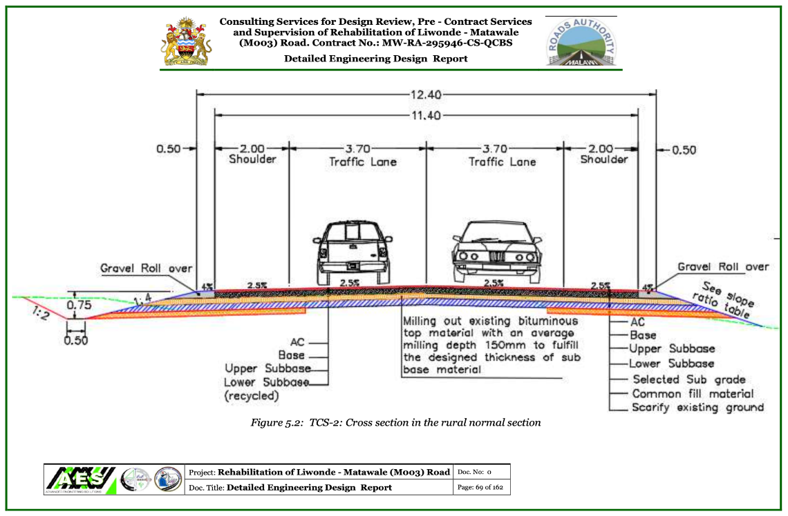
Figure 4: Cross-Sectional View in Rural Section

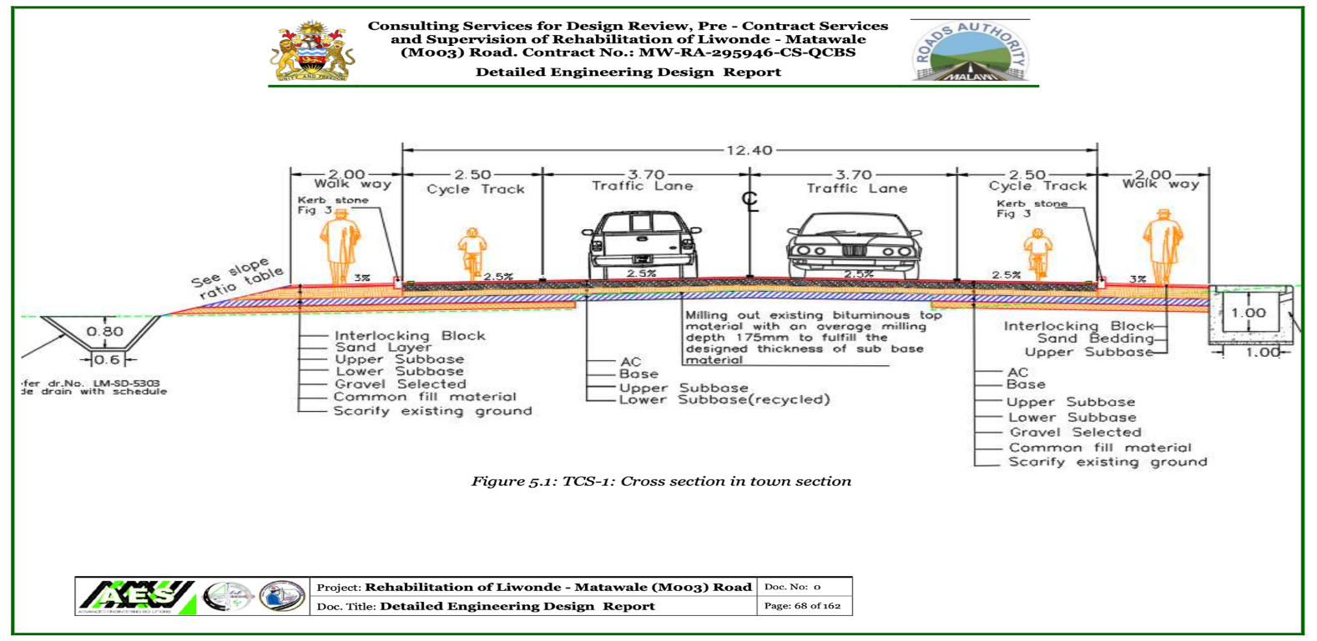
Figure 5: Cross-Sectional View in Urban Section

In line with the resettlement objectives, displacement under the Project has been minimized through the following design procedures:
- Wherever inhabited dwellings may potentially be affected by the proposed project, the road was re-routed as far as practicable to avoid any impact on such dwellings to avoid displacement/relocation;
- The same applies to structures used for commercial activities and other businesses; and
- To the extent possible, Project facilities such as diversions, bridge’s temporary by-pass and access roads, culverts, etc. will be routed inside the existing RR wherever possible.

The asset inventory undertaken by the Ministry of Lands under the supervision of the RA provides information on the issues listed below (as relevant and appropriate):
- Approximate land acquisition requirements;
- Affected households / businesses;
- Loss of private buildings and other structures;
- Livelihood impacts;
- Income sources of affected households / businesses;
- Loss of produce;
- Impacts on vulnerable groups; and
- Loss of heritage items.

The inventory indicates that while the Design Engineers have aimed to avoid displacement, the Project will impact on a number of households, business operators (both formal and informal), institutions; utility and service infrastructure, signboards and advertisements (Table 30). Asset inventory information provided included the name of the PAP, the village within which the PAP or resource is located; description of the asset; size of the asset (in m2); rate applied and asset value; name (type) and number of trees and size (small, medium or large tree); disturbance value; and total compensation value.

Table 30: Summary of Asset Inventory Findings
No. | Area | No. of PAPs Affected | Typical Aspects requiring compensations
1 | Zomba District | 1,169 | Houses and associated infrastructure, walls, shops (formal and informal), sign posts and trees
2 | Machinga District | 576
 |  | 1,745

Table 30 indicates that a total number of 1,745 PAPs are affected. Broad categories of losses, affected entities and the potential social and economic impacts resulting from these losses are listed in Table 31. Such losses qualify for compensation and resettlement assistance.

Table 31: Category of loss and Social and Economic Impacts
Category of Affected Losses | Affected Entities | Potential Social and Economic Impact
Loss of residence and or associated residential structures | People who will be displaced by having to move their place of residence to allow for the construction of the road, construction camps, access roads, or any other associated infrastructure and or who will lose associated residential infrastructure such as stand-along kitchen, bathroom, pit, walls, etc. | - Landlessness, homelessness  - Disturbance of house production systems  - Loss of or weakening of community system
Loss of business structures (income) | People who will be displaced by having to move their places of business to allow for the construction of the road-related infrastructure.  Structures such as boundary walls, associated with formal shops will need to be removed and or moved.  Similarly, many informal business structures are located within the road reserve. Examples of informal businesses include brick ovens, rice drying and selling points, stands used by informal vendors selling thatch, vegetables, sugar cane, chickens, etc.  Many signboards and advertisements (brick structures) were seen in all the trading centres. | - Impoverishment  - Loss of self-employment opportunities  - Affects rights to education, health, etc.
Loss of access to communal resources or social amenities | Members of communities who will lose access to their communal resource base. These will include boreholes, water taps, communal play grounds, market places and other resources. | - Impoverishment  - Loss of employment opportunities  - Loss of sources of income as people may start buying the service  - Increased time to access resources  - Loss or shortage of time for other activities
Disruption of cultural and traditional ceremonies | At certain times the communities closer to the road or at graveyards near the road might have funerals or other traditional ceremonies that might potentially be disrupted by construction works | - Disrupted ceremonies and social unrest
Loss of land | People who will lose land over which they have established ownership or rights of usufruct (either in a permanent or temporary fashion) to allow for the construction of the road and associated infrastructure such as culverts, widening of existing bridges, etc.  No loss of communal resources was identified during the asset inventory. | - Landlessness  - Loss of productive resource for agriculture  - Loss of businesses  - Impoverishment of people
Archaeology and cultural heritage | While no archaeological remains and structures of historical importance were identified within the road corridor during the ESIA, places of cultural heritage located within the road reserve were identified. These will not be affected but still measures have to be incorporated | - Loss of identity and culture

Resettlement Mitigation
The key mitigation measure for land take includes the implementation of this RAP whereby PAPs are compensated for any losses experienced as a consequence of the road upgrade and rehabilitation Project. Further, no construction should commence until all land and property expropriation procedures have been completed, replacement land allocated, and cash compensation paid.

Rehabilitation works for the proposed road will involve land clearing along the Liwonde-Matawale route particularly where diversions, access roads, sites for extraction of construction materials and campsites will be established. Mitigation measures for clearing land include:
- Including in the construction contract, a clause prescribing quarry sites, borrow pits and access roads as part of the site, so that the powers and authority of the Engineer extend to them in the same way as to other areas where works are being undertaken;
- Written agreements should be developed and signed between the land owners and community leaders and the Contractor;
- A detailed material plan should be prepared as part of the initial design review. Subsequent to this, quarries areas and borrow pits should be identified, marked on engineering drawings, and specified in the tender/contract document. Only approved quarry areas and borrow pits shall be used and the requirement to rehabilitate quarry areas, borrow pits, as well as access roads, should be included in the contract – some of the initial steps shall include site risk assessment and payment of adequate compensations;
- Debris from the proposed project area shall be dumped at appropriate places designated by the concerned Councils and where community members request such materials, proper documentation will be prepared;
- The Contractor shall observe the requirement of confining earthworks within the road reserve of 60 meters (30 m either side of the road from the centre line) of works. The purpose is to minimise the potential impact of loss of vegetation;
- The contractor, through their Social Officer, will liaise with communities whenever cultural and traditional ceremonies are scheduled or are happening to avoid disruption of such ceremonies and causing social unrest; and
- The Contractor shall seek approval prior to felling trees and where trees are felled, these will be compensated by replanting at appropriate locations or compensation of the owners.

The Contractor will establish camps that will be used to provide residence for workers, as well as act as project administration offices, storage facilities for different building materials and equipment, workshop for servicing the vehicles and road construction machinery. The establishment of construction camps and residential houses for the construction work force and the Engineer’s camp may compete with the limited local resources. The existence of camps for the construction workers close to settlement areas could influence negatively on local life style and sometimes may lead to cultural and social conflicts. To avoid such type of conflicts and problems the establishment of the construction camps shall be subjected to site risk assessment and planned in such a way that they will not negatively affect the local resources and society. Consultation with communities (land owners, their neighbours and leaders) and local authorities shall be done to assist in identification of the appropriate camp site that can serve dual purposes. The Contractor is responsible for compensating the land owner for the use of the construction camp area.

It is expected that Contractors will be responsible for removing signboards that are located within the road reserve whose owners fail to remove them. Similarly, Contractors will be responsible for restoring access to property.
Social impacts that may affect stakeholders during the construction phase and that will be managed by the Contractor responsible for the works included the following:
- The level of dust and noise that was going to be generated during construction phase;
- The need for provision of road signs and speed control devices during construction and especially upon road completion;
- Safety concerns for pedestrians in the settlements along the Road corridor during the construction phase (large construction vehicles such as haul trucks);
- Disruption of school activities in different places by noise and other construction activities;
- The need to manage overburden properly rather than dumping the overburden in peoples’ gardens;
- The need for proper location of borrow pits and quarries and that these should be effectively rehabilitated after the Project is over; and
- Conduct public awareness and education on the merits and demerits of the Project for the beneficiary communities to appreciate the Project.

These aspects are not directly related to resettlement and have been addressed in the Environmental Management Plan (EMP) that Contractors are required to comply with.

Eligibility Criteria for Compensation
This chapter outlines the eligibility criteria for compensation, resettlement assistance, and livelihood restoration under the Liwonde-Matawale Road Rehabilitation Project. It defines the categories of affected persons (PAPs), the types of losses eligible for compensation, and the entitlements provided under the National legislation and World Bank ESF, specifically ESS5. The goal is to ensure fair, equitable, and transparent compensation while minimizing the adverse effects of displacement and supporting the restoration or improvement of livelihoods.
Eligibility for compensation is based on the principles of this RAP, consistent with ESS5 and Malawi legal frameworks, including the Land Act and the Public Roads Act. The following categories of PAPs are entitled to compensation and resettlement assistance:
- Formal landowners: Individuals with legal ownership or titles to land.
- Claimants without legal titles: Individuals with claims to land or assets recognized under national or customary laws.
- Public property: facilities provided by government for public use
- Occupants without legal rights (squatters and encroachers): Individuals using land without a legal claim but who were present before the cut-off date.
- Occupants outside project area with damaged assets from to project works (to be compensated by the contractor)

PAPs in categories (i), (ii) and (iii) are entitled to compensation for land and other assets, as well as resettlement assistance. In category (iv), PAPs are compensated only for non-land assets, such as structures and crops. However, for temporary vendors who do not have any assets will be assisted with livelihood restoration because their livelihood will be affected. Persons who occupy/encroach the land or assets after the cut-off date (31st July 2023) are not eligible for compensation. All persons included in (i), (ii), or (iii) will be compensated for loss of assets other than land.

Therefore, it is clear that all PAPs, irrespective of their status or whether they have formal titles or legal rights or are squatters or otherwise encroaching illegally on land, will be eligible for some kind of assistance if they occupied the land before the entitlement cut-off date. People who encroach the area after the socioeconomic study (census and valuation) are not eligible for compensation or any form of resettlement assistance.
The identification of persons eligible for compensation and resettlement will be based on the following the entitlement matrix (Table 32):
- Persons losing land with or without legal title;
- Persons losing temporary or permanent access or rights to services;
- Persons losing business or residential property;
- Person with homes, farmland, structures or other assets within the proposed Project area;
- Vulnerable individuals who may be too old or ill to fend for themselves. These PAPs shall receive additional assistance;
- Persons that incur losses whether partial or total and whether they have their own land or rent land, including those that rent or occupy buildings individually or as a group for business or as households.

The impact relating to the loss of land through permanent land acquisition is not listed or addressed in this matrix as road rehabilitation activities are located within the gazetted road reserve. No permanent acquisition of land located outside the road reserve has been identified.
The manner in which the resettlement principles referred to in Section 1.2.3 have been applied are indicated below:
- Avoid or Minimise Resettlement: The design engineers have minimised the need for resettlement by not requiring all structures located within the road reserve to be removed;
- Some of the required compensation will be temporary in nature, e.g. stalls have to be moved backwards or away to a designated space (identified by the council) during the construction phase and may return once the activities have been completed;
- Deliberative stakeholder consultation has taken place as outlined in Chapter 3;
- A pre-Resettlement socio-economic survey and database was established;
- The RA will provide 20% Resettlement Assistance and provide compensation for improvements made within the road reserve as indicated in the Entitlement Matrix (Table 32);
- A fair and equitable set of compensation options was negotiated as per Table 32;
- Resettlement shall take place in accordance with Legal Requirements and International Best Practice. It includes seeing resettlement as an ‘Upfront’ Project cost’ by the RA.
- Vulnerable Social Groups were identified and shall be specifically provided for;
- An Independent Monitoring and Evaluation Process shall be in place following compensation of PAPs and this will include Land Officers from councils and Ministry of Lands; RCCs and World Bank Safeguards team;
- A Grievance Mechanism was set in place and so far, RA established 16 RCCs at group village level that potential PAPs (representative in terms of gender, age and disability), local leaders and be in place. The proposed mechanism is outlined in Sections 6.4 through 6.7.

The land laws consider all titled landowners, customary landowners, encroachers, persons affected by loss of access to sources of income and persons affected by loss of access to natural resources (water, wood, grazing areas, etc.), as PAPs. Therefore, PAPs will be entitled to compensation based on the status of their occupation of the affected areas.

PAPs whose houses (located outside the road reserve) are affected by the Project will be provided with cash compensation reflecting the full replacement value of the structure. This will be in accordance with the cost of the structure as per non-depreciated rates. However, it is not anticipated that any houses will be relocated outside the 60m RR. For commercial trees, it is the value of production lost until replacement seedlings mature and the scribed list provided by the Forestry Department was used. For the loss of business or income, the reported income and employee wages will be taken into consideration.

A cut-off date for which this RAP is effective was affected after the final property valuation and verification is done and that was 31st July 2023. All affected persons, RCCs and village heads and other Traditional Authorities were informed of this date. This means that any new inhabitants coming to the Project affected area after this date will not be considered for compensation.

Table 32: Entitlement Matrix
Type of Loss | Entitled Persons | Entitlements | Intent / Requirement
A. Land
Loss of Land (Residential / Commercial / Agricultural) | Registered Land/Title holders | Cash payments for land lost at full replacement cost | Payment for lost assets, assistance to reorganize on existing land or relocate to alternate land, and support for the transition period.
Loss of Land (Residential / Commercial / Agricultural) | Registered Land/Title holders | Disturbance allowance at 28% (based on Central Bank reference rate as of September 2024) to cover land transition costs and processing of title documents.
Loss of Land (Residential / Commercial / Agricultural) | Registered Land/Title holders | Land restoration post work
Loss of Land (Residential / Commercial / Agricultural) | Unregistered Land/ encroachers | No payment of compensation for land within the Road Reserve (RR). | Include PAPs in livelihood restoration to assist in transitioning
B. Structures
Loss of Commercial Structures | PAPs with legal rights to the affected structures. | Compensation for affected buildings at full replacement cost calculated at current market prices without deduction for depreciation or salvage materials. | Payment for lost assets, lost income assistance to reorganize on existing land or relocate, and support for the transition period.
Loss of Commercial Structures | PAPs with legal rights to the affected structures. | Compensation for income loss
Loss of Commercial Structures | PAPs with legal rights to the affected structures. | Relocation/Shifting Allowance.
Loss of Commercial Structures | PAPs with legal rights to the affected structures. | Disturbance allowance at 28% (based on Central Bank reference rate as of September 2024).
Loss of Commercial Structures | Informal users and squatters (containers, movable hawkers) | Compensation for income loss | Payment for lost income, assistance to relocate, and support for the transition period.
Loss of Commercial Structures | Informal users and squatters (containers, movable hawkers) | Relocation/Shifting Allowance.
Loss of Commercial Structures | Informal users and squatters (containers, movable hawkers) | Disturbance allowance at 28% (based on Central Bank reference rate as of September 2024).
Loss of Residential Structures |  | Compensation for affected buildings at full replacement cost calculated at current market prices without deduction for depreciation or salvage materials.
Loss of Residential Structures |  | Relocation/Shifting Allowance.
Loss of Residential Structures |  | Disturbance allowance at 28% (based on Central Bank reference rate as of September 2024).
Loss of community premises | Community facilities (access to boreholes) | Provision of alternative facilities | Provision of alternative community facility to ensure communities still have access to their amenities
Partial or Complete Loss of Other Property (e.g., Billboards, Fences) | All PAPs | Cash payment for affected structures at replacement cost. | Payment for loss and relocation if required.
 | All PAPs | Cash assistance for relocation of structures. | Payment for loss and relocation if required.
Tenants of Residential Premises | Tenants of affected residential structures | Rental allowance for two months to secure alternative residential accommodation. | Assistance in finding new affordable rental accommodation.
Tenants of Residential Premises | Tenants of affected residential structures | Relocation/Shifting Allowance. | Assistance in finding new affordable rental accommodation.
Tenants of Commercial Premises | Tenants of affected commercial structures | Rental allowance for two months to secure alternative commercial premises. | Assistance in finding new affordable commercial accommodation.
Tenants of Commercial Premises | Tenants of affected commercial structures | Relocation/Shifting Allowance.
C. Loss of Trees
Fruit Trees | Owner of affected fruit trees | Cash compensation for lost production value until replacement seedlings mature, including replanting and maintenance costs.
Fruit Trees | Owner of affected fruit trees | Provision of replacement trees (2 seedlings for each affected tree).
Exotic Trees | Owner of affected exotic trees | Cash compensation at current market prices for replacement cost, including replanting and maintenance costs.
Exotic Trees | Owner of affected exotic trees | Provision of replacement/ alternative trees (2 seedlings for each affected tree).
Indigenous Trees | Owner of affected indigenous trees | Cash compensation at current market prices for replacement cost, including replanting and maintenance costs.
Indigenous Trees | Owner of affected indigenous trees | Provision of replacement/ alternative trees (2 seedlings for each affected tree).
D. Loss of Income
Loss of Income due to Business Stoppage | Owners/operators of non-registered businesses/vendors | Cash compensation equivalent to three months of net income based on verified records.
E. Loss of Wages for Employees
Temporarily Affected Employees | Employees affected temporarily | Cash payment for lost salary/wages for each month the PAP cannot work.
Permanently Affected Employees | Employees affected permanently | Cash payment equivalent to six months’ salary/wages or the government’s minimum wage, whichever is higher. | Employers are encouraged to provide severance pay, and affected employees will have preferential access to project construction employment opportunities.
F. Special Assistance
Vulnerable PAPs | Vulnerable PAPs, including the poor, elderly, female-headed households, and persons with disabilities | Additional 20% compensation over and above asset compensation. | Assistance to mitigate disproportionate resettlement impacts and ensure restoration or improvement of socio-economic status.
G. Public Assets I.e. Road Signs, Power lines, Water Mains
Public Assets | Public utility companies (ESCOM, OCL, Airtel and SRWB) | - Cash compensation at full replacement cost for all infrastructure requiring relocation or reinstatement | - To ensure continuous service provision and restoration of utility infrastructure to equal or improved condition.  - Relocation to begin only after full compensation and clearance of working space.  - Utilities (e.g. ESCOM, OCL, Airtel SRWB) will maintain on-site presence and submit final invoices for any unforeseen issues.  - In line with cost-based valuation principles and service provider-specific procedures.
Public Assets | Public utility companies (ESCOM, OCL, Airtel and SRWB) | - Cash payment of relocation fees as quoted by the service providers.
Public Assets | Public utility companies (ESCOM, OCL, Airtel and SRWB) | - Post-intervention cash compensation for emergency repairs or missed assets.
Public Assets | Public utility companies (ESCOM, OCL, Airtel and SRWB) | - Cash compensation for transaction and administrative costs.
Public Assets | Public utility companies (ESCOM, OCL, Airtel and SRWB) | - Cost of materials, labor, transport, excavation, engineering, and technical design.
 | Police (Relocation of roadblock) | - Compensation for Relocation: RA to provide support for the relocation and reinstallation of police infrastructure at a new site.  - Provision of Facilities: Toilets, shelter, and safe drinking water (if possible). | - Formal letter from Roads Authority (RA) is required to initiate relocation.  - RA to provide support to clear and prepare new site; relocate and reinstall police infrastructure; and provide toilets, shelter, and potable water (if possible).  - Expect coordination with RA’s supervising consultant and contractor’s social officer.  - RA to formally initiate and ensure logistical support for a smooth process.
 | Fiber Line Relocation (OCL, Airtel etc) | - Trenching Support: Assistance with trenching from the main road contractor when needed, especially for emergency relocation.  - Emergency Response: cash payment for emergency responses  - cash compensation for fiber section relocation and protection | - Trenching Support: RA to coordinate with the main road contractor for trenching assistance.  - On-Site Monitoring: to enable OCL and Airtel to monitor works continuously.  - Emergency Response: project to pay for emergency responses  - Cash compensation for relocation
Unanticipated Adverse Impacts | Any affected persons | Any unforeseen impacts due to the project will be mitigated in line with the agreed resettlement framework.

Valuation of Affected Assets and Compensation Process
The valuation of assets that may be lost during resettlement is a sensitive issue and it was undertaken by the Ministry of Lands with due care and rigor. The general approach adopted for the valuation procedures is summarised below:
- Identify Eligibility under National Guidelines: All relevant legislation, policy and valuations guidelines defined by the Government of Malawi was taken into cognisance. This formed the basis for the identification of eligibility to compensation and valuation methodology;
- Asset Survey: The asset survey determined the assets owned by affected individuals, households or communities (see Annex B - 1);
- Valuation Methodology: The valuation process involved the assessment of national guidelines, international best practice and local market research. The outcomes of this process is a set of practical and measurable values/rates for each asset category (see Annex B - 1); and
- Entitlement Contracts: Contracts will be produced for affected individuals that will contain a summary of all their assets, adopted compensation rates or options and final valuations.

Validation of the affected properties was based on the provisions in the Malawi legislation for consistency and accountability. The valuation of properties was undertaken by the Ministry of Lands under the supervision of the RA. Payment of compensation is undertaken by the Roads Fund Administration (RFA) as soon as the RAP is cleared for purposes of payment of compensations.

All the factors explained in the Public Roads Act 2014 will be considered in the validation/verification process. The assets to be verified shall include crops, fruit trees, indigenous trees, houses, land and businesses (formal and informal).
The valuation of physical structures will be based on the following general criteria:
- Survey of physical structures (size, build, materials) and all its related structures and support services;
- Determine average replacement costs of different types of structures based on information on the cost, quantity, and type of materials used for construction, e.g. bricks, rafters, bundles of straw, doors;
- Costs for transportation and delivery of these items to acquired/ replacement land or building site; and
- Estimates of construction of new buildings including labour required.

Valuation Methods
There are five methods which are commonly used in valuation of properties as follows:
- The Comparison Method: This is an approach of determining the value of a property by comparing it with similar properties for which transactions have already taken place. This method is widely adopted in practice but requires the keeping of adequate records of transactions. The aspects of value with this method looks at the location of the property, topography, accessibility, age, construction material and legal factor of the property. Comparable must be comparable in terms of the legal rights being sold. If the legal titles are not the same or similar, then valuation by comparison may be impossible. The method can only be used in markets with regularly occurring sales of comparable parcels of real estate. The valuer's knowledge of the market together with other market data and statistics enables a judgment to be made as to whether the market is rising, falling or static. The valuer's awareness of all the factors that affect changes in value supports the valuer's opinion of the level or rate of price movement between sale dates and valuation dates.
- Investment method: The investment method is used to value properties held as investments. The approach determines the annual income obtained from the property and estimates the net income by subtracting annual expenses on the property. The net income is capitalized with a suitable rate to come up with capital value. The valuation process for this method is as shown below: -
- Determination of Gross Annual Income.
- Determination of Annual Expenses.
- Obtain Net Operating Income (NOI).
- Choose a suitable capitalization rate; and
- Capitalize NOI using the formula.
- Profit Method: The approach wholly or partly depends on a capacity to earn income on occupation of the property. The method requires the estimation of the annual average annual gross earnings of the property and the deduction of working expenses (excluding rent) and an amount for occupier’s remuneration, including interest on the capital tied up in the business. The balance represents the amount available for annual rent, which is then capitalized by an appropriate Years Purchase to arrive at capital value.
- Residual Method: This approach is well used in valuation of undeveloped land or land with obsolescent or otherwise unsuitable buildings incapable of producing an economic rent and where the site is ripe for development or redevelopment. The actual value of a particular piece of land (or site) will depend on not only on its current or existing use but also on its potential use and the anticipation of development rights – often referred to as hope value or development value. The value of the site in its proposed state is estimated, as are all of the costs involved in the development, including a suitable level of return to the developer. It is also referred to as “hypothetical” method.
- Cost approach: This approach requires the estimation of the cost of rebuilding a particular property and adding to it the value of the land on which it stands. The method is mostly used to properties which do not come on the market and which you cannot find comparable data. Costs of construction may be assessed on either the replacement or renewal approach. The replacement cost approach assesses the costs, including fees, of reconstructing the existing building in exactly the same style and materials, as it currently exists; whereas the renewal approach is to construct a new building of the same size and to perform the same function as the present structure, but in modern materials and style.

Approach to the valuation of affected properties
The assessment of affected assets is based on two approaches because no two properties are identical in characteristic making the use of one approach unrealistic.
- Loss of Land: The valuation process for land in the affected areas would have utilised the direct comparison approach, which involves analyzing similar land transactions in the same area and comparing them to the subject affected land. For this project, land will not be compensated as it falls within public land boundaries.
- Loss of structures: The valuation for structures is based on the construction approach, according to which the main concern is to replace the affected structure with a similar structure or a better one. The applicable replacement costs for construction materials, as well as the associated labor costs needed to build replacement structures, are used to determine asset values. The construction approach of valuation does not consider depreciation. The Project has conducted market research on the prices of building materials to ensure that PAPs receive their compensation at full replacement cost.
- Loss of trees: Section 86 of the Forestry Act has provided guidelines on values/rates for sale of both indigenous trees and exotic trees. These rates are gazette and are reviewed from time to time on a needs basis to reflect current values by senior government officials. The current values were gazette in June, 2024 and are used so that those who are involved in forestry are paid reasonable compensations on their timber trees and fruit trees. Normally, the valuation of people’s trees is done based on species of trees, measured diameter of breast height and market price in kwacha per cubic meter.
- Fruit trees will be compensated according to their full replacement value, which is equivalent to the production value lost between the destruction of the tree and the period when the new tree will have the same level of production as the felled tree. The method assesses the market value for lost productivity until the new replacement tree attains the same level of production as the lost tree
- Loss of crops: Compensation can be paid at full replacement cost for the production lost. This rate incorporates the value of crops, and the value of labour invested in preparing new land. Market value is equivalent to the average of last three years of market value for a mature and harvested crop. The value of labour invested in preparing agricultural land and planting can be compensated at the average wage in the community for the same period. The computation for crops is as shown below:
Affected area * Yield/hectare/Kilogram * Market Price for the subject crop/Kilogram = Value.
NOTE: Crops will not be compensated as affected PAPs were given an opportunity to harvest their crops.
- Loss of public infrastructure: The Cost Approach is the preferred method for valuing public infrastructure like ESCOM, OCL, Airtel and SRWB during the relocation process because these types of infrastructure typically do not have a market value or comparable sales data. Public utilities such as power lines, water pipes, and cables are unique assets that are not bought or sold in the traditional real estate market, making it difficult to apply market-based valuation methods. The key costs include labor, materials, excavation, and transportation, as well as post-relocation intervention for emergencies. Clear communication and coordination throughout the process will be essential to ensure smooth relocation of public infrastructure.
- Disturbance allowance: Typically refers to a compensation or financial benefit provided to individuals or communities who are physically displaced and this has also factored in a shifting allowance. The amount levied on the total compensation amount will be taken at 20% of the value of the property loss, based on the Central Bank Lending Rate (26%) also considered as consumer inflation rate plus 2% allowance.
- Loss of waged Income: Workers or employees, including those in shops, businesses, plantations, agriculture, and market gardening, whose livelihoods are adversely affected either permanently or temporarily, will be eligible for compensation. This compensation will be provided in the form of cash equivalent to two months’ wages. The determination of monthly wages has been conducted through consultations with both employees and employers. It's important to note that the Government of Malawi has set minimum wage standards, and if the wages reported by employers or employees fall below these standards, the minimum wage will be applied for compensation calculations.
- Valuation and Compensation for Loss of Profit: Loss of profit refers to damages payable to the owner of the business whose business is to be shut down to give way for the implementation of the proposed project. The value for each type of loss of profit is paid to the affected person. The appraisal covers the type and number of such losses that individuals suffer, in addition to total compensation payable in loss of Land and improvement thereon.

For the purposes of this document, the values of the structures to be replaced was determined to obtain an estimate of the compensation costs. The compensation package was determined by a government valuator as derived from summation of the costs of affected land, buildings, trees and crops to which was added an 20% mark-up to cater for involuntary acquisition. The addition of the mark-up to the calculated value brings the value equal to a pre-payment value.
The total compensation cost is MK 1,764,339,286.56 (include 10% contingency) for 1,745 PAPs (see Annex B - 1). The matrix lists the PAPs and identifies the land/structures and resources such as trees that will need to be acquired and compensated. Upon revising the Assessment report based on issues encountered during verification, disclosure and negotiation of values, Ministry of Lands will submit a report to RA to facilitate payment of compensations. There is also provision for cracks and other damages that might occur during the works amounting to MK 882,169,643.28, 50% of the compensations amount.

Utility and Service Infrastructure
RA facilitated site visits with RAP Consultants and Utility and Service companies to verify existence of their respective infrastructure within the work section. Prior to the site visits, RA wrote the companies informing them of the pending works, requested a liaison person and shared a kmz file indicating the extent of road works and further requested the companies to determine and identify the location of their infrastructure in view of the provided kmz file. During the site visits, all utility companies (ESCOM and SRWB) and service companies (OCL and Airtel) confirmed that they have some infrastructure running parallel to the road and also some crossing the road. They welcomed the idea of protecting these infrastructures including possible relocation, however, requested that RA should meet the cost for protection interventions.

RA undertook engagement activities with SRWB, ESCOM, OCL and Airtel to facilitate identification of potentially affected service and utility infrastructure within the road reserve. The engagements also discussed and agreed upon protective measures which included avoidance, barricading and relocation. RA requested the institutions to provided cost estimates for relocation and coordinates of their infrastructures. SRWB provided a cost estimate of MK 5,799,850,362.62, OCL provided a cost estimate of MK 812,188, 118.22 while ESCOM provided a capital cost fee of MK 1, 887, 848.50 and a BOQ for RA to purchase materials and also engage an ESCOM certified contractor to undertake the works. Airtel did not submit the requested information and RA indicated to them that it will not consider them.

Upon receipt of the coordinates, RA through the consultant superimposed them with the road design and determined sections which will be affected by the works and classified them as high (requiring relocation), medium (require protection), and low (avoidable). Considering the works are sectional and time consuming, RA and the utility and service companies agreed that this will be undertaken during the project implementation upon joint verification of the infrastructures. These protective measures and their cost will be negotiated upon with respective companies A chance find and emergency works procedure was also agreed upon and this will guide all works that might ensure in case such infrastructure is damaged (Annex C).

CHAPTER 7: GRIEVANCE REDRESS MECHANISM

Introduction
Even when the Project can ultimately claim successful resettlement, there may still be individuals and groups who feel that they have been treated inadequately or unfairly. Providing a credible and accessible means for PAPs to pursue grievances allows the Project to address genuine issues in a timely manner and decreases the chances of resistance to the Project from disgruntled PAPs. Grievances relating to any aspect of the Project must be dealt with through negotiations aimed at reaching consensus between the Project and the PAPs.

To that end, SATCP establish RCCs in 16 group village headmen areas that were trained in grievance management and their mandate includes receiving, deliberating and providing resolutions on land/property ownership, assisting in identifying and verifying property owners and also disseminating information. The RCCs were also involved in the assessment process where they assisted in verification of owners and extent and nature of people’s properties as well as informing and reminding community members to observe the RR after assessment was done. Land officials from both the councils and Ministry of Lands as well as the Social Safeguards Specialist from RA are also part of the RCCs. Above the RCCs, there is the National Grievance Redress Committee and it include a representative from Ministry of Land and that committee serves as referral GRC for resettlement and compensation related issues and grievances.

Grievance Redress Principles
Grievance redress will be based on the following principles:
- The project’s grievance redress mechanism took into account community and traditional dispute settlement systems whereby the Group Village Head man several other village heads are incorporated into the RCCs. The incorporation was done in view that traditionally people approach traditional leaders to resolve disputes, particularly in issues relating to use and ownership of land, trees and housing structures;
- Awareness raising on GRM was done through meetings with PAPs and community sensitization where people were informed about potential resettlement related grievances and issues; GRM procedures and processes and also RCC members were introduced;
- By establishing RCCs in each group village head and appointing members across the whole road stretch, RCCs were made accessible to all PAPs and the process was cost free;
- The RCCs members ship is representative and it consists of 7 local members including potential PAPs, women, youth and disabled members and this ensures that the RCC’s undertakings are independent and impartial to foster the trust and confidence of all stakeholders;
- The RCCs were provided with grievance log books ensure that all grievances raised and the entire grievance resolution process is recorded, and a copy is made available to the aggrieved person(s); and
- The principle of confidentiality applies to all processes. Confidentiality of the complainant, if so requested, and to information provided by any of the parties to a complaint.

Procedure Negotiations and Resolution of Conflicts
The negotiations between Government and the affected persons shall be done in the spirit of finding amicable solutions with full respect of all the parties concerned. Negotiations will be guided by the following:
- Procedure – The procedures include receiving of grievances through various available uptake methods which include face-to-face, phone calls or WhatsApp texts. Following uptake, the grievances will be recorded in the grievance log book and investigation of the grievance and alter deliberation shall follow. Resolutions will be shared with complainants with specified time frames where two weeks is the standards acceptable maximum time for redress however, due to the nature of the issues particularly property and land related, redress might take longer and the grievant will be kept informed of progress made on weekly basis after the lapse of the two weeks period;
- Full Disclosure - Full disclosure of the implications and provisions of the displacement will made to the affected people;
- Back and Forth Discussions- Adequate time shall be given to the affected communities to discuss the matter amongst themselves with their traditional leaders and they should be allowed to do so for as long as they feel necessarily without necessary causing unwarranted delays in project implementation; and
- Recording for Proceedings- All proceedings from negotiations meetings shall be filed and be open to all for reference purposes. The local language shall be used in recording so that the local people can understand the minutes.

The court of law will be a last resort for all parties as the spirit will be to have some kind of consensus among the negotiating teams. Various legislation, including the Constitution of Malawi makes provision for grievances to be addressed through the formal court system. This is a constitutional right but practice has shown that this can be a costly and time-consuming exercise. The approach outlined above is readily accessible to deal with complaints expeditiously. However, if this fails the aggrieved party can refer the matter to the formal court system.
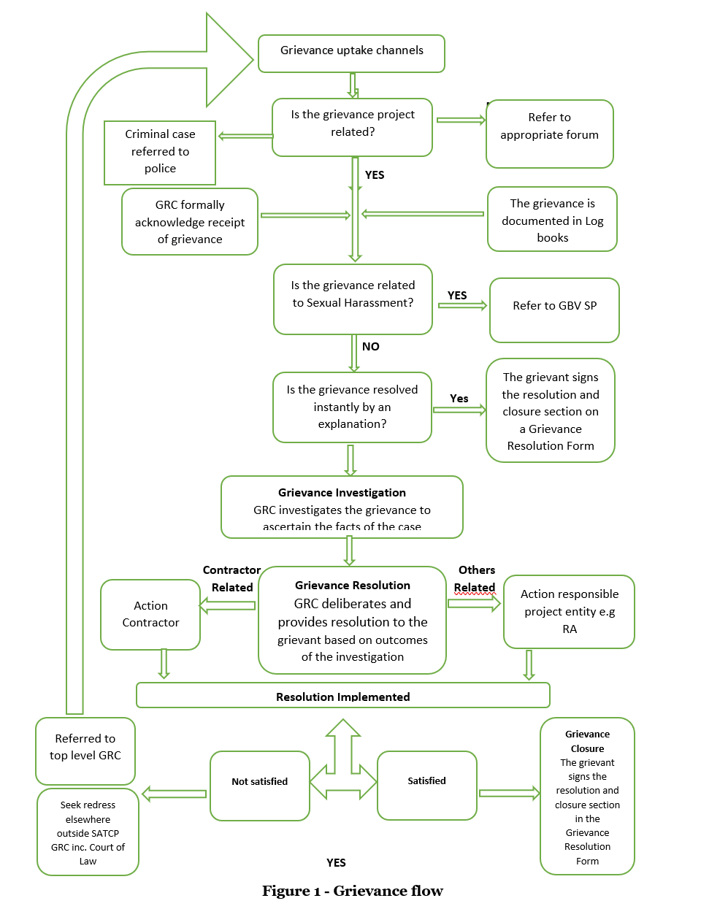
Grievance Flow Chart: Presenting grievance management procedure

Grievance Redress Process
A all attempts shall be made to settle grievances amicably. Those seeking redress and wishing to state grievances will do so by notifying the Resettlement and Compensation Committee (RCC) within their locality. The RCC will investigate the matter then inform and consult with RA and Lands Officer at the Council to determine validity of claims. If valid, the RCC will notify the complainant and s/he will be assisted. If the complainant's claim is rejected, the grievant will be informed why and told that if he is not satisfied with the response provided, he can engage the council. All such decisions must be reached within a full growing season after the complaint is lodged.
It has to be noted that in the local communities, people take time to decide to complain when aggrieved. Therefore, the grievance procedures will give people up to the end of the next full agricultural season, after surrendering their assets, to allow for enough time to present their cases. The grievance procedures will ensure that the PAPs are adequately informed of the procedure, before their assets are taken.

The grievance redress mechanism is designed with the objective of solving disputes at the earliest possible time, which will be in the interest of all parties concerned and therefore, it implicitly discourages referring such matters to the external platforms (ombudsman or court of law) for resolution. Contracts for compensation and resettlement plans will be binding under statute, and will recognize that customary law is the law that governs land administration and tenure in the rural areas. This is the law that most Malawians living in these areas, are used to and understand.

All objections to land acquisition shall be made in writing, in the language that the PAPs understand and are familiar with, to the RCC. Channelling complaints through the RCCs is aimed at addressing the problem of distance and cost the PAPs may have to face. The Local Leaders shall maintain records of grievances and complaints, including minutes of discussions, recommendations and resolutions made. The procedure for handling grievances will be as follows:
- The affected person should file their grievance in writing (in English or the local language that they are conversant with), to the RCC. The grievance note should be signed and dated by the aggrieved person. Where the PAP is unable to write, he should obtain assistance to write the note and emboss the letter with his thumb print; and
- The RCC should respond within 14 days during which any meetings and discussions to be held with the aggrieved person should be conducted. If the grievance relates to valuation of assets, experts may be requested to revalue the assets, and this may necessitate a longer period of time. In this case, the aggrieved person must be notified by the RCC that his/her complaint is being considered. If the local leader cannot provide an appropriate solution to the problem, the problem will be referred to the RCC to use established mechanisms of grievance redress, which may include the presence of peers of the PAP and other local leaders. Conflict Resolution with Utility and Service Providers

Companies with infrastructures along the road that might be affected due to the works or other activities associated with the works may be aggravated and wish to express or launch their issues with the project. These companies will have to formally write a letter or email to the Roads Authority or the consultant expressing their issues. Representatives of these institutions will meet with aggravated parties for discussion and consensus. RA will ensure that all issues raised are deliberated and are closed within two weeks or companies are updated on weekly basis the status of the matter.

Emergency Procedures have been established between the project and all utility and service companies whose infrastructure is within the road reserve and might be affected by the works. These companies are ESCOM, Southern Region Water Board, Open Connect Limited and Airtel.

Summary of Grievances Received
During the development of the Resettlement Action Plan (RAP), the project received a total of 21 grievances. These grievances were received through Resettlement and Compensations Committees that were responsible for receiving, investigating and deliberation on resolutions. All grievances were related to the omission of structures during the property census and valuation. The project ensured that eligible properties that were not valued would be assessed and included in the compensation schedule. This rectification meant that the grievances were resolved and the resolution was communicated to the grievant parties. Table 33 presents summary of grievance.

Table 33: Summary of resettlement related grievances received along Liwonde-Matawale Road
Grievance | Nature of complaint/  grievance | Date  Received | Response | Action Recommended
The community noted that the consultant did not involve the RCC as indicated by RA and the work was done without proper plan. The consultant communicated about the exercise but did not show up. As a result, the assessment was only done for very few structures and other PAPs were not reached. | Resettlement | 12-Nov-23 | RA will engage an independent consultant to check objectivity of the E&S instruments and note the gaps | 1. RA, with guidance from the World Bank, engaged an independent consultant to review the E&S instruments to check suitability. This seeks to ensure objectivity of the instruments as the same firm was assigned to review the designs and also develop the instruments. Observed shortfalls will be addressed through this process before implementation of the RAP;  2. With regard to omitted PAPs, RA normally engages the Valuation Department under the Ministry of Lands, Housing and Urban Development to carry out property assessments and through this exercise, RA will ensure that properties that were in existence during RAP development but were omitted should be incorporated. For properties to be incorporated, a letter will have to be provided by the RCC or Group Village Headman to vet the PAP;  3. Carry out community sensitizations along the Liwonde-Matawale road to manage expectations and address concerns regarding the manner which the RAP study was handled  RA carried out sensitizations and instructed the RAP consultant to revisit the site and address the issues raised and other irregularities .RA also facilitated the assessment of properties by Min. of Lands. At the end of the exercise all grievances were closed and the project did not register any new grievances
The consultant only captured structures that were within 16meter corridor and trees were not captured. Also, one shop owner was not captured | Resettlement | 12-Nov-23 | i. RA will check with the consultant on why the trees were not captured;  ii. Capturing of properties within 16 meter corridor could possibly be informed by the designs. However, RA will compensate for all structures that will be affected by the works;  iii. The consultant was tasked with updating the 2018 data and it is possible that the shop was included in that data. However, RA will carry out assessments with Ministry of Lands, Housing and Urban Development for actual property values
The RAP team from the consultant did not do assessment in the area and only the Socio-economic team. The assessments did not capture trees | Resettlement | 12-Nov-23 | The consultant was to assess properties that were within the road reserve and within a set range to be affected by the works. Possibly this section did not have such structures to be affected by the road. However, RA will ensure that all structures that will be affected by the works are compensated for. The trees will be assessed and compensated for.
Some sections of the road were not covered by the consultant. Traders including those that do not have structures are concerned about what will be done in terms of compensations. | Resettlement | 12-Nov-23 | It is possible the skipped sections did not have any structure; however, RA will ensure that all structures that will be affected by the works are compensated for. The RAP study is precisely being undertaken to develop an approach to how such matters will be handled
The Consultant used 2018 RAP data and only recorded the new PAPs, skipping the ones initially captured in 2018. Trees were not recorded. | Resettlement | 12-Nov-23 | The consultant was tasked with reviewing and updating the 2018 data thus this was within his exercise. The trees will be assessed and compensated for.
The consultant only captured data for structures that were within 16-meter corridor from the centre line not the whole road reserve and the RCC expressed their concern to the consultant. | Resettlement | 12-Nov-23 | Capturing of properties within 16-meter corridor could possibly be informed by the designs. However, RA will compensate for all structures that will be affected by the works
The consultant did not work with the RCCs, the members were sidelined, and the consultant possibly captured wrong information with regard to ownership. | Resettlement | 12-Nov-23 | This is not what was expected as it was clearly expressed to the consultant that involvement of the RCC was critical to the extent RA facilitated an interface meeting. RA will engage an independent consultant to check objectivity of the E&S instruments and note the gaps
He was not reached during the consultant property capturing exercise and her properties namely trees and properties were omitted | Resettlement | 18-Jan-24 | RA and Min of Lands will carry out assessment and will ensure all properties will be covered
She was not reached during the consultant property capturing exercise and her properties namely trees and properties were omitted | Resettlement | 14-Nov-23 | RA and Min of Lands will carry out assessment and will ensure all properties will be covered
The consultant only engaged tenants and not shop or house owners. We our properties were recorded in tenants' names | Resettlement | 12-Aug-23 | Since we are yet to receive the RAP and ESIA report, it is difficult for RA to say for sure the topic of engagement with tenants. However, it is worth noting that the consultations were on three aspects: collecting baseline data for socio-economical aspects, assign properties for estimates and collecting data on economic activities
He was not reached during the consultant property capturing exercise | Resettlement | 23-Jan-24 | RA and Min of Lands will carry out assessment and will ensure all properties will be covered
He made an a agreement with the people who constructed the shops that they will build, use the shops until their building cost is returned and then I will return ownership | Resettlement | 15-Feb-24 | RA owns the land within the road reserve and it is only compensating for the developments and not the land. The grievant should provide an agreement that will be vetted by the local leaders and the city council
The consultant did not work with the RCCs, the members were sidelined, and the consultant possibly captured wrong information with regard to ownership. | Resettlement | 12-Nov-23 | This is not what was expected as it was clearly expressed to the consultant that involvement of the RCC was critical to the extent RA facilitated an interface meeting. RA will engage an independent consultant to check objectivity of the E&S instruments and note the gaps
The consultant undertook property census without involvement of the owners | Resettlement | 03-Nov-23 | This is not what was expected as it was clearly expressed to the consultant that involvement of the RCC was critical to the extent RA facilitated an interface meeting. RA will engage an independent consultant to check objectivity of the E&S instruments and note the gaps
The Consultant did not involve the Committee during property census | Resettlement | 10-Oct-23 | The consultant was hired to produce a preliminary report. There after Ministry of Lands will be engaged to produce the asset inventory that will be used during payment of compensations upon verification by Roads Fund Administration and World Bank
A school which I own and some trees within my plot were not counted during asset inventory | Resettlement | 10-Oct-23 | RA and Min of Lands will carry out assessment and will ensure all properties are covered
Trees were not included during property census conducted by the Consultant | Resettlement | 05-Oct-23 | RA will engage Ministry of Lands in the near future to undertake a detailed census and will ensure that all properties including trees are covered
The House is within the road reserve boundary but the consultant did not record it during property evaluation | Resettlement | 20-Feb-24 | RA will engage Ministry of Lands in the near future to undertake a detailed census and will ensure that all properties including trees are covered
The House is within the road reserve boundary but the consultant did not record it during property evaluation. There are also trees Infront of the house that were missed during the census | Resettlement | 17-Jan-24 | RA will engage Ministry of Lands in the near future to undertake a detailed census and will ensure that all properties including trees are covered
Two kiosks were not recorded during the initial assessment | Resettlement | 18-Sep-24 | RA will instruct the RAP consultant to capture these two when they revisit the site to redo the assignment. When doing the final assessment, RA will ensure that Min. of Lands should capture the properties
The sellers complained that their colleagues were captured in the assessment while they were not considered. The requested government should give them money so that they should do other activities while the project is being implemented | Resettlement | 04-Oct-24 | RA and MoTPW safeguards team engaged the traders. It was explained to them that the compensation is being done for properties and those that will be disturbed. The project will not affect the trade of these workers and also if they are will to change trade, the project can engage and provide employment

During the disclosure process, the affected Project-Affected Persons (PAPs) were verified to ensure their properties were accurately captured. The PAPs also negotiated and agreed to the valuation amounts. All PAPs were informed about the available grievance channels for raising complaints related to resettlement and compensation. Additionally, RA will establish a site office in the project area during the construction and demobilization period to interact with affected parties and respond to queries and grievances promptly.

CHAPTER 8: RESETTLEMENT PLANNING, SCHEDULING, BUDGET & RESPONSIBILITIES

Introduction
Information in terms of resettlement planning, schedules, budget and responsibilities are provided. These various components have been developed based on the outcomes of the previous tasks and will need to be negotiated and discussed with the consultative fora and relevant authorities.

Resettlement Planning
The overall strategy in terms of resettlement, likely phasing and means of compensation must be defined as outlined in this RAP. Further consideration will be needed in terms of construction of any resettlement structures, labour and other issues. The compensation process involves several key steps:
- Disclosure of Compensation Values: PAPs and utility providers were informed of compensation entitlements. Service providers (e.g. ESCOM, SRWB) were engaged during stakeholder consultations to review infrastructure impacts and estimated relocation costs.
- Approval of Compensation Schedules: Schedules for PAPs will be reviewed by the Regional Lands Commissioner and approved by the Chief Valuation Officer. For public utilities, cost schedules and coordinates were submitted directly by the institutions and will be reviewed by the project’s engineering and valuation teams for areas where they can be avoided and verification of those that have to be relocated.
- Payment of Compensation: For PAPs- Payments will be disbursed Roads Fund Administration either using cheques or in cash if the amount is less that MK 100,000, with proper documentation public facilities will be paid directly to their accounts or cheques will be issued upon determination of affected infrastructure and submission of verified quotations. Payment triggers commencement of relocation works. However, for ESCOM, RA will identify a contractor from a list of ESCOM pre-certified contractors to undertake the relocation of identified ESCOM infrastructures.
- Appeals and Grievances: PAPs may raise complaints via the Grievance Redress Mechanism (GRM) while Utility and Service providers will coordinate through technical review meetings and escalate unresolved issues to the National Grievance Redress Committees
- Post-Intervention Invoicing (for Public Facilities): Public utilities are entitled to submit additional invoices for unplanned or emergency works that occur after initial relocation, ensuring full cost recovery.

Scheduling
The timing for resettlement in terms of the physical resettlement, payment of any cash compensation and ensure it aligns with any civil engineering required by the Project must be defined. Typically, the preparation of a RAP will run over more than six months. Timeframes are often dictated by the consultative process that has to be followed and the need to reach agreement with affected people.
The implementation schedule for the RAP will be concluded by July 2026 as the construction schedule is scheduled for November 2025 (see Appendix 3). The timeline below present the RAP planned activities:

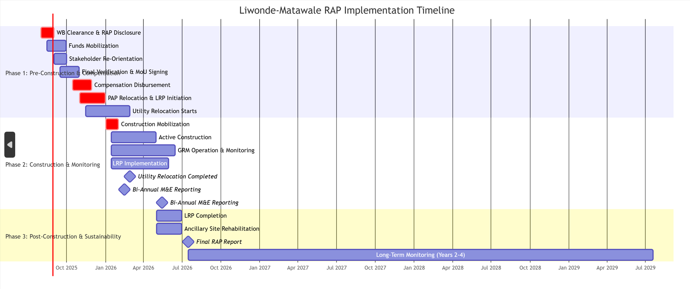

To facilitate the resettlement process, the following key activities were initiated immediately upon commencement of the Project:
- Submission of Assessment Report by Ministry of Lands;
- Disclosure and negotiation of values with PAPs;
- Finalization of Assessment of Report by Ministry of Lands;
- Clearance of the RAP by World Bank;
- Disclosure of safeguards instruments by RA;
- Request and availability of funds by the GoM through Roads Funds;
- Compensation payment and signing of Resettlement MoU; and
- Resettlement and Monitoring.

Budget
Resettlement costs are often underestimated and thus detailed budgeting/costs for the implementation of the resettlement shall be provided. By far the greatest cost will be the replacement of the structures affected. The Resettlement Action Plan (RAP) for the Liwonde-Matawale Road project is expected to require a total budget of MK 10,716,678,785.10 as presented in Table 33. Some of the activities have already been undertaken such as consultations and assessment and partial awareness raising and grievance management.

Table 33: Budget for RAP Implementations
Allocation | Item | Total Compensation (MWK)
Property Assessment |  | 55,000,000.00
Stakeholder Engagement | Consultations | 35,000,000.00
Stakeholder Engagement | Awareness Raising/Sensitizations | 60,000,000.00
Stakeholder Engagement | Disclosure | 40,000,000.00
Stakeholder Engagement | Grievance Management | 30,000,000.00
Compensations Payment | Verification | 25,000,000.00
Compensations Payment | Payment Facilitation | 25,000,000.00
Compensations Payment | Compensations | 1,764,339,286.56
Compensations Payment | Livelihood Restoration | 60,000,000.00
Utility and Services Relocation |  | 6,625,926,329.34
Cracks Repair/Compensations |  | 882,169,643.28
Chance Find procedure |  | 100,000,000.00
Monitoring |  | 40,000,0000.00
Total |  | 9,742,435,259.18
Contingency (10% of Total Compensation) 1933 |  | 974,243,525.92
Grand Total Compensation |  | 10,716,678,785.10

A detailed breakdown of the Compensation Budget is presented in Error! Reference source not found., highlighting costs associated with various categories of losses, including fruit trees, exotic trees, indigenous trees, structures, disturbance allowance, and shifting allowance.

Asset Inventory and Budget Assumptions

Utility and Service
Utility and service companies provided a list of infrastructure that will be damages as part of their BOQs. RA through the consultant superimposed the coordinates provided by the consultant on the road design and determined sections which will be affected by the works and classified them as high (requiring relocation), medium (require protection), and low (avoidable). Considering the works are sectional and time consuming, RA and the utility and service companies agreed that this will be undertaken during the project implementation upon joint verification of the infrastructures.

Properties for Government Agencies – Forestry Department and Police
Through thorough engagement, it was agreed that RA through the project will facilitate restoration of lost forestry products through engagement of an independent service provider with expertise in forest ecology and native species restoration be engaged to lead the reforestation and ecosystem rehabilitation activities.

Regarding road block structures along the road, RA through the contractor will facilitate safe removal and relocation of such structures to an agreed location Malawi Police and also provide temporary sanitary facilities. Upon completion of works on that particular section, the removed structures will be replaced with equal or improved structures.

Details of the PAPs by type of loss per District
The total number of Project Affected Persons (PAPs) impacted by the project is 1,745, distributed across Machinga and Zomba Districts. Specifically, 576 PAPs are in Machinga District, while 1,169 PAPs are in Zomba District. Of the total PAPs, 820 are female, 924 are male. The inventory of affected assets includes 14,224 trees, categorized as 8,272 fruit trees, 2,735 exotic trees, and 3,217 indigenous trees. Additionally, there are 969 affected structures, excluding signposts, and 182 signposts impacted by the project. The breakdown of these impacts is provided in Table 34, which details the number of PAPs and the types of losses experienced across different Traditional Authorities (TAs) within the two districts.
Table 34: Summary of Impacts per Traditional Authority
District | TA | No.  of  PAPs | PAP Categorization |  |  |  | Asset Categorization
District | TA | No.  of  PAPs | Male | Female | Institutional | Fruit  Trees |  | Exotic  Trees | Indigenous  Trees | Sign  Posts | Structures
Machinga | Liwonde | 2 | 1 | 0 | 1 | - |  | - | 3 | - | 1
Machinga | Mkula | 335 | 130 | 186 | 19 | 879 |  | 828 | 1,233 | 20 | 101
Machinga | Sitola | 262 | 113 | 95 | 54 | 258 |  | 534 | 759 | 40 | 27
Zomba | Chikowi | 11 | 1 | 0 | 1 | - |  | - | - | 2 | -
Zomba | Malemia | 1053 | 539 | 459 | 56 | 7,007 |  | 1,352 | 1,219 | 107 | 761
Zomba | Mkagula | 75 | 50 | 22 | 3 | 128 |  | 21 | 3 | 13 | 77
Zomba | Mulumbe | 7 | 0 | 1 | 0 | - |  | - | - | - | 2
Total |  | 1,745 | 834 | 763 | 134 | 8,272 |  | 2,735 | 3,217 | 182 | 969

Communal properties like sign posts and trees were recorded under an individual selected by the group and the value was disclosed to the whole group. Assets like curvets, crossing points and access roads will also be replaced by the project while boreholes and similar assets will be replaced at a location agreed upon with community members.
Table 35 gives a summary breakdown of affected structures in the project.

Table 35: Summary of Project-Affected Persons (PAPs) by Type of Structure Lost
 | Structure |  |  |  |  |  |  |  |  |  |  |  | Crops and Trees
District | GVH | Number of PAPs | Temporary Movable-Business (Hawkers, Kiosk, Shade) | Auxiliary | Business and Dwelling | Business | Community/  Public | Dwelling | Fences and Walls | Incomplete structures | Sign posts | Crops and Trees |  | Grand Total
Machinga | Chabwera | 41 | 5 | 1 |  | 1 |  |  |  |  | 7 | 145 |  | 159
Machinga | Lipongo | 68 | 17 | 1 |  | 27 |  |  | 1 | 1 | 3 | 35 |  | 85
Machinga | Malindima | 16 |  | 1 |  |  |  |  |  |  | 1 | 20 |  | 22
Machinga | Mlangala | 57 | 7 | 1 |  | 2 |  |  |  |  | 64 | 86 |  | 156
Machinga | Ndaje | 35 | 2 |  |  | 9 |  |  |  |  | 3 | 90 |  | 104
Machinga | Mkalo | 49 | 8 |  |  | 2 | 1 |  |  |  | 4 | 192 |  | 208
Machinga | Mliwo | 97 | 19 |  |  | 3 |  |  |  |  | 2 | 78 |  | 102
Machinga | Kalanje | 23 |  |  |  | 1 |  |  |  |  | 3 | 66 |  | 70
Machinga | Chibwana | 29 | 2 | 1 |  | 2 | 2 |  | 1 |  | 13 | 73 |  | 94
Machinga | Chingoli | 161 | 32 | 1 | 1 | 18 |  | 6 |  |  | 15 | 278 |  | 352
Zomba | Chopi | 294 | 106 | 17 | 1 | 64 | 1 | 7 | 12 | 4 | 50 | 236 |  | 498
Zomba | Kapyepye | 45 | 57 | 2 |  | 7 | 1 |  | 2 | 2 | 8 | 114 |  | 193
Zomba | Masambuka | 57 | 78 |  |  | 19 |  |  |  |  | 4 | 5 |  | 106
Zomba | Minama | 398 | 158 | 5 |  | 49 | 1 |  | 2 |  | 25 | 471 |  | 711
Zomba | Mtogolo | 375 | 85 | 8 |  | 14 | 2 |  | 2 |  | 20 | 418 |  | 549
Grand Total |  | 1,745 | 553 | 38 | 2 | 216 | 8 | 13 | 20 | 7 | 222 | 2311 |  | 3409

Table 36: Estimated Compensation Amount and Budget
District | TA | Fruit Trees Amount (MWK) | Exotic Trees Amount (MWK) | Indigenous Trees Amount (MWK) | Structures Amount (MWK) | Disturbance Allowance (MWK) | Shifting Allowance (MWK) | Vulnerability Allowance (MWK) | Total Compensation (MWK)
Machinga | Liwonde | - | - | 220,000 | - | - | - | - | 220,000
Machinga | Mkula | 17,864,500 | 60,175,000 | 49,350,000 | 139,085,195 | 41,725,559 | 1,240,000 | - | 309,440,254
Machinga | Sitola | 4,610,600 | 36,312,500 | 33,740,000 | 21,689,505 | 6,506,852 | 2,000,000 | - | 104,859,457
Zomba | Chikowi | - | - | - | 500,000 | 150,000 | 100,000 | - | 750,000
Zomba | Malemia | 130,399,700 | 90,562,500 | 55,115,000 | 669,260,285 | 200,778,086 | 9,790,000 | - | 1,112,293,607.56
Zomba | Mkagula | 3,705,500 | 1,450,000 | 80,000 | 50,624,050 | 15,187,215 | 1,250,000 | - | 72,296,765
Zomba | Mlumbe | - | - | - | - | - | 120,000 | - | 120,000
Total |  | 156,580,300 | 188,500,000 | 138,505,000 | 881,159,035 | 264,347,711 | 14,500,000 | - | 1,603,944,805.96
Contingency (10% of Total Compensation) |  |  |  |  |  |  |  |  | 160,394,480.60
Grand Total Compensation |  |  |  |  |  |  |  |  | 1,764,339,286.56

Budget Assumptions (public facilities relocation cost will be updated once service providers make provide the invoice)
- Land Compensation: Compensation for land is excluded as the land within the corridor of impact falls under the road reserve (public land).
- Crops: Crops have not been budgeted, as it is assumed that PAPs will be given adequate time to harvest field crops prior to project commencement.
- Livelihood Restoration Plan: The budget does not include livelihood restoration activities, as these will be addressed separately.
- Pre-Construction Stage: The budget is applicable only to losses incurred at the pre-construction stage of the project.
- Fruit Tree Seedlings: Three fruit tree seedlings are included for each fruit tree lost. The cost of these seedlings is factored into the budget to promote replanting Compensation is based on stipulated prices provided by Department of Forestry and it is covering loss of production and benefits/income from the fruit trees.
- Contingency: A contingency of 10% has been added to the total compensation amount to cover unforeseen expenses.
- Vulnerability Allowance: Vulnerability allowance is excluded pending analysis from valuation.

Roles and Responsibilities
Organisational structures and responsibilities must be clarified prior to resettlement. This includes all actions that must be adopted by relevant stakeholders including, amongst others, the proponent (RA), the relevant government departments (referred to as the GoM in this section) and the representative for PAPs such as the Resettlement and Compensation Committees (RCC) and Grievance Redress Committees (GRCs).

Roads Authority (Proponent)
The RA will provide the financial resources necessary for the resettlement and compensation process and will provide significant additional managerial and technical expertise. The role of the RA may be broken down into two distinct phases: pre-implementation and implementation. This is conceptual and will be further refined during the resettlement planning phase.
During pre-implementation, the RA must ensure it has:
- Collected all data required to effect resettlement.
- Drawn up Terms of Reference and contract all major planning services needed to effect resettlement.
- Attend consultative meetings, and provide administrative support and ad hoc managerial and technical support as required.

In the implementation phase, the RA must continue to finance implementation of the RAP. This will be done via the establishment of a dedicated team. The team will have as its primary responsibilities the following:
- Drawing up offer documents for each individual household / entity affected;
- Managing compensation and resettlement payments;
- Ensuring that the principles of the RAP is respected;
- Providing technical and managerial input to the implementation of the RAP;
- Establishing a socio-economic monitoring programme for the affected households;
- Identifying entities that are ‘failing’ as a result of the resettlement impacts of the Project and, together with the relevant local authorities, defining and implementing appropriate corrective action;
- Attending consultative meetings and providing support and input as and when required.
- Addressing compensation and resettlement grievances; and
- Defining and implementing the monitoring programmes to ensure that affected households are not worse off in the post-implementation phase.

Ensuring compliance with the resettlement and social commitments contained in this document will be the responsibility of the manager of the resettlement team who will have operational, daily responsibility for the execution of the RAP, including the following specific programme components:
- Survey and value assets taken during project construction;
- Conduct census updates of affected households; and
- Plan and supervise compensation activities, including for lost crops, land buildings and livestock, and to restore lost livelihoods.

Institutional Responsibilities for Implementation of the RAP
Institutional responsibilities for co-ordination, planning, administration, management and control of development and environmental issues (including resettlement) are shared among a number of agencies, ministries and organizations. The GoM is the primary proponent of the project and will have the overall responsibility of coordinating the implementation of the RAP through the RA. The key government institutions that are typically involved during a RAP include:
- Roads Authority and SATCP PIU;
- Councils (Zomba CC, Zomba DC and Machinga DC);
- Road Fund Administration;
- Ministry of Lands;
- Resettlement and Compensation Committee;
- Liwonde-Matawale Site Team (Consultant and Contractor)

The RA will set up a Project Management team to manage and implement the resettlement process. The RAP will be executed through RA in conjunction with RFA and Ministry of Lands Roads Fund. The contact persons and teams in each entity will be oriented by the RA representative to ensure that the exercise is undertaken with respect and due care to all PAPs. The councils, RCCs and Contractor will be tasked with identifying the issues emerging from the implementation of the RAP and forwarding them to RA who will in turn forward to RFA or Ministry of Lands depending on the nature.

Resettlement and Compensation Committee
RA established 16 RCC along the Liwonde-Matawale road at group village level. The RCC interfaces with the Project Management team and with the PAPs. The RCC was constituted as the primary representative voice of the PAPs. The RCC was established during the final design stage and consists of not more than 7 people and these will be:
- Lands Officer from the District Councils;
- Equal representation of male and female PAPs.
- Market representatives, GVH, Youth Representative, Vulnerable groups representative, Male PAPs representative, Female PAPs Representative.

This committee will help to ensure that all legal processes involving valuation and compensation are followed in a just and transparent manner and will be responsible for handling resettlement related grievances during preparatory phase of individual subprojects. The committee is proposed to ensure participation and inclusion of stakeholders. The RCC will ensure effective communication among affected persons, Ministry of Lands, Housing and Urban Development, District Councils and implementing entities. The RCC will include land officers from respective District Councils and gendered representation of the PAPs.

The RCC works hand in hand with RA Social Safeguards Specialists and the NGRC. Issues from the RCC will be reported to the NGRC by the PIU and the NGRC will facilitate site visits. The site visits by the NGRC will provide an opportunity for the RCCs to report on any concerns or challenges they face, including issues related to the PIU, District Officials, or other matters. Specifically, the RCC is responsible for:
- Acting as the primary channel of communication between the various interest groups/organizations involved in the resettlement process. In particular, it serves to facilitate communication between RA and the affected population;
- Help identify the owners of property during verification and payment of compensation;
- Solve amicably any problems relating to the resettlement process. If it is unable to resolve any such problems, it is to channel them through the appropriate grievance procedures;
- Assume primary responsibility of assisting RA in overseeing the resettlement processes in all its phases;
- Ensure that the terms of the RAPs are followed;
- Monitoring the implementation of the RAP and suggesting modifications if and when necessary;
- Identify issues/areas of concern that may have been overlooked/under emphasized in the ESIA or RAPs and suggesting ameliorative and or mitigation measures; and
- Monitor the Project area so as to prevent illegal encroachment.

The interactions among the relevant institutions for purposes of managing resettlement and compensation are depicted in Figure 6.
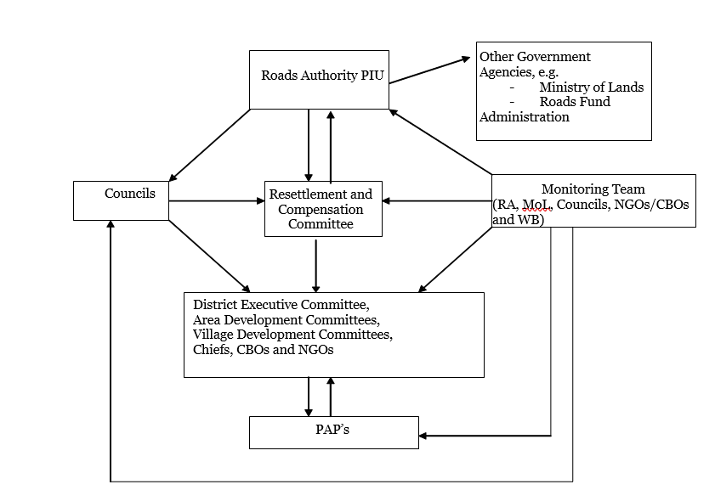
Figure 6: Implementation Arrangement Chart

Table 37: Summary of institutions’ Responsible for Resettlement Activities
Institution | Role/Responsibility
Roads Authority (RA) | - Review and monitor RAP implementation.
Roads Authority (RA) | - Finance the RAP.
Roads Authority (RA) | - Ensure PAP compensation is completed.
Machinga and Zomba Councils | - Identify alternative trading spaces for vendors.
Machinga and Zomba Councils | - Facilitate relocation of physically displaced PAPs.
Machinga and Zomba Councils | - Support compensation processes.
Ministry of Lands | - Conduct land surveys and valuations.
Ministry of Lands | - Facilitate compensation payment.
Ministry of Lands | - Support grievance resolution.
Civil Society Organizations | - Monitor the RAP implementation.
Civil Society Organizations | - Advocate for PAP rights.
Local Leaders (GVH and TA) | - Witness compensation payments.
Local Leaders (GVH and TA) | - Support PAP integration and conflict resolution.
Local Leaders (GVH and TA) | - Monitor RAP activities locally.
PAPs | - Participate in consultations.
PAPs | - Accept compensation packages.
PAPs | - Engage with grievance redress mechanisms.
Public Service Providers (ESCOM, Southern Region Water Board) | - Participate in consultations
 | - Accept relocation packages and relocate services
 | - Engage in negotiations

CHAPTER 9: MONITORING, EVALUATION AND REPORTING

Introduction
Monitoring and evaluation will form an integral part of project implementation, providing the necessary information about the involuntary resettlement aspects of the project, measuring the extent to which the goals of the resettlement plan have been achieved and the effectiveness of mitigation measures. Problems and successes will be identified as early as possible so that timely adjustment of implementation arrangements will be made. The process needs to be undertaken for a reasonable period after all resettlement and related development activities have been completed.

The RAP specifies the methods to be employed, frequency of measurement, reporting procedures, and the organizational arrangements to be made to undertake the activities including the involvement of those affected in the process.

Indicators
Indicators and targets will be established for the project as a whole, in consultation with representatives of the affected communities and other key stakeholders. Indicators will be grouped into the following categories:

- Input indicators – will measure the resources (financial, physical and human) allocated for the attainment of the resettlement objectives, such as livelihood restoration goals.
- Output indicators – will measure the services/goods and activities produced by the inputs. Examples will include compensation disbursements for acquired assets.
- Outcome indicators – will measure the extent to which the outputs will be accessible and used, as well as how they will be used. They will also measure levels of satisfaction with services and activities produced by the inputs. Examples will include the ways in which recipients used compensation. Although they are not measures of livelihood restoration in themselves, they will be used as key determinants of well-being.
- Impact indicators – will measure the key dimensions of impacts to establish whether the goals of the Resettlement Plan will be achieved. Examples will include restoration and diversification of income levels and the sustainability of income-generating activities, as dimensions of livelihood restoration and well-being.
- Process indicators – will measure and assess implementation processes. Examples will be the functioning of liaison/participation structures, the levels of representation of different social categories/interest groups, and the processes by which conflicts and disputes are resolved.

Indicators will also be disaggregated to ensure that social variables are properly accounted for. Table 39 provides details of different indicators and variables to be monitored
Table 38: Indicators and Variables to be monitored
Aspect | Variable | Indicator | Suggested Monitoring Period
Land | Affected land | - Area of cultivable land acquired or impacted. | Yearly, for 3 years post displacement
Land | Affected land | - Area of communal land acquired or impacted. | Yearly, for 3 years post-displacement
Land | Affected land | - Area of private land acquired or impacted. | Yearly, for 3 years post-displacement
Land | Affected land | - Area of government land acquired or impacted (e.g. in forest). | Yearly, for 3 years post-displacement
Land | Mitigation for land loss | - Number of affected households receiving compensation for land (land restoration or equivalent support). | Quarterly during first year of project, then yearly
Land | Mitigation for land loss | - Number of Land restored/rehabilitated | 4 months before commissioning
Land | Mitigation for land loss | - Implementation of livelihood restoration programs (e.g., alternative land and host area, number of PAPs that received technical skills). | Yearly for 2 years post-displacement
Land | Mitigation for land loss | - Number of PAPs employed | Yearly for 2 years post-displacement
Buildings/Structures | Affected buildings | - Number and type of private buildings impacted. | Yearly, for 2 years post-displacement
Buildings/Structures | Affected buildings | - Number and type of community facilities/structures impacted. | Yearly, for 2 years post-displacement
Buildings/Structures | Affected buildings | - Number and type of public facilities/utilities impacted. | Yearly, for 2 years post-displacement
Buildings/Structures | Mitigation for building/structure loss | - Number of households or businesses receiving compensation for lost structures. | Quarterly in first year, then yearly
Buildings/Structures | Mitigation for building/structure loss | - Number of structures rebuilt or restored | Yearly for 2 years post-displacement
Buildings/Structures | Mitigation for building/structure loss | - Number of PAPs employed | Yearly for 2 years post-displacement
Buildings/Structures | Mitigation for building/structure loss | - Number of PAPs given technical training | A year after compensation
Trees | Affected trees | - Number and type of trees impacted (commercial or subsistence use). | Yearly, for 2 years post-displacement
Trees | Mitigation for tree loss | - Compensation for affected trees (e.g., seedlings and replanting or monetary compensation). | Yearly for 2 years post-displacement
Hazards and Disturbances | Introduction of nuisance factors | - Number of homesteads affected by construction-related hazards (noise, dust, vibration, increased traffic). | Monthly during construction
Hazards and Disturbances | Introduction of nuisance factors | - Changes in traffic patterns and safety hazards for local communities. | Quarterly during construction
Hazards and Disturbances | Introduction of nuisance factors | - Disturbance from increased blasting or excavation activities. | Monthly during construction
Hazards and Disturbances | Mitigation for nuisance factors | - Implementation of mitigation measures for nuisance factors (e.g., noise barriers, dust suppression). | Monthly during construction
Social/Demographic | Population migration | - Number of households required to relocate and resettlement patterns. | Yearly during resettlement phase and 1 year after project completion
Social/Demographic | Population migration | - Type of support provided for relocation (, transportation allowance etc.). | Yearly during resettlement and livelihood restoration phase
Social/Demographic | Population migration | - Number of vulnerable groups (chronically ill, elderly, female-headed households, child-headed households, people with disabilities) impacted by resettlement | Yearly during resettlement phase
Social/Demographic | Mitigation for migration impacts | - Livelihood restoration support provided to those affected by resettlement (skills training, cash support). | Yearly for 2 years post-displacement
Changes to Access | Changes in access to services | - Changes in access to water, health, education, and markets (impact due to labour influx) | Quarterly during construction, yearly for 2 years after
Changes to Access | Mitigation for loss of access | - Construction of alternative access roads, water supply points due to water extraction, if necessary, assistance in health facilities to cover labour influx, | Yearly until restoration of services
Health and Safety | Health impacts | - Number of people affected by health-related issues due to the project (e.g., malaria, respiratory issues, diarrhoea, STIs). | Yearly during project construction, then 1-year post-project
Health and Safety | Health impacts | - Monitoring of waterborne diseases or health impacts arising from construction activities (e.g., contamination of water sources- water extraction, runoff from project works, sand mining). | Quarterly during construction
Health and Safety | Health impacts | - Access to healthcare for PAPs during resettlement and rehabilitation- which may be congested due to labour influx | Quarterly during resettlement and livelihood restoration phase
Health and Safety | Mitigation for health impacts | - Provision/ assistance to health facilities (e.g., clinic at camps, health education, sanitation programs). | Monthly during construction, yearly for 1-year post-displacement
Health and Safety | Mitigation for health impacts | - Community Health & safety measures for surrounding/nearby villages | Monthly during construction
Vulnerable Groups | Impact on vulnerable groups | - Number of vulnerable groups affected by the project (chronically ill, elderly, female-headed households, child-headed households, disabled persons). | Yearly during and after resettlement
Vulnerable Groups | Mitigation for impacts on vulnerable groups | - Tailored assistance to vulnerable groups, including compensation, relocation support, and livelihood restoration programs. | Quarterly during 1st year, then yearly
Livelihood Restoration Programs | Implementation of livelihood restoration activities | - Number of affected households and individuals involved in livelihood restoration programs (skills training, business support, etc.). | Yearly for 3 years post-displacement
Livelihood Restoration Programs | Implementation of livelihood restoration activities | - Types of livelihood restoration programs implemented (vocational training, small business support, financial literacy). | Quarterly for first year, then yearly
Livelihood Restoration Programs | Implementation of livelihood restoration activities | - Number of displaced individuals or households that restore or improve livelihoods. | Yearly for 3 years post-displacement
Livelihood Restoration Programs | Livelihood restoration effectiveness | - Percentage of participants in livelihood programs who report successful income restoration or improvement. | Yearly during livelihood restoration phase
Compensation | Compensation effectiveness | - Number of affected persons receiving fair and adequate compensation for land, structures, crops, businesses, and other assets. | Quarterly for first year, then yearly
Compensation | Compensation effectiveness | - Timeliness of compensation payments and provision of entitlements. | Yearly for 2 years post-displacement
Compensation | Compensation effectiveness | - Number of grievances related to compensation resolved. | Monthly during construction, yearly after
Population Influx | Influx of temporary workers or settlers | - Increase in local population due to construction workforce and displaced persons. | Yearly during construction phase
Population Influx | Mitigation for population influx | - Infrastructure improvements to handle influx (e.g., water supply, sanitation, temporary housing). | Yearly during construction phase
Population Influx | Mitigation for population influx | - Monitoring of informal settlements and providing basic services (e.g., toilets, water, health care). | Quarterly during construction phase
Consultation Program | Stakeholder consultation and engagement | - Frequency and number of public consultations held with affected communities. | Quarterly during planning and construction phase
Consultation Program | Stakeholder consultation and engagement | - Number of grievances and concerns raised during consultations and how they were addressed. | Quarterly during consultation meetings
Consultation Program | Stakeholder consultation and engagement | - Number of local committees and community stakeholders involved in planning and implementation. | Quarterly during the project period
Grievance Redress Mechanism | Grievance resolution | - Number of grievances raised, categorized by type (e.g., compensation, livelihood, resettlement issues). | Monthly during construction, yearly after
Grievance Redress Mechanism | Grievance resolution | - Number of grievances resolved and compensation provided to complainants. | Quarterly during project, then yearly
Grievance Redress Mechanism | Grievance resolution | - Monitoring of unresolved grievances and steps taken to resolve them. | Yearly after construction phase ends
Mitigation for Environmental Impacts | Implementation of environmental safeguards | - Monitoring of the effectiveness of environmental safeguards (e.g., erosion control, tree planting, waste management). | Monthly during construction, yearly for 2 years
Mitigation for Environmental Impacts | Implementation of environmental safeguards | - Mitigation measures for auxiliary sites (quarries, borrow pits, spoil sites) to prevent environmental degradation. | Quarterly during auxiliary site operations
Auxiliary Site Management | Environmental & safety impacts at auxiliary sites | - Monitoring of dust, noise, and water contamination at quarries, borrow sites, spoil sites. | Monthly during site operation
Auxiliary Site Management | Environmental & safety impacts at auxiliary sites | - Monitoring of worker safety at auxiliary sites (PPE, sanitation, accident rates). | Monthly during site operation
Auxiliary Site Management | Environmental & safety impacts at auxiliary sites | - Measures to prevent soil erosion, water contamination, and vegetation loss at auxiliary sites. | Monthly during site operation
Communication/Responses/Disclosure | Project communication and transparency | - Regular updates provided to affected communities about project progress and mitigation measures. | Quarterly during project, then yearly
Communication/Responses/Disclosure | Project communication and transparency | - Frequency of meetings with local authorities, NGOs, and stakeholders for feedback and concerns. | Quarterly during the project period

Suggested Monitoring Periods

During Construction Phase:
- Monthly: For issues like noise, dust, health & safety measures, and environmental impacts from quarries, borrow pits, spoil sites, and roadwork.
- Quarterly: For changes in traffic, health impacts, socio-economic conditions of PAPs, and grievance resolution.

Post-Displacement Monitoring:
- Yearly for 3 years’ post-displacement: To track livelihood restoration, health, access to services, compensation effectiveness, and socio-economic status of PAPs.
- Yearly for 2 years: To assess the success of mitigation measures and livelihood recovery, particularly for vulnerable groups.

Environmental and Safety Monitoring at Auxiliary Sites:
- Monthly: For dust control, water contamination, and worker health & safety measures at quarries, borrow pits, spoil sites, and other auxiliary locations.

Livelihood and Compensation Monitoring:
- Yearly: To ensure compensation adequacy, effectiveness of livelihood restoration programs, and social impacts.

Key Considerations
- World Bank ESF Alignment: The monitoring period and aspects are designed to align with the World Bank ESF, ensuring continuous engagement and adaptive management strategies throughout the project lifecycle.
- Socio-Economic Monitoring: Regular yearly assessments of the socio-economic status of PAPs (including vulnerable groups) will ensure the long-term sustainability of the mitigation and livelihood restoration strategies.
- Health & Safety: Regular monitoring will help mitigate health risks associated with the project, especially in construction and auxiliary site operations, safeguarding both workers and local communities.

This comprehensive approach ensures that both the social and environmental impacts of the road rehabilitation and auxiliary sites are effectively managed, while also ensuring that affected communities, particularly vulnerable groups, receive the necessary support to restore their livelihoods and well-being.

At the end of the compensation and resettlement period the RAP shall be evaluated on its performance. The evaluation will assess the number of people to be resettled, issues to be addressed versus what will have been achieved in the agreed period.

Monitoring Program
The monitoring program will involve the following:
- Establishment of required institutional structures;
- Operation of compensation, grievance and other necessary procedures;
- Disbursement of compensation payments;
- Development of livelihood restoration programs; and
- Preparation and submission of monitoring and evaluation report.

Reporting
Reporting on involuntary resettlement activities forms an integral part of monitoring and evaluation, to:
- Ensure early detection of conditions that necessitate particular mitigation measures; and
- Provide information on the progress and results of mitigation. Reporting methods of any resettlement activities on the project to date seem to have been limited to reports from consultants working on different aspects of the project. It is recommended that in the future all consultation and disclosure activities be reported in detail, internally and externally.

CHAPTER 10: CONCLUSION

Introduction
The primary challenge posed by the project is the displacement and relocation of businesses and households. However, adherence to this Resettlement Action Plan (RAP) will minimize inconvenience and ensure that the livelihoods and well-being of the displaced persons are effectively restored or improved. To achieve this, the Roads Authority will:
- Maintain effective coordination with other supporting institutions RAP implementation and monitoring.
- Continuously engage communities through meetings, sensitization activities and maintaining a liaison office to share information, receive grievances/issue and foster prompt response to issues raised.

By implementing these measures and maintaining regular engagement with stakeholders, the project will address resettlement challenges effectively while ensuring the rights and welfare of PAPs are protected in line with international best practices and the World Bank Environmental and Social Framework (ESF). RA commits to start works on the project upon finalization of resettlement activities.

APPENDICES
Appendix 1: ESTIMATED COMPENSATION AMOUNT AND BUDGET

District | TA | Fruit Trees Amount (MWK) | Exotic Trees Amount (MWK) | Indigenous Trees Amount (MWK) | Structures Amount (MWK) | Disturbance Allowance (MWK) | Shifting Allowance (MWK) | Vulnerability Allowance (MWK) | Total Compensation (MWK)
Machinga | Liwonde | - | - | 220,000 | - | - | - | - | 220,000
Machinga | Mkula | 17,864,500 | 60,175,000 | 49,350,000 | 139,085,195 | 41,725,559 | 1,240,000 | - | 309,440,254
Machinga | Sitola | 4,610,600 | 36,312,500 | 33,740,000 | 21,689,505 | 6,506,852 | 2,000,000 | - | 104,859,457
Zomba | Chikowi | - | - | - | 500,000 | 150,000 | 100,000 | - | 750,000
Zomba | Malemia | 130,399,700 | 90,562,500 | 55,115,000 | 669,260,285 | 200,778,086 | 9,790,000 | - | 1,112,293,607.56
Zomba | Mkagula | 3,705,500 | 1,450,000 | 80,000 | 50,624,050 | 15,187,215 | 1,250,000 | - | 72,296,765
Zomba | Mlumbe | - | - | - | - | - | 120,000 | - | 120,000
Total |  | 156,580,300 | 188,500,000 | 138,505,000 | 881,159,035 | 264,347,711 | 14,500,000 | - | 1,603,944,805.96
Contingency (10% of Total Compensation) |  |  |  |  |  |  |  |  | 160,394,480.60
Grand Total Compensation |  |  |  |  |  |  |  |  | 1,764,339,286.56

Appendix 2: COMPENSATION SUMMARY FOR RELOCATION

NO. | Utility/Service Company | Amount (MK)
1 | ESCOM | 13,887,848.50
2 | Open Connect Limited | 812,188,118.22
3 | Southern Region Waterboard | 5,799,850,362.62
Contingency (10%) |  | 6,625,926,329.34

Note: This amount excludes actual relocation cost for ESCOM infrastructure, which has been tentatively costed at MK 938,580,392.85.

Appendix 3: RAP Implementation Schedule - 12 Months (August 2025 – July 2026)
This schedule hinges on the assuming that RA receive the World Bank clearance for the RAP is received by September 15, 2025.
Phase 1: Pre-Construction & Compensation (Months 1-5: Aug - Dec 2025)
This phase is critical for preparing the ground, finalizing approvals, and disbursing all compensation to ensure PAPs can timely relocatee.

Timeframe | Activity | Key Actions | Responsible Party | Status/Notes from RAP
2022 | Preliminary Stakeholder Engagement | Engaged Councils and local leadership to inform them about the project and hear their concerns, expectations and determine their role | RA | Done
2022 | Establishment Resettlement and Compensation Committees | Established, oriented and trained RCCs | RA | 16 RCCs were established, oriented and trained
May to July 2023 | Socio-economic Survey and Asset Inventory/Census | Study the context of the project | Consultant and RA | Done
Aug 2023 | Community engagement and grievance uptake and resolution | Engage the communities to capture issues that emerged post asset inventory | RA and Councils | Done
September to October 2024 | Asset Assessment and Valuation | Assessed all potentially affected assets | Ministry of Lands, RA, Councils and RCCs | Done
November 24 | Community engagement and grievance uptake and resolution | Engage the communities to capture issues that emerged post asset assessment and also close grievances | RA, Councils and RCCs | Done
June 2025 | Asset and Ownership Verification; Value disclosure and negotiation; and Grievance Redress | Verify affected assets, ownership as well as disclose expected values and negotiate with PAPs on the same | RA, RFA, Ministry of Lands, Councils and RCCs | Done
Post World Bank Clearance
Month 1 (September 2025) | RAP Disclosure | Finalize any minor adjustments post-WB clearance. | Roads Authority (RA), World Bank | Required by ESS10. RAP is scheduled for disclosure in August 2025.
Month 1 (September 2025) | RAP Disclosure | Public disclosure of WB-cleared RAP at Council offices & online. | Roads Authority (RA), World Bank
Month 1 (September 2025) | Funds Mobilization & Readiness | Roads Fund Administration (RFA) secures and transfers compensation budget to designated account. | RFA, RA, Ministry of Finance | Total RAP budget is MWK 10.7 billion.
Month 1 (September 2025) | Funds Mobilization & Readiness | Confirm banking/payment mechanisms for PAPs. | RFA, RA, Ministry of Finance | Total RAP budget is MWK 10.7 billion.
Month 2 (October 2025) | Stakeholder Re-Orientation & Sensitization | Conduct meetings with RCCs, Councils, and Traditional Leaders to review the final RAP, payment process, and their roles. | RA (PIU), Councils, RCCs | RCCs are already established and trained. This is a refresher and kick-off.
Month 2 (October 2025) | Stakeholder Re-Orientation & Sensitization | Launch broad public awareness campaign (radio, community meetings) on the compensation process. | RA (PIU), Councils, RCCs
Month 2 (October 2025) | Final Verification & Signing of MoUs | RCCs and Lands Officers conduct final door-to-door verification of PAPs and assets against the approved schedule. | RCCs, Ministry of Lands, Councils, PAPs | Annex B shows the schedule was already disclosed and negotiated (97% acceptance). This is the final administrative step.
Month 2 (October 2025) | Final Verification & Signing of MoUs | PAPs sign Memoranda of Understanding (MoUs) accepting compensation amounts. | RCCs, Ministry of Lands, Councils, PAPs
Month 3 (Nov 2025) | Compensation Disbursement | Bulk of compensation payments (structures, trees, disturbance allowance) are made via cheques/cash. | RFA, RA, Councils | Payment is a precondition for construction.
Month 3 (Nov 2025) | Compensation Disbursement | Meticulous recording of each transaction, with copies to PAP, RCC, and Council. | RFA, RA, Councils | Payment is a precondition for construction.
Month 4 (Nov-Dec 2025) | PAP Relocation & Livelihood Restoration Initiation | PAPs voluntarily dismantle and relocate structures using their compensation and shifting allowance. | PAPs, RA, Utility Companies | 2-3 month relocation period was committed to PAPs. Utilities require a 12-week timeline.
Month 4 (Nov-Dec 2025) | PAP Relocation & Livelihood Restoration Initiation | Begin initial rollout of Livelihood Restoration Plan (LRP) activities (e.g., financial literacy training). | PAPs, RA, Utility Companies
Month 4 (Nov-Dec 2025) | PAP Relocation & Livelihood Restoration Initiation | Utility Relocation Commences: Issue formal notices and payments to ESCOM, SRWB, OCL to begin their relocation work. | PAPs, RA, Utility Companies

Phase 2: Construction & Active Monitoring (Months 6-10: Jan - Apr 2026)
Construction begins only after the compensation and relocation period is complete. This phase focuses on monitoring the resettlement outcomes and managing any issues arising from construction

Timeframe | Activity | Key Actions | Responsible Party | Status
Month 6 (Jan 2026) | Site Handover & Construction Mobilization | - RA and Councils certify that the RR is clear of compensated assets  - Contractor is formally granted access to the road corridor to mobilize equipment and set up sites. | RA, Councils, Contractor | Construction was anticipated to start by Nov 2024 in early plans; this timeline reflects the updated schedule.
Month 6-10 (Jan-Apr 2026) | Active Construction & Continuous Monitoring | - Continuous GRM Operation: RCCs and PIU actively receive and resolve any construction-related grievances (e.g., dust, noise, damage to non-compensated assets).  - Ongoing LRP Implementation: Skills training, vocational programs, and employment facilitation continue.  - Utility Relocation Completed: All utility companies complete their infrastructure moves under RA/Consultant supervision.  - Chance Finds & Damages: Implement procedures for unplanned discoveries (Annex C) and assess/compensate for any cracks or damages caused by construction. | Contractor, RA (PIU), RCCs, Supervising Consultant, Utility Companies | Contractor is responsible for undertaking crack survey and observing the damages during construction. A specific budget (MWK 882 million) exists for cracks/repairs under the RAP.
Month 7 & 10 (Feb & May 2026) | Bi-Annual M&E Reporting | Independent monitor submits detailed M&E reports on compensation status, livelihood restoration progress, and grievance resolution to RA and World Bank. | RA (PIU), Independent Monitor | Aligns with WB reporting requirements and Table 39 of the RAP

Phase 3: Post-Construction & Livelihood Sustainability (Months 11-12 & Beyond: May - July 2026+)
This phase ensures the long-term sustainability of livelihoods and the formal closure of the resettlement process.

Timeframe | Activity | Key Actions | Responsible Party | Status/Notes from RAP
Month 11-12 (May-June 2027) | Completion of LRP & Ancillary Site Rehabilitation | - Finalize all training and support under the Livelihood Restoration Plan.  - Contractor rehabilitates and hands back all ancillary sites (borrow pits, quarries) to landowners, certified by Councils and Traditional Leaders. | Contractor, RA, Councils, Landowners | Required by WB ESF and Malawi law (MEPA).
Month 12 (July 2027) | Final RAP Implementation Report | - Prepare and submit a comprehensive report to the World Bank detailing all RAP activities, expenditures, outcomes, and final status of all PAPs. | RA (PIU) | Marks the formal end of the RAP implementation period.

Appendix 4: PAP CENSUS QUESTIONNAIRE
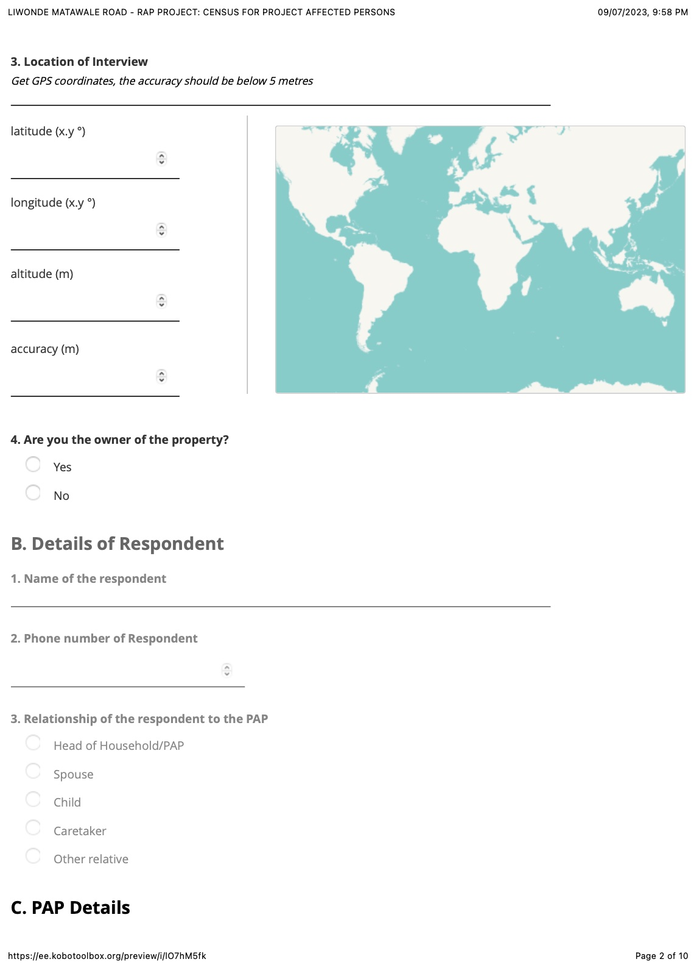
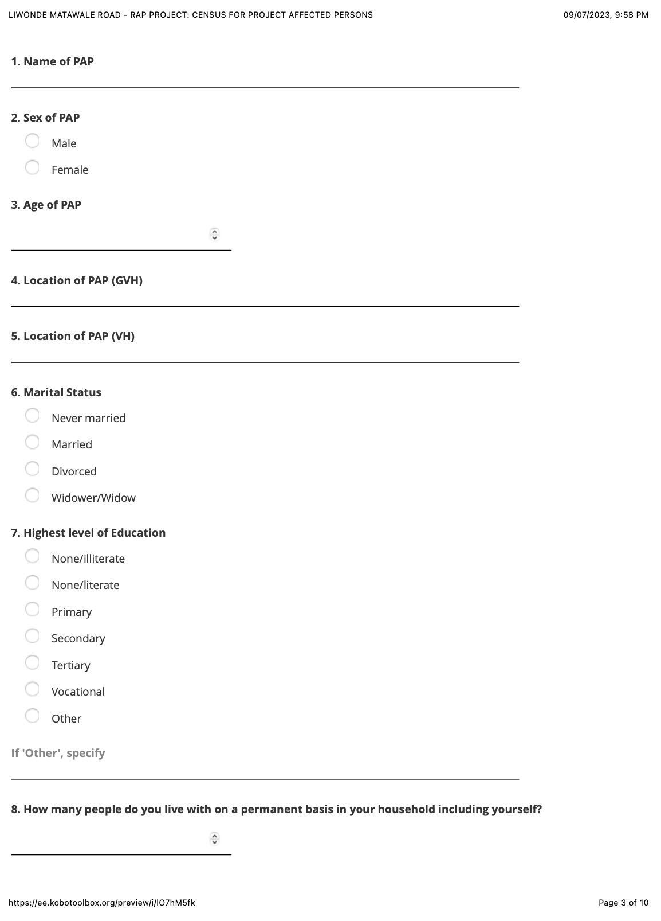
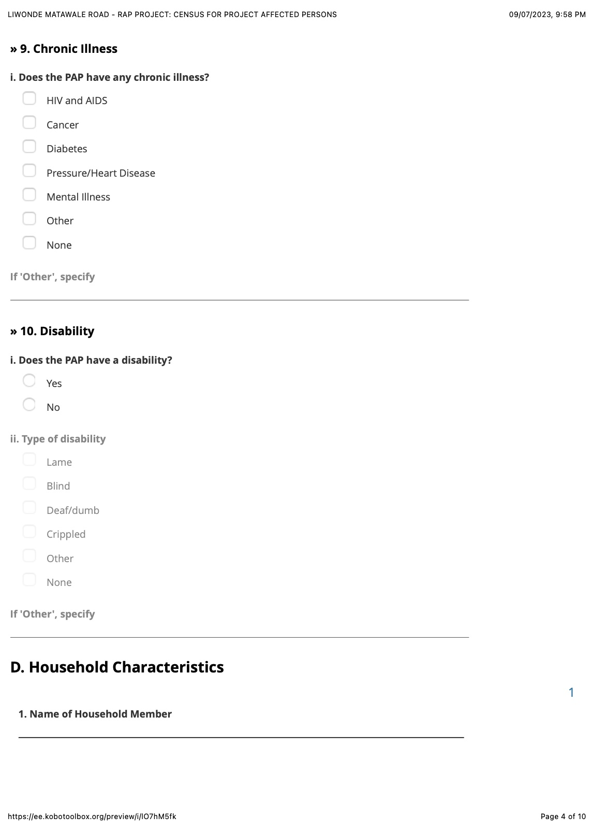
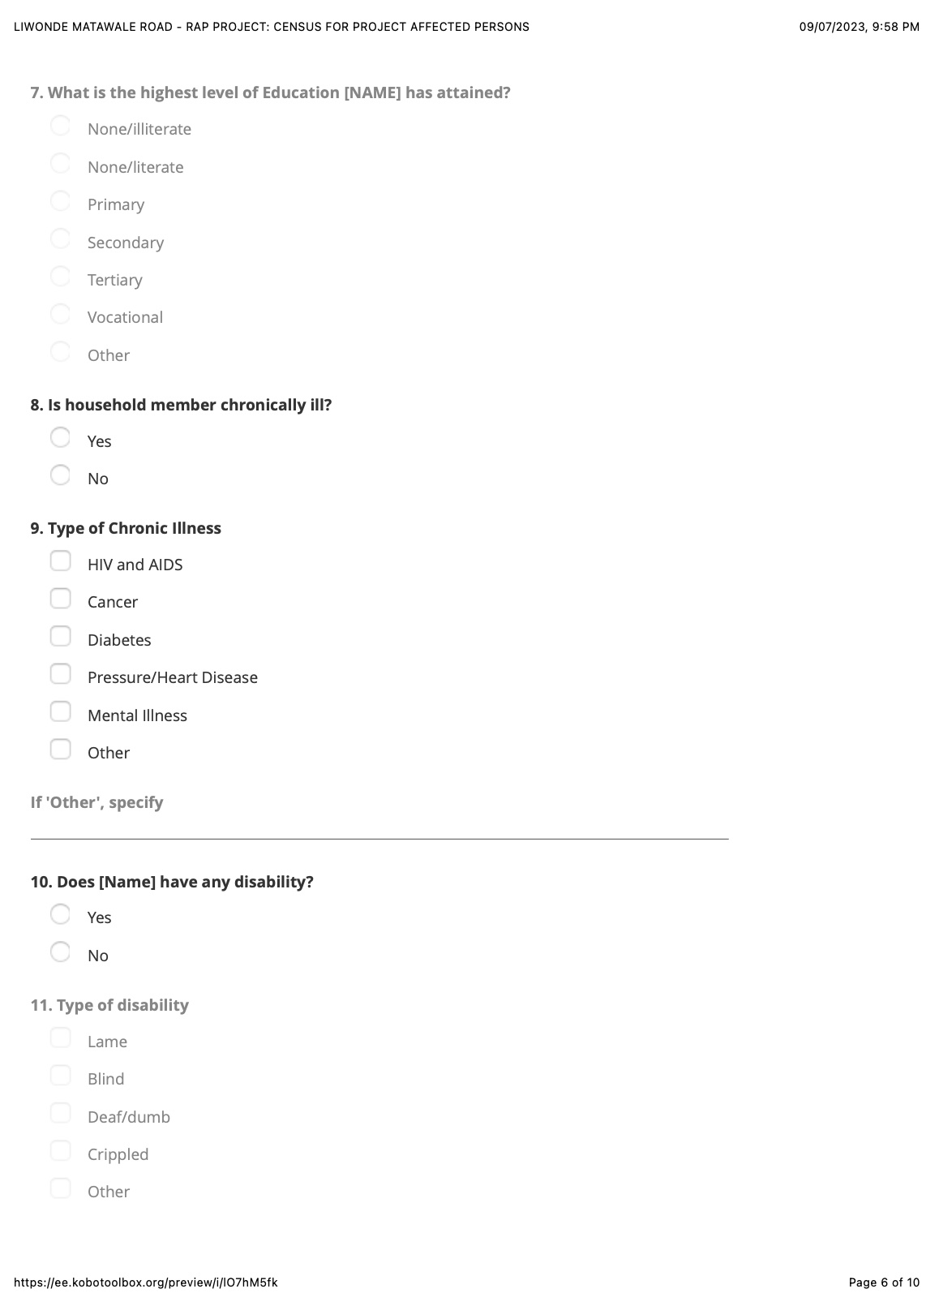
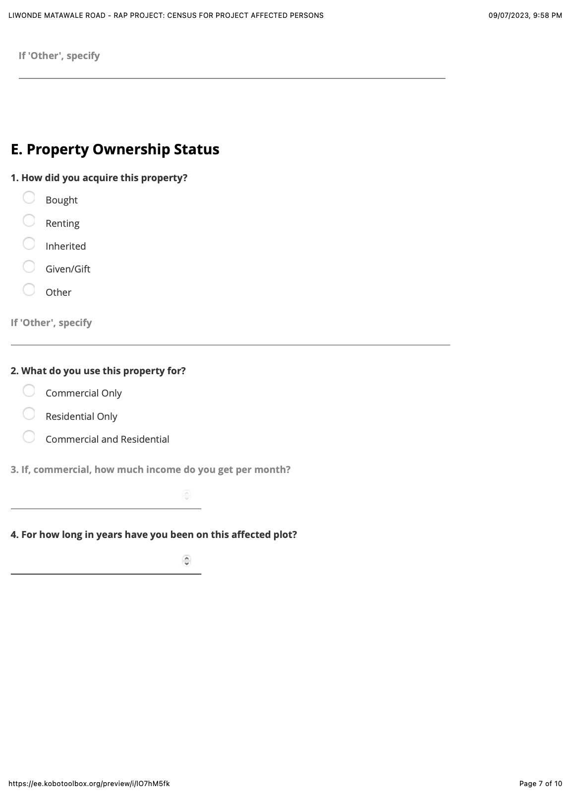
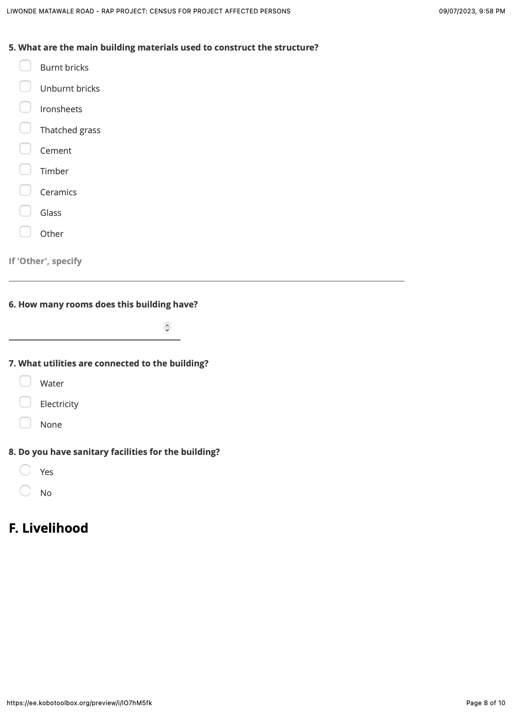

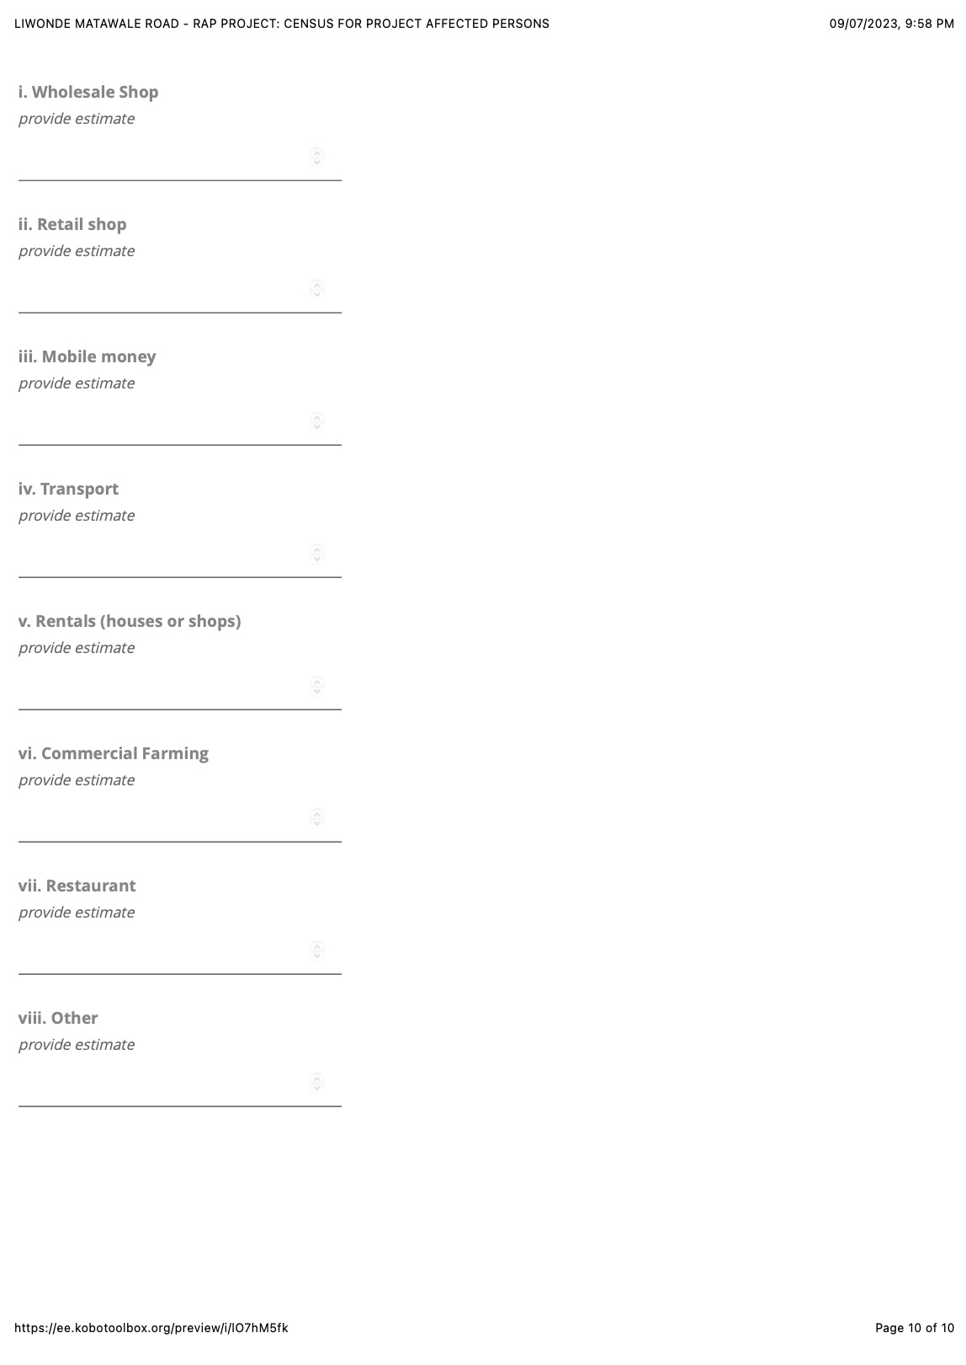

Appendix 5: MULTI-CRITERIA SCREENING FOR SOCIAL AND ENVIRONMENTAL IMPACT MITIGATION
Table 39: Multi-Criteria Screening for Social and Environmental Impact Mitigation
Project Component | Potential Environmental Impacts | Potential Social Impacts | Mitigation Measures | Impact Severity (High/Medium/Low) | Monitoring Requirements | Compliance with World Bank Safeguards
Borrow Pit | Soil erosion, water contamination, dust, habitat disruption | Land acquisition, displacement of informal settlers, safety risks | Erosion control, water management, fencing, health and safety protocols | Medium | Regular water quality monitoring, dust control measures | Assessment and Management of Environmental and Social Risks and Impact (ESS1),
Quarry Site | Air pollution, noise pollution, land degradation, dust, visual impacts | Displacement, land use conflicts, labour conditions | Site rehabilitation, noise barriers, dust suppression, land restoration | High | Environmental audits, worker safety inspections | Assessment and Management of Environmental and Social Risks and Impact (ESS1), Land Acquisition, Restrictions on Land Use and Involuntary Resettlement (ESS5)
Camp Site | Waste generation, water contamination, soil erosion, land degradation | Influx of workers, public health risks, social tensions | Waste management systems, water treatment, community health outreach | Medium | Waste monitoring, health inspections, grievance mechanism | ESS1, ESS5
Access Roads | Deforestation, soil erosion, water pollution, habitat destruction | Community access disruption, land conflicts | Road design modification, erosion control, reforestation, community engagement | Medium | Regular inspection of road conditions, biodiversity monitoring | ESS1, ESS5
Water Abstraction Site | Water depletion, impact on aquatic life, water quality issues | Reduced water availability for local communities, conflicts over water use | Sustainable water uses practices, water quality monitoring, community water management | High | Water quality monitoring, community water availability assessments | ESS1, Resource Efficiency and Pollution Prevention and Management (ESS3)
Quarry Mining Site | Air pollution, dust, noise, soil degradation, loss of biodiversity | Land use conflict, labour rights issues, safety | Dust suppression, noise mitigation, worker protection, biodiversity conservation | High | Regular environmental monitoring, labour rights audits | ESS1, ESS5
Sand Mining Site | Habitat destruction, water pollution, erosion, loss of biodiversity, riverbank destabilization | Community displacement, livelihood disruption, conflict over resources | Reforestation, riverbank stabilization, water quality monitoring, livelihood support programs | High | Monitoring of riverbank conditions, water quality, community livelihoods | ESS1, ESS5, Cultural Heritage (ESS8)

ANNEXES

Annex A: LIVELIHOOD RESTORATION PLAN

1.0 Introduction
The primary objective of this Livelihood Restoration Plan (LRP) is to ensure that the livelihoods of Project-Affected Persons (PAPs) are either improved or, at the very least, restored to pre-displacement levels. Recognizing the significant impacts caused by land acquisition, displacement, and other project-related activities, this LRP establishes a framework for restoring and enhancing PAPs' living standards. In alignment with World Bank ESS5, the LRP prioritizes fairness, inclusivity, and sustainability in addressing the physical and economic displacement of PAPs. It ensures compensation for lost land, property, and income-generating assets at full replacement cost and introduces measures to restore livelihoods effectively. The plan seeks to minimize vulnerabilities while fostering opportunities for economic growth, resilience, and self-sufficiency.

1.2 Objectives
The LRP is designed to achieve the following objectives:
- Ensure PAPs regain or exceed their pre-displacement income levels and living standards.
- Provide targeted assistance to ensure equitable participation in and benefits from livelihood restoration activities.
- Diversify income sources to reduce reliance on a single livelihood stream.
- Build capacity and provide resources to ensure long-term economic viability and environmental protection for PAPs.
- Empower PAPs to make informed decisions and actively participate in livelihood planning and implementation.

1.3 Key Principles Underpinning the LRP
The LRP is guided by a set of principles that align with World Bank ESS5 and national development objectives, including:
- Holistic Approach: Addresses multiple dimensions of livelihoods, including financial, physical, natural, human, and social capital.
- Community Participation: Encourages inclusive decision-making processes, ensuring the active involvement of women, youth, and marginalized groups.
- Equity and Inclusion: Tailors interventions to address disparities in access to resources and opportunities among PAPs.
- Building Back Better: Promotes sustainable infrastructure and livelihood systems that are more resilient to future shocks.
- Sustainability: Integrates capacity building, skills training, and environmental stewardship into livelihood restoration activities.
- Monitoring and Evaluation: Establishes robust systems to track progress, measure outcomes, and identify areas for improvement.

1.4 Distribution of PAPs for Livelihood Restoration Support
Livelihood restoration activities will be tailored based on the type and extent of livelihood and asset losses experienced by Project-Affected Persons (PAPs). The following measures will guide the distribution of livelihood restoration support:
- Cash compensation for support structures: PAPs losing support structures such as toilets, kitchens, or sheds will receive cash compensation at full replacement cost.
- Compensation for main dwelling structures: PAPs losing main dwelling structures will be given compensation at full replacement cost, including relocation allowance. The PAPs will be allowed to savage their construction materials.
- Compensation for crops and trees: Standing crops and trees, including fruit-bearing, indigenous, and exotic species, will be compensated at rates agreed with the government. Additionally, fruit tree seedlings will be provided to encourage replanting at resettlement locations, promoting long-term environmental and livelihood benefits.
- Compensation for additional impacts during construction: Any additional impacts identified during the construction phase, which were not documented during the preparation of the final RAP, will be compensated based on rates defined in the RAP’s Entitlement Matrix. The contractor will be responsible for addressing these impacts in line with requirements of ESS 4 (Community Health and Safety) as per project’s ESMP to avoid conflicts and tension between contractors and community members.
These measures aim to ensure that PAPs receive fair and adequate support, addressing both their immediate needs and long-term livelihood restoration.

1.5 Livelihood Restoration Interventions and Activities
To support PAPs whose livelihoods will be impacted by the road project, a range of livelihood restoration interventions have been proposed. These interventions are informed by the documented impacts of the project, the existing livelihood systems of PAPs, and their socio-economic characteristics.
- Restoration of existing livelihoods: Focuses on re-establishing the current livelihood activities of PAPs to enable them to resume familiar and effective practices.
- Intensification of existing livelihood strategies: Aims to sustainably increase productivity, ensuring that the remaining land or resources yield as much or more than before the impact.
- Introduction of alternative livelihoods: Emphasizes resilience and diversification, introducing viable options that do not increase burdens on women or other vulnerable groups.
The proposed interventions are categorized into general and specific measures:
- General interventions: Applicable to all eligible PAPs and largely related to ongoing government programs, such as agricultural extension services. These programs will continue beyond the LRP period.
- Specific interventions: Tailored to individual PAPs based on the type of negative impact, existing skills, age, and education levels. These measures will be evaluated at the end of the project.

The preliminary livelihood enhancement interventions include:
- Skills training: Focused on severely affected especially younger PAPs and vulnerable PAPs to improve employment opportunities, with business development support provided to improve income generation potential diversify and income sources.
- Employment Opportunities: PAPs will be prioritized for jobs related to the project.
- Support through Corporate Social Responsibility (CSR): The Contractor and Roads Authority will explore initiatives to support adversely affected communities, including funding for community-based projects.

Table 1: Appendix A Provides the livelihood interventions identified for PAPs under LRP
Type of Loss | Category of PAP | Livelihood Restorative Measures | How It Will Assist PAPs
PRE-CONSTRUCTION STAGE
Loss of land | PAPs in auxiliary sites | 1. For permanent land acquisition for auxiliary land with freehold title, transferring replacement land ownership within one year from compensation. | 1. Ensures timely transfer of land rights, minimizing disruption for PAPs.
 |  | 2. Taxes and costs for land transactions, including cadastral survey, new land titling, and registration for replacement land to be borne by the Contractor for permanent land acquisition | 2. Covers transactional costs, reducing financial burden on PAPs.
 |  | 3. Income loss compensation for temporary land acquisition/ rental as per agreement with PAP | 3. Provides financial assistance during temporary land displacement
 |  | 4. Land rehabilitation | 4. Ensures the land is safe for communities and capable of growing natural vegetation
Residential Property | Dwelling/fence/toilet | 1. Transaction and replacement costs to be borne by the Project within one year from compensation. | 1. Ensures financial support for relocation and rebuilding.
 |  | 2. Provision of relocation allowance. | 2. Provides financial assistance for moving and rebuilding.
 |  | 3. Allow PAPs to salvage materials from the existing structure (except hazardous materials like Asbestos). | 3. Salvaging materials lowers reconstruction costs.
Commercial Property | Permanent structures (shops/immovable hawkers) | 1. Transaction and replacement costs to be borne by the Project within one year from compensation. | 1. Provides financial support for relocation and rebuilding.
 |  | 2. Provision of relocation allowance. | 2. Provides financial assistance for moving and rebuilding.
 |  | 3. Provision of compensation for income loss | 3. Prevents economic loss during displacement
 |  | 4. Allow PAPs to salvage materials from the existing structure (except hazardous materials like Asbestos). | 4. Salvaging materials lowers reconstruction costs.
 |  | 5. Skills development and vocational training for financial literacy, carpentry, tailoring, bricklaying, cell phone repair, weaving. | 5. Helps PAPs develop skills for new income sources.
 | Temporary structures (Movable hawkers/containers) | 1. Provision of compensation for income loss | 1. Prevents economic loss during displacement
 |  | 2. Provision of relocation allowance. | 2. Provides financial assistance for moving and rebuilding.
 |  | 3. Allow PAPs to salvage materials from the existing structure (except hazardous materials like Asbestos). | 3. Salvaging materials lowers reconstruction costs.
Loss of Work/Business | Wage Earners (Workers/Employees in shop/business, temporary vendors) | 1. Provision of income and wage loss compensation. | 1. Prevents economic loss during displacement by compensating wage loss.
 |  | 2. Skills development and training in financial literacy, carpentry, tailoring, bricklaying, cell phone repair, weaving to enhance employability. | 2. Provides training to enhance employability and diversify income streams.
 |  | 3. Provision of work opportunities by the contractor. | 3. Creates employment opportunities to bridge income gaps during relocation.
 |  | 4. Market linkages – help allocate new area for trading during project works (e.g., outside contractor campsites). | 4. Helps PAPs access new markets to sell goods or services during temporary restriction to selling good in RR
 | Traders using Temporary Structure | Identify a space to relocate these traders to continue their businesses. This can be inside existing markets, expansion of existing markets or finding a new place entry. This process will be consultative with both the affected PAPs and the local authorities | This will assist traders to continue plying their business and also enable traders maintain their customer base and social ties within the same setup.
Loss of Livelihood | All PAPs (including vulnerable groups) | 1. Financial literacy training. | 1. Improves financial management, enhancing the PAP’s ability to cope with change.
 |  | 2. Skill and business development training. | 2.Supports business growth and new opportunities.
 |  | 3. Prioritise PAPs for both skilled and unskilled labour opportunities during the construction | 3. Supports PAPs by providing stable income through construction jobs; and Income earned can help PAPs improve their living standards and increase their resilience thereby to reduce the effects of displacement;
 |  | 4. Access to social and financial training such as life skills and financial literacy through NGOs. | 4. Provides life skills and financial education to help PAPs manage their resources effectively.
 |  | 5. Vocational Training in Technical Skills (e.g., cell phone repair, weaving, bricklaying, tailoring), with business management training, and provision of start-up toolkits and capital for selected PAPs to establish small-scale service businesses. | 5. Equips middle-aged PAPs with technical and business management skills, helping them establish sustainable small businesses, increasing household income.
Loss of Crops/Trees | Crop and Tree Owner | 1. Compensation at replacement cost. | 1. Compensates PAPs for crop/tree loss, ensuring they can restore their agricultural livelihoods.
 |  | 2. Three seedlings will be provided for each fruit tree lost. | 2. Provides seedlings to help restore the environment and future crop production.
Public Utilities |  | 1. Compensation for relocation costs and financial loss, with rates to be provided by service providers | 1. Mitigates disruptions caused by relocation of public utilities, ensuring PAPs are compensated.
Public Forests |  | 1. Compensation at replacement cost. | 1. Compensates for forest loss to mitigate negative impacts.
 |  | 2. Three seedlings will be provided for each tree lost and land rehabilitation | 2. Restores environmental balance by offering seedlings for replanting.
Vulnerable groups |  | 1. Linkage to Government Social Cash Transfer Program through Ministry of Gender for vulnerable PAPs. | 1. Ensures long-term social support for vulnerable households, linking them to existing government assistance programs.
 |  | 2. Access to CSR initiatives by the client. | 2. Provides access to additional social programs or initiatives that benefit vulnerable groups.

1.6 PAPs Participating in the LRP
Participation in livelihood restoration programs will be voluntary and demand driven. Eligible PAPs willing to participate in the LRP will be identified through meetings where details of the livelihood restoration programs will be disclosed. A final list of participants will be compiled, and activities will proceed according to the proposed implementation schedule provided in the LRP.

1.7 Potential Training Institutions for Skills Training and Courses Offered
Several institutions have been identified as potential partners for providing vocational skills training to enhance the livelihoods of Project Affected Persons (PAPs). Table 41 provides a summary of the courses offered by these institutions, which align with the livelihood restoration objectives outlined in this plan. These institutions will play a critical role in delivering tailored capacity-building programs for the PAPs.

Table 41: Summary of Potential Courses under LRP
SN | Institution | Course(s) Offered | Requirement(s)
1 | Mikolongwe College of Veterinary Sciences | Livestock production, livestock management. | Courses are modified to suit the literacy levels of the beneficiaries.
2 | Department of Community Development and Zomba Community Technical College | Business management, food processing, savings and investment, financial literacy, environmental safeguards. | Courses are modified to suit the literacy levels of the beneficiaries.
3 | Department of Labor/TEVETA, Nasawa Technical College and Sakata Community Technical College | Tailoring, carpentry & joinery, bricklaying, welding, weaving, hair salon, handicraft, tinsmith. | Courses are modified to suit the literacy levels of the beneficiaries.
4 | San Wecka Techno Companions and Sakata Community Technical College | Cell phone repairs, home gadgets repairs, computer repairing, dish installation, video production. | JCE/MSCE. For Sakata Community Technical College courses are modified to suit the literacy levels of the beneficiaries.
5 | Sakata Community Technical College and Nasawa Technical College | Training in entrepreneurship, business management. | Courses are modified to suit the literacy levels of the beneficiaries.

The Livelihood Support Agent will collaborate with the recommended training institutions to implement training and follow-up activities during the project duration. Upon project completion, the relevant government departments and development partners, including NGOs, will take over these programs to ensure sustainability and continuity.

The practical skills, including carpentry, tailoring, weaving, welding, and bricklaying, will be delivered through apprenticeship programs due to the limited availability of formal vocational training opportunities and the long duration of such programs. Training institutions will collaborate with Master Craftsperson’s to provide hands-on training for the PAPs. This approach will enable beneficiaries to balance their daily activities with the acquisition of skills. The apprenticeship program is expected to last three (3) months, providing sufficient time for the participants to develop their expertise.

1.8 Risks and Limitations to the Livelihood Restoration Plan and Mitigation Measures
The Livelihood Restoration Plan (LRP) is designed to ensure that PAPs not only restore but also improve their livelihoods to a level better than their pre-project status. However, the implementation of these interventions is not without risks and limitations. One key risk is the long-term nature of some interventions, such as agricultural support programs and skills training, which may take time before yielding measurable results. If relevant sector ministries, such as the Ministry of Agriculture and Ministry of Gender and Social Welfare, do not remain actively engaged after the LRP implementation phase, the sustainability of these programs may be jeopardized. To mitigate this risk, these key ministries will be actively involved from the start of the LRP to build their ownership and capacity for continuity.

Another challenge is the limited capacity of District Councils to fully integrate PAPs into ongoing programs such as the social cash transfer initiative. While linking PAPs to such programs is a viable mitigation strategy, these initiatives often target specific groups, making it difficult to accommodate all eligible PAPs immediately. This limitation will require additional planning and prioritization to ensure that the most vulnerable PAPs are supported without delay.

Further risks include external factors such as natural disasters, which may disrupt planned activities, and potential accountability issues during the implementation of the LRP. Mitigation measures will include regular monitoring of program implementation, capacity-building for implementers, and establishing robust grievance redress mechanisms to address any complaints or irregularities. By addressing these risks and limitations proactively, the LRP aims to ensure that the interventions are effectively implemented and contribute to the long-term resilience and sustainable livelihoods of the PAP.

Annex B: REPORT FROM MINISTRY OF LANDS, HOUSING AND URBAN DEVELOPMENT. THE SCHEDULE IS SHARED SEPERATELY

  - Compensation Assessment Report for Affected Assets (The schedule is shared separately)
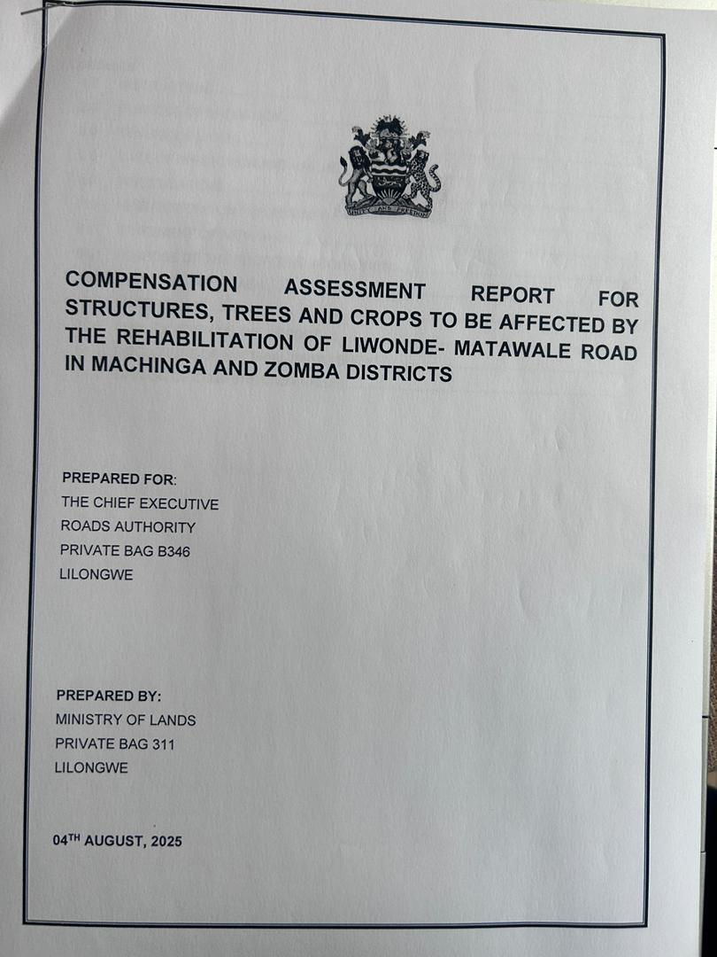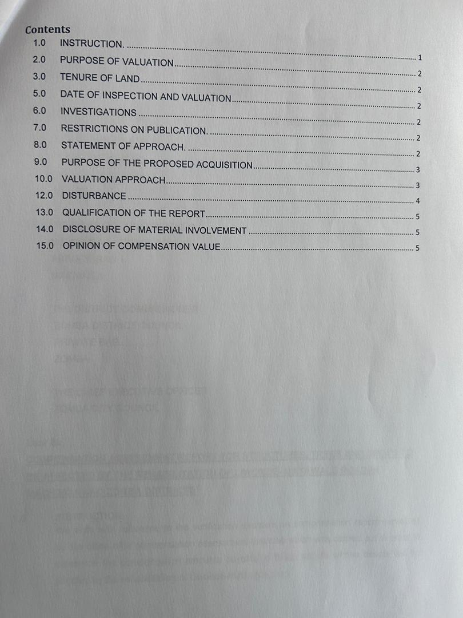
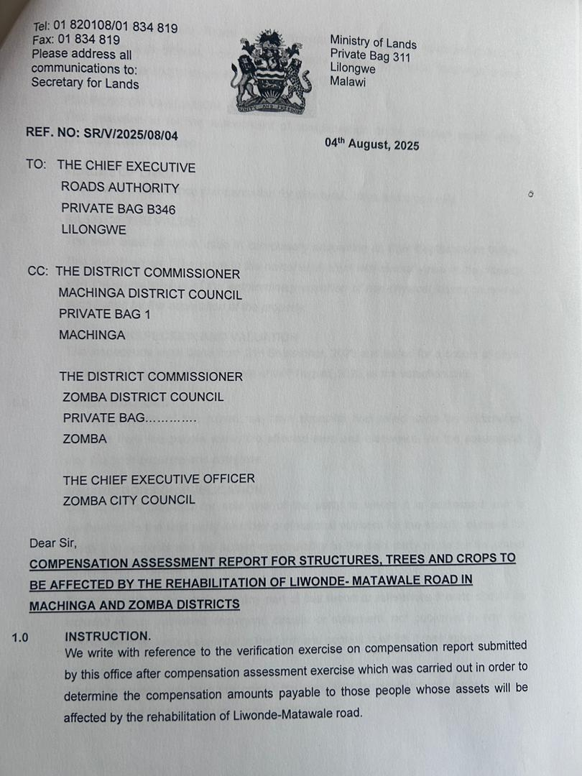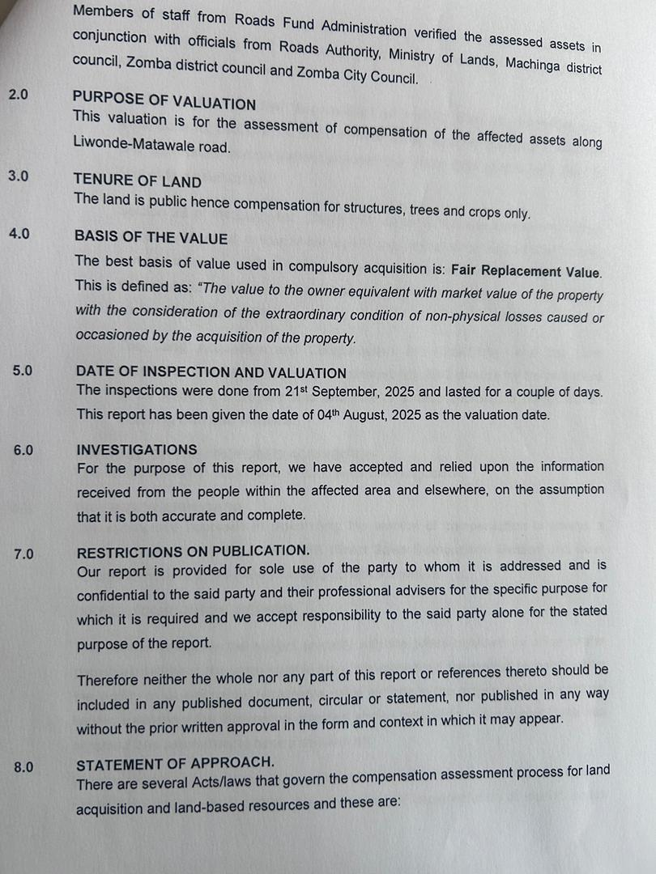

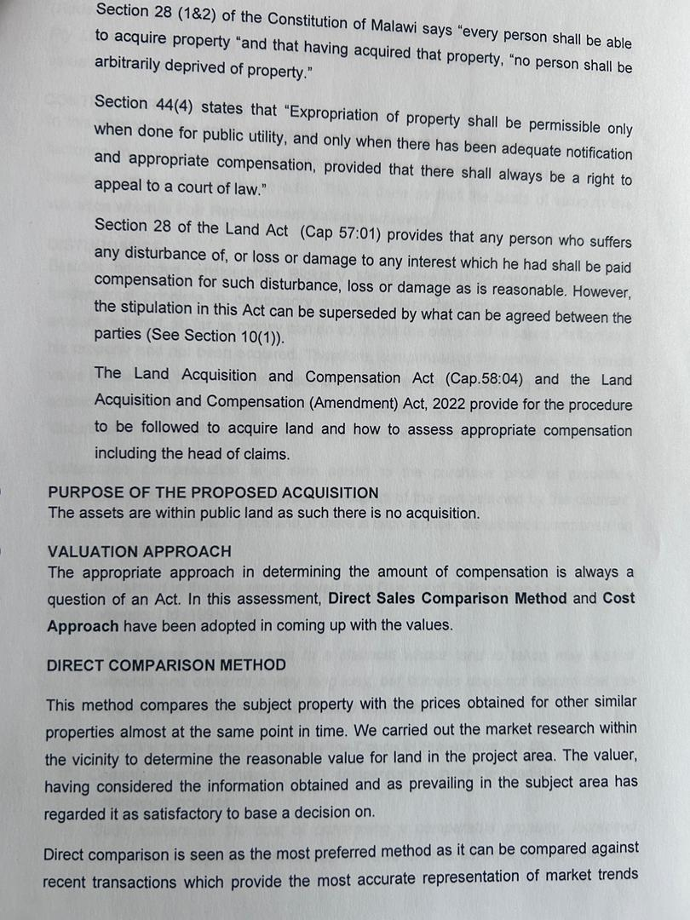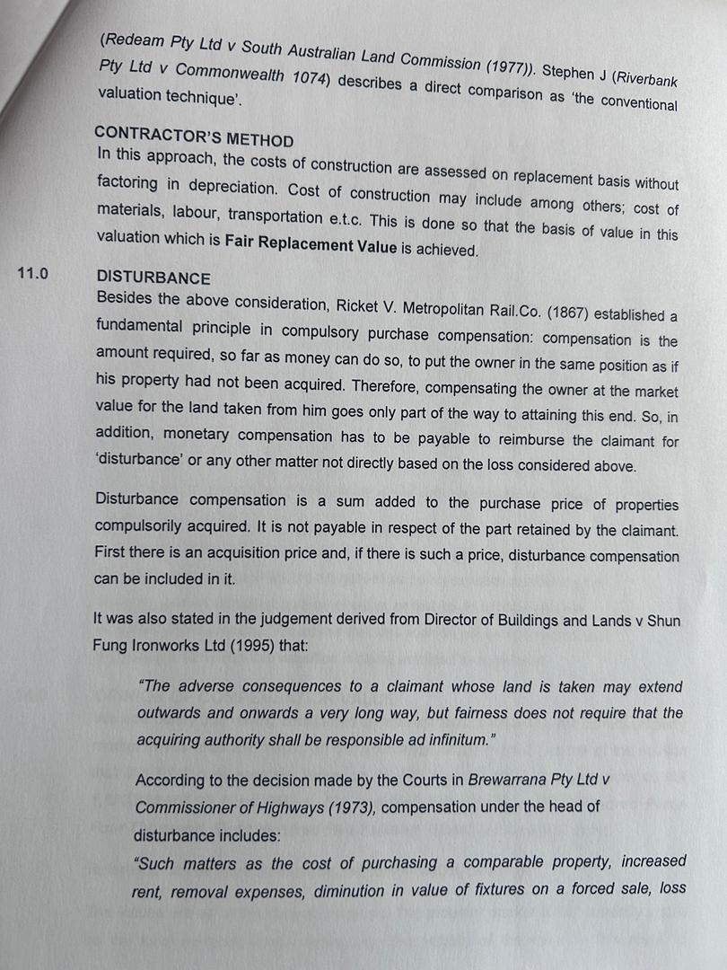
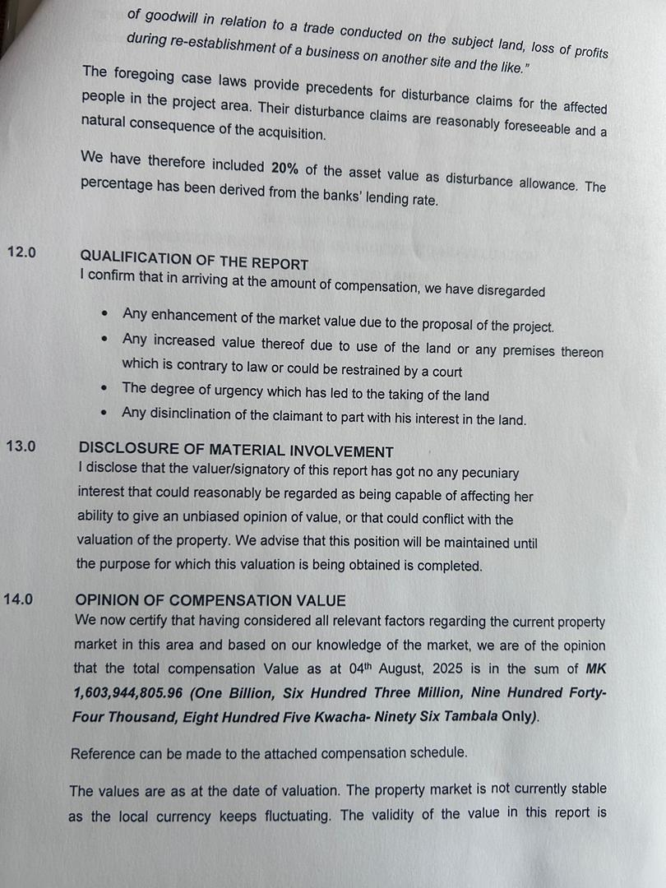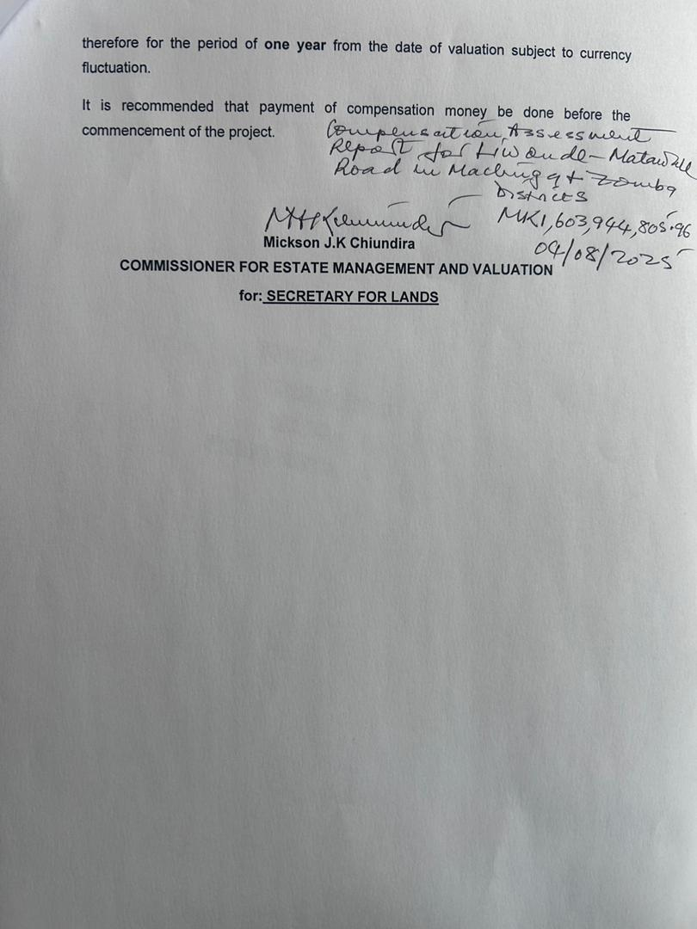

  - Signed Schedule that was Disclosed, Negotiated and Accepted Values by Project Affected Persons (Schedule shared separately)

Annex C: PROCEDURES FOR UNPLANNED ACTIVITIES AND ASSOCIATED COMPENSATIONS

C.1 Management Procedures for Land Acquisition for Ancillary Works
The project will acquire land and structures for offices or residential outside the Road Reserve for ancillary works such as contractor’s camp site, material sources (borrow site, quarry site, water sources and mining) and access roads to such sites. To that regard, the contractor will be responsible for facilitating and footing the cost for such acquisitions.

Potential Issues
- Conflict on resources – water, energy etc.
- Conflict with surrounding communities due to disturbance (environmental such as dust and noise or social such as SEA, Community Health and Safety etc.)
- Land related issues – land grabbing/encroachment, fraudulent lease agreements, unpaid or underpaid compensations, unrehabilitated or poorly rehabilitated land; and
- Tenancy related issues – Damaged property, Unpaid utility bills, fraudulent lease agreements, unpaid or underpaid compensations, unrepaired or poorly repaired structures.

In view of the above mention impacts, this procedure sets out to guide contractor’s acquisition of land and structures for office or residential use during the implementation of the Liwonde-Matawale Project.

Procedures
  - Site Selection
All sites under this project will be located as far away from communities as possible in order to ensure there is minimal interaction with communities. It is recognized that quarry sites and borrow pits are subject to availability of areas that have been prequalified as material sources, however, strict measures will be undertaken including carrying out a joint site risk assessment with consultants and council officials (from departments of Lands, Environmental, Community Development/Social Welfare).

  - Stakeholder Engagement
Upon identifying a suitable site, the contractor will have to undertake engagement sessions with various stakeholders including council officials, community leaders, claimed land owners and neighbors.
- Ownership Verification: The contractor will be responsible for identifying the owners of the land they want to acquire, ownership status and size. At this point only owner’s willingness to lease the land should be expressed and consent to undertake tests;
- Consultations: Once owners are identified, the contractor should undertake consultations with local leaders, owners, neighbors and council’s officials on possible utilization of the site for whatever intended use with associated risks, impacts and mitigation measures – method statement. Issues raised, response provided and assurances/guarantees should be captured in a report for inclusion in the Site Risk Assessment Report. It is highly recommended that the contractor’s representatives should be as honest and preemptive as possible. Obviously, this is a reiterative process;
- Site Assessment: In line requirements of ESS 4 (Community Health and Safety), the contractor will undertake appropriate measures to avoid conflicts and tension between contractors and community members. Each identified site will be assessed for risk with regard of the activities to be undertaken at that particular site and in relation to the surrounding. This has to be undertaken jointly with all stakeholders in order to ensure credible and honest results. A report on the activity with its findings and proposed mitigation measures shall be shared with RA for review and approval – where necessary, RA safeguards team will be involved in the assessment for smoother processes. The risk assessment report shall also capture existing land uses, location, ownership status, size, consultation minutes with other stakeholders, method statement for intended activities; risk matrix, risks and impacts, mitigation measures and access issues;
- Assessment and Price Determination: No site will be acquired for free or paid in kind. For all land acquisition Land office from the Council shall be responsible for assessments and those reports will serve as basis for compensation payment. Negotiated prices will only be allowed where the owner is requesting for prices higher than those reached at by the councils. For rented structures, owners are at liberty to set their own prices but these have to be shared with the Council Officials for knowledge seek in case something rises in future
- Lease Agreement: Draft lease agreement should be share with the consultant and will be vetted by RA. All possible contentious issues should be included and cleared in the agreement. For rented structures such issues can include but not limited to: post evacuation repairs, rights to enter and modify the structure, payment of utility bills, use of premises;
- Verification and Vetting: Before payments are made, ownership should be verified with involvement of local leaders and councils. Once ownership is verified and before payment is made, signed lease agreements should be annotated and stamped by both local leaders and councils;
- Grievances and Conflict: Grievances can be launched directly to the contractor but a grievant is also at liberty to go to the Community Grievance Redress Committees, consultant, local leader, council or even the Gender Based Violence Service Provider (depending on the nature of the complaint). The contractor shall be responsible for investigating, responding and addressing issues raises promptly. All issues and grievances shall be recorded and presented in a safeguards bi-weekly reports and monthly reports;
- Operation: The contractor shall implement all agreed measures as stipulated in site assessment report and lease agreement including effective communication, addressing grievances and issues raised from owners, neighbors and community, secure and maintain the site and also adhere to safeguards requirements for environment, social, health and safety (both occupational and community);
- Monitoring: The contractor shall inspect the site and accompany RA/Council/MEPA on site monitoring sessions. Reports shall be prepared on adherence to method statement, compliances, non-compliances, grievances, issues and new risks associated with operationalization of the sites;
- Rehabilitation and Handover: The contractor shall carry out a post works site assessment to determine to extent of damage caused which in turn will inform rehabilitation measures. The contractor shall undertake all recommended actions to rehabilitate the site in line with national standards, WB ESS and project recommendations (owners views will be incorporated as long as they align with the aforementioned requirements). Upon completion of the rehabilitation, RA and MEPA will come to certify the rehabilitation and close the site. The contractor shall be required to prepare Land Acquisition and Compensation Report for all sites acquired. For rented facilities, a letter from the council will be a clearance document for the contractor certifying that all rentals and other obligations stipulated in the lease agreement were satisfied by the contractor and that there are no outstanding issues – this can be cosigned by the property owner.

C.2 Management Procedures for Damaged Structures (Cracks)

- Objective
Ensure that structures (houses and shops) that are with the road reserve and any other structures along access roads to or near sites for ancillary works are compensated for damages caused by compaction, vehicle impacts, or electrical wire tangling.

- Scope
Applies to permanent and temporary structures along road reserves; near borrow pits, quarries, sand sites, and camp sites; and along access road to such ancillary works sites. The scope activities include baseline data collection, inspection, assessment, repair, prevention, and stakeholder engagement.

Roles and Responsibilities
- Roads Authority and Roads Fund: Determine cause of action, facilitate implementation and monitor undertaking of determined action;
- Resident Engineer: Oversee implementation, compliance, and reporting;
- Site Engineers: Conduct inspections and supervise repairs;
- Social Safeguards Expert: Ensure adherence to safety protocols;
- Contractors: Execute repairs and preventive measures
- Social Safeguards Officer: Baseline data collection, engage stakeholders and facilitate redress of concerns; and
- Councils: Assess contested damages to determine causes and monitor closeout of issues

- Procedure Steps

    - Baseline Data Collection
The contractor’s Social Officer shall engage property owners that are found with the aforementioned areas but were not compensated and explain to them about the purpose of data collection and the process for damage responsibility determination, intervention determination and availability of grievance redress mechanism. The contractor shall undertake Dilapidation Survey capturing photos of the structure and existing cracks (with date and location – GPS-Camera is an alternative app), ownership information, existing use and location (GPS) and commentary on nature of construction and condition. The file for structures that might be affected by compaction in the RR will be kept separate from other because this will be compensated for by RA while the rest is the contractor’s responsibility.

    - Inspection & Monitoring
Frequency: Depending on stated condition or weather conditions, the structures can be inspected weekly. There are also inspections that can be done post-weather events, activity (blasting or working close to structures), after heavy machinery use (jackhammer) or incident/accident (vehicle hitting structure or flooding);
Methods: Visual checks or high-end technologies (drones, IoT sensors, and 3D mapping).
Documentation: Digital logs with photos, GPS tagging, and severity classification (Low/Medium/High).

    - Risk Assessment
Categorization: Use a risk matrix (severity × likelihood) to determine level of intervention. This can be informed by expert judgement and narrations from owners for instance how shaky the structure is.
Root Cause Analysis: Compaction (soil testing), structure settling, weak structure integrity (poor construction method and materials), vehicle impact (traffic patterns), wire tangling (utility audits), earth vibration from blasting, weather impacts (thermal effects on timber), water (flooding, heaving or roof leaking from rain) impact on the structure, or actual hitting by construction vehicles.
Tools: Expert judgement or use of high-end technologies (Crack gauges, ultrasonic testing, structural modelling).

    - Immediate Mitigation
The damages will be classified in three categories:
- High-Risk Cracks: Erect barriers, divert traffic, stabilize structures or compensate for repairs or relocation;
- Electrical Hazards: Coordinate with utilities to insulate/reroute wires; and
- Emergency Response: Evacuate areas if imminent danger; notify authorities.

    - Repair & Rehabilitation
The measures presented below have been proved to be effective, however, the engineers will determine what interventions to be made.
- Non-Structural Cracks: Sealants (polyurethane/epoxy);
- Structural Cracks: Epoxy injection, carbon fibre reinforcement, or reconstruction; and
- Quality Control: Post-repair inspections per ASTM/ACI standards.
E. Preventive Measures
- Compaction Control: Geotextiles, proper soil gradation;
- Physical Protections: Bollards, guardrails, reinforced poles;
- Electrical Safety: Elevate wires, routine utility checks; and
- Training: Driver education on load limits, speed controls via signage.
F. Documentation & Reporting
- Records: Digital database for inspections, repairs, costs.
- World Bank Reporting: Quarterly progress aligned with ESF requirements.
G. Stakeholder Engagement
- Community: Notifications via meetings/signage; feedback hotline.
- Utilities: Monthly coordination for wire maintenance.
- Workers: Safety drills, crack management workshops.
H. Review & Improvement
- Audits: Bi-monthly by third parties.
- Lessons Learned: Adapt procedures based on incident reviews.
I. Emergency Protocol
Contractor shall set a Rapid Response Team for responding to emergencies for critical cracks.

4. Budget & Resources
There is need to dedicated funds for repairs, training and compensations. The project has set allocated a budget that might be used for repairs or compensations;

The contractor together with the supervising engineer will develop the following:
- Risk Assessment Matrix
- Inspection Checklists
- Contact List for Utilities/Emergency Services
- Baseline Data
- Database for monitoring

C.3 Chance Find Procedure for Rehabilitation of Liwonde-Matawale Road Projects
This is a protocol to follow when unexpected cultural heritage items are discovered during construction. This has been developed in line with the Monument and Relics Act of 19191 and the World Bank's Environmental and Social Framework (ESF), particularly Environmental and Social Standard 8 (ESS8) on Cultural Heritage, which requires protecting cultural heritage during projects. The field survey that was conducted during the development of this RAP revealed that there will be no form of a monument or relic whose removal or destruction would trigger the application of the act. Consequently, the project’s designs have made considerable effort to avoid cultural and heritage facilities and places in view of the Act. However, for the artifacts and other cultural, heritage and religious materials unknown and undiscovered, particularly those buried underground, the project has chance find procedure that will guide management of such materials in an event they have been discovered.

The Protocols
Consultants, Contractors and Subcontractors’ Workers shall be trained beforehand on what to do if they find something through project kick-off meeting, safeguards training, inductions and toolbox talks. Maybe include this in the environmental management plan. The chance find protocol shall be included in the contract documents so contractors know their responsibilities.
Budget considerations for handling chance finds, like contingency funds in the project for such events have also been included in the RAP Budget

1. Immediate Response Upon Discovery
- Halt Construction: Cease all activities within at least 50 meters of the discovery to prevent damage.
- Secure the Area: Cordon off the site using barriers and post guards to restrict unauthorized access.
- Initial Documentation: Photograph/video the find and record GPS coordinates, depth, and context.

2. Notification Protocol
- Internal Reporting: Site supervisor notifies the Social Officer who will in turn inform the Site Agent within 1 hour.
- External Reporting: Site Agent informs Resident Engineer who shall inform Roads Authority (RA). The national cultural heritage authority (e.g., Ministry of Culture, Archaeology Department) will be notified by RA within 24 hours.
- World Bank Notification: Coordinator from RA alerts the World Bank Task Team Leader (TTL) if the find is significant, per ESS8 requirements.

3. Expert Assessment
The cultural heritage authority or a qualified archaeologist would need to evaluate the find. They would determine the significance—whether it's a minor artifact or a major site. Based on that, they decide on mitigation measures. For minor finds, maybe document and remove the artifact. For major finds, more extensive measures like salvage excavation or redesigning the project to avoid the site.
- Deploy Specialists: Cultural heritage authority dispatches a qualified archaeologist/heritage expert within 48 hours.
- Evaluate Significance: Determine if the find is minor (e.g., isolated artifact) or major (e.g., monument, burial site).
- Mitigation Measures:
  - Minor Finds: Document, recover artifacts, and resume work after clearance.
  - Major Finds: Conduct salvage excavation, redesign project alignment, or preserve in situ with Bank approval. This will be facilitated by the responsible ministry.

The World Bank would need to be informed, especially if there's a significant impact. The project might need to adjust plans, which could require approval from the Bank. Also, local authorities and stakeholders should be involved, maybe the community as well, especially if the site has cultural significance to them.
4. Stakeholder Engagement
Informing the councils and local community (local and religious leaders) about the find, especially if it's significant. Maybe involve them in decisions if it affects their cultural heritage
- Community Involvement: Consult local communities if the site holds cultural or religious significance.
- Public Communication: Share findings with academic institutions and media (if appropriate), upon guidance from ministry responsible while respecting confidentiality during sensitive assessments.

5. Approvals and Compliance
- World Bank Review: Submit mitigation plans to the Bank for approval if project redesign or major excavations are needed.
- Legal Compliance: The project shall ensure that subsequent actions align with national legislation on monuments and relics as well as ESS8 requirements.

6. Documentation and Reporting
- Detailed Records: The project will compile excavation reports, photographs, and expert assessments into a dossier.
- World Bank Reporting: Such findings will be included in semi-annual ESIA/ESMP reports and final project documentation.

7. Resumption of Work
Once everything is documented and the site is either preserved or artifacts are removed, then construction can continue and measures will be in place for monitoring to ensure compliance.
- Clearance Certificate: The project shall obtain written approval from the cultural heritage authority and Bank (if applicable).
- Monitoring: The project will liaise with responsible ministry to assign an archaeologist to monitor continued work near the site if preservation in situ is chosen.

8. Preparedness Measures
- Training: The project will conduct pre-construction workshops for workers on identifying artifacts and reporting protocols. These will be done through Safeguards Training for management teams from both the consultant and contractor, induction sessions for new workers and repetitive toolbox talks.
- Contractual Clauses: Chance find procedures were included in contract agreements, with penalties for non-compliance. These will be translated into the contractor’s management strategies and implementation plans for the project.
- Contingency Fund: Allocate budget for unexpected excavations, lab analysis, and community consultations. The RAP budget has included cost for facilitating excavation, transportation and ceremonial activities for relocating graveyards which is the most common encountered artefacts.

9. Legal and Ethical Safeguards
- Repatriation: All discovered artifacts shall be transfer to designated museums or institutions per national laws.
- Anti-Looting Measures: The artifacts will be secured on site during storage/transport to prevent theft and this is only upon request from the responsible agencies. In order to safeguard against this, all site workers will side Code of Conduct that has punitive measures and it will be enforced through the contract or contractor’s Human Resource process this

10. Timeline Framework
- Expert assessment within 48 hours.
- Mitigation plan submission within 7 days for major finds.
- Bank approval (if needed) within 14 days.

References
- World Bank (2018) ESS 8: Cultural Heritage. Environmental and Social Framework
- Malawi Government (1991) Monument and Relics Act
- Roads Authority (2025) ESIA Liwonde-Matawale Road Rehabilitation Project

Annex D: CONSULTATIONS WITH PROJECT AFFECTED PERSONS (PAPS) FOR THE ROAD PROJECT

1.1 Introduction
The consultations with Project Affected Persons (PAPs) were conducted to ensure meaningful engagement and transparent communication about the proposed road project. These discussions focused on project objectives, anticipated impacts, compensation measures, livelihood restoration strategies, and the grievance redress mechanism. The process adhered to the World Bank Environmental and Social Framework (WB ESF) to guarantee inclusivity, transparency, and alignment with international best practices. Public consultations and engagements are critical, ongoing activities that span the entire project lifecycle. This chapter outlines the approach and outcomes of consultations and engagements conducted for the road project. These efforts align with the principles of the World Bank Environmental and Social Framework, which emphasize the importance of involving affected populations and host communities in the design and implementation of resettlement plans through open, inclusive, and effective consultations.

The consultations prioritized active participation and dialogue to amplify the voices of affected communities and ensure their concerns and aspirations were integrated into the resettlement planning process. Both Malawi laws and the WB ESF underscore the need for meaningful engagement with stakeholders, particularly PAPs, to foster their involvement in planning and decision-making. During the preparation of this Resettlement Action Plan (RAP), consultations were carried out with a wide range of stakeholders to raise awareness about the road project, discuss potential impacts, and gather support for its implementation. These efforts created a platform for stakeholders to voice their concerns, ask questions, and propose solutions, ensuring that the project remains people-centered and responsive to the needs of those it affects.

1.2 Objectives of the Consultations and participation
The World Bank Environmental and Social Framework (WB ESF) emphasizes the need for meaningful consultations with Project Affected Persons (PAPs) and stakeholders, ensuring their active participation in the planning and implementation of resettlement programs. These consultations are essential for fostering transparency, exchanging information, addressing concerns, and incorporating community input into project planning. For the proposed road project, stakeholder engagements were designed to share detailed information, address grievances, build consensus, and minimize potential conflicts or delays. This participatory approach ensures project acceptability, enhances sustainability, and aligns with international best practices and national policies.

The specific objectives of the consultations were as follows:
- Share detailed information about the road project, including its scope, purpose, components, and anticipated impacts, to create awareness and a shared understanding among stakeholders.
- Identify and document the concerns, fears, and suggestions of stakeholders related to physical, social, and economic impacts, and discuss proposed mitigation measures to address these issues.
- Provide clear information on compensation options for losses, relocation assistance, and the grievance redress mechanism, while gathering feedback on preferences and perceived risks to ensure stakeholder needs are addressed effectively.
- Encourage stakeholders, particularly PAPs, to actively engage in the planning, design, and implementation of resettlement activities, fostering a sense of ownership and inclusion in the process.
- Enlist stakeholder support to reduce potential conflicts, address community issues proactively, minimize project delays, and ensure that outcomes are sustainable and equitable.

1.3 Stakeholder Identification and Analysis
During the reconnaissance of the proposed approach for the road project, the RAP team identified key stakeholders to initiate the stakeholder engagement process. A comprehensive stakeholder identification matrix was employed to categorize, analyze, and assess stakeholders' roles and significance in the project. The analysis considered responsibilities, influence, proximity to the project, dependency, representation, and strategic alignment with the project's objectives. Table 42 below outlines the categories of stakeholders, their mandates or interests, their influence on the project, and their expectations.

Table 42: Appendix D: Stakeholder Identification and Analysis Matrix
Stakeholder Category | Stakeholders | Mandate/Interest | Influence on the Project | Expectations
Community within the RR | Directly Affected Persons (Households, Farmers, Business Community) | Sustainability of their livelihoods | Can influence level of acceptability and public interest in the project | Prompt and fair compensation for all property
Community within the RR |  | Fair compensation for their properties | Can influence the mode of compensation | Restoration of livelihoods
Community within the RR |  | Preservation of social networks |  | Vulnerability support
Local Governments | 3 Local Councils (Zomba City, Zomba District, Machinga District) | Monitoring project activities within their jurisdiction | Can influence level of acceptability and public support for the project | Enhanced public support for the project
Local Governments |  | Community mobilization and support |  | Effective livelihood restoration and community benefit
Development Partners | World Bank (WB) | Ensuring compliance with international best practices and standards | Can influence adherence to international standards | Full compliance with international standards
Development Partners | World Bank (WB) | Providing financial support and monitoring | Can influence budgetary allocations and implementation | Effective project implementation and reporting
Central Government Agencies | Ministry of Labour, Ministry of Lands, Ministry of Gender and Social Welfare, MEPA, Ministry of Transport and Public Works | Protection of human rights and security of livelihoods | Can influence preparation of mitigation plans | Prompt and fair compensation
Central Government Agencies |  | Ensuring compliance with national laws and guidelines | Can affect the pace of implementation | Restoration of livelihoods with special focus on vulnerable groups
Central Government Agencies |  | Approvals for operations | Can enforce local content laws

1.4 Methodology
The consultation process was conducted using a participatory and systematic approach, including the following steps:
- Stakeholder Identification:
  - PAPs and other stakeholders were identified during site reconnaissance and socioeconomic surveys. Community leaders provided information on households and individuals likely to be affected by the project.
- Announcement of the Cut-Off Date:
  - The cut-off date for eligibility was announced during community meetings. PAPs were informed that no new developments, land use changes, or claims made after this date would be considered for compensation.
- Community Meetings:
  - Meetings were held in all affected Traditional Authorities (TAs), including Mkula, Sitola, Malemia, and others. Discussions were conducted in the local language to ensure accessibility and understanding.
  - PAPs were informed of the compensation process, valuation criteria, and grievance mechanisms.
- One-on-One Engagements:
  - Specific discussions were held with vulnerable groups, including women, elderly individuals, and persons with disabilities, to understand their unique needs and ensure tailored support.
- Documentation and Follow-Up:
  - Attendance registers, meeting minutes, and recorded feedback ensured all concerns and agreements were documented. These records will guide the implementation of the Resettlement Action Plan (RAP).

1.5 Key information disseminated to the project affected communities
The RAP team prepared comprehensive talking points to guide engagement teams in effectively disseminating and disclosing essential project-related information. While the specific content varied slightly based on the type of stakeholder being engaged, the following core topics were consistently covered during public consultations and sensitization meetings:
- Overview of the Proposed Road Project: Information on the road construction and the safety zone required within the Road Reserve (RR) was shared, including clarification of the project’s objectives and the scope of works.
- Planned Surveys and Studies: Details on upcoming surveys such as socio-economic assessments, livelihood studies, cultural heritage assessments, and property valuation surveys were discussed. PAPs were assured of their involvement and the importance of their participation in these processes.
- Compensation for Affected Assets: An explanation of compensation mechanisms was provided, covering structures, trees, and other affected assets. The eligibility criteria, calculation methods, and timelines for compensation were clearly outlined. PAPs were informed that only those who had assets, land, or livelihoods documented by 31 July 2023 would be eligible for compensation. The implications of the cut-off date were explained, emphasizing that no claims after this date would be honored
- Project Impacts and Mitigation Measures: Both the negative and positive impacts of the project were addressed. An overview of mitigation measures was shared to explain how the project aims to minimize adverse effects on livelihoods, property, and social networks.
- Grievance Management Mechanisms: The grievance redress mechanism (GRM) was introduced as a system to address concerns and disputes. Its accessibility, transparency, and confidentiality were emphasized to build trust among the affected communities.
- Roles and Responsibilities of Stakeholders: The roles of various stakeholders, including the Roads Authority (RA), local councils, community leaders, and PAPs, were explained to ensure clarity on their contributions to the resettlement and compensation process.
- Civil Works and Associated Impacts: Potential impacts of civil works, such as noise, dust, traffic disruptions, and safety concerns, were discussed. Measures to manage and mitigate these impacts were communicated effectively.
- Other Relevant Topics: Additional project-related topics or issues specific to the engagement setting or community context were addressed to ensure that all concerns and queries were adequately responded to.

These key messages were tailored to ensure transparency, inclusivity, and meaningful participation of the affected communities in the project planning and implementation processes. The approach aligns with the principles outlined in the WB ESF.

1.6 Community Engagement Outcomes
The RAP team ensured that these key messages were consistently delivered in public forums, focus group discussions, and one-on-one consultations. Feedback from the communities was documented, and their concerns were incorporated into the RAP implementation strategy. This approach fostered inclusivity, transparency, and meaningful participation, ultimately building trust and cooperation among stakeholders. The methodology for community engagement, guided by WB ESF principles, ensured that affected communities were fully informed and actively involved in decisions that impact their lives. This alignment with international standards not only supports compliance but also strengthens the social sustainability of the road project.

Concerns from Participants | Issue/Concern | Response/Proposed Mitigation
Crops | Shall we continue growing our crops in the road reserve? | Those with crops will be allowed to harvest them, including commercial trees. However, cultivation within the road reserve is prohibited by law.
Structures | There are people who have their houses built within the reserve. What is the plan for such structures? | Compensation for illegal structures will be based on the materials used and valuation. Structures built after the cut-off date will not be compensated.
Markets | There are several markets along the road, especially in high-density areas. What will happen to these? | Markets within the RR will be demolished to pave way for the works. The Livelihood Restoration Plan (LRP) will include mitigation measures. Local authorities will work with RA to identify suitable locations for relocation.
Loss of Livelihood | What happens to people who derive their livelihood along the road reserve? | A detailed Livelihood Restoration Plan will be implemented to support those impacted economically. Priority will be given to restoring livelihoods through compensation and other measures.
Employment | Will our people gain employment in the road construction works? How will the project benefit the locals? | Local content is prioritized to maximize direct and indirect employment for locals. Contractors will ensure fair hiring practices and training opportunities. Labor laws will be enforced to safeguard workers' rights.
Project Start | When is the project likely to start? | The project will commence after the compensation process is complete. Construction is expected to begin by November 2024.
Dust Impact | What about dust from construction affecting nearby businesses? | Contractors will mitigate dust impacts by employing water sprinkling and other measures. A grievance mechanism is in place to address concerns.
Eligibility for Compensation | Who qualifies for compensation? What about tenants or new property owners? | Compensation is based on assets documented before the cut-off date. Tenants and new property owners are eligible if they meet assessment criteria.
Cut-off Date Awareness | How will people know about the cut-off date? | Public announcements via local radio, loudspeakers, and community meetings will ensure awareness. Committee members will assist in spreading information.
Damaged Properties | If road construction causes cracks in houses outside the reserve, will there be compensation? | Damages caused by construction activities will be addressed through a contingency fund or contractor accountability. Complaints should be reported through the grievance committee.

1.7 Stakeholder Engagement Follow-Up Activities
To ensure the effective and continuous implementation of the project, follow-up activities will focus on fostering meaningful participation, addressing community concerns, and supporting the project-affected persons (PAPs). These activities include:
- Community Sensitization and Selection of Grievance Management Committees: Continuous community sensitization will be conducted to ensure stakeholders remain informed about the project’s progress, impacts, and grievance mechanisms. Various communication methods will be employed, including announcements on local radio stations, public events, and community meetings. The process will prioritize inclusive participation to reflect the diversity of the community.
- Formation and Training of Grievance Management Committees (GMCs): Community-based Grievance Management Committees (GMCs) will be established to address grievances at the local level. These committees will act as the first point of contact for resolving community concerns before escalation to higher levels. Training sessions will be conducted to enhance the GMC members' understanding of grievance handling processes, their roles, and their responsibilities. This will ensure they are equipped with the skills and knowledge needed to resolve issues effectively and efficiently.
- Financial Literacy Training for PAPs: Prior to compensation, financial literacy training will be provided to all PAPs. This training will cover essential topics such as budgeting, savings, and investment strategies to help PAPs manage compensation funds effectively and sustainably. The training will also aim to prevent financial mismanagement and ensure long-term benefits for the PAPs and their households.
- Follow-Up on Vulnerable PAPs: A detailed assessment of all vulnerable PAPs will be conducted to understand their individual circumstances and needs. Based on this assessment, tailored action plans will be developed to provide targeted support. This support will ensure that vulnerable PAPs, including elderly individuals, female-headed households, and persons with disabilities, receive the assistance they need to restore their livelihoods and mitigate project-related impacts.
- Verification and Disclosure: A final verification exercise will be carried out to ensure that all PAPs and their entitlements are accurately recorded and aligned with the project’s compensation and resettlement plans. Following verification, the findings will be disclosed transparently to all stakeholders. This disclosure process will include sharing information on compensation amounts, timelines, and grievance procedures to maintain trust and accountability within the affected communities.

Pictorial Evidence
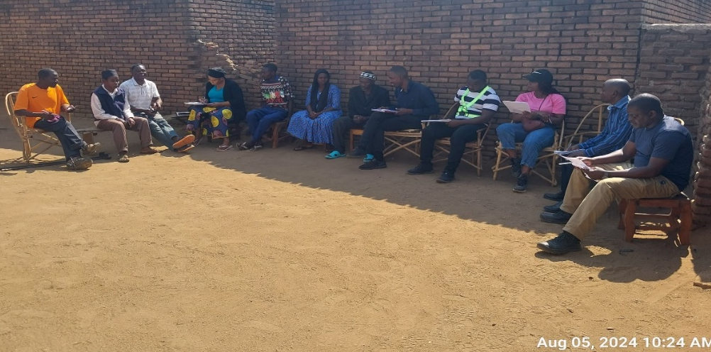
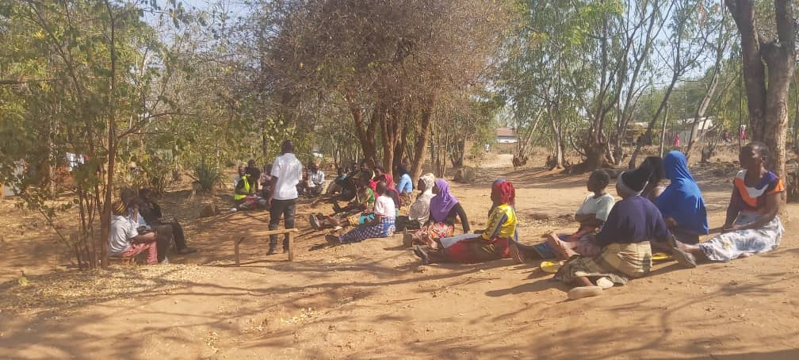
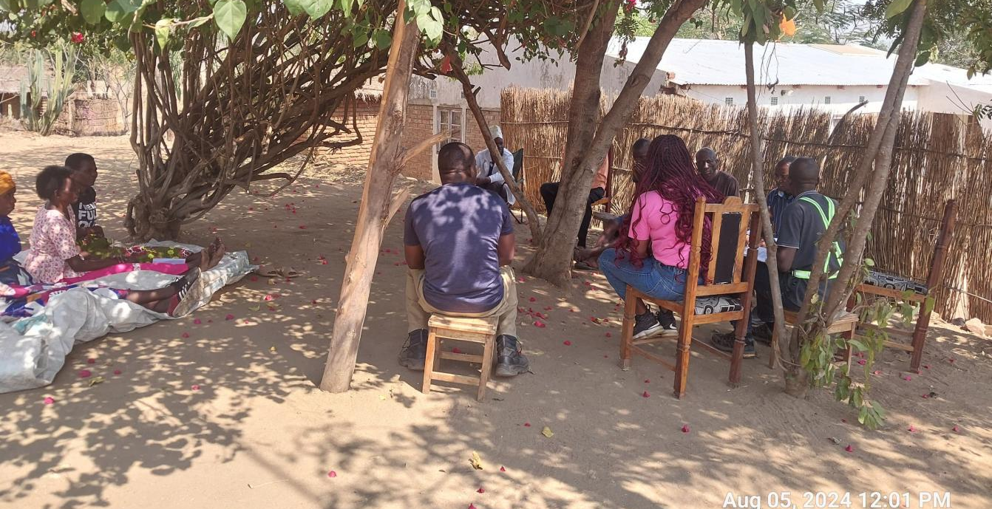
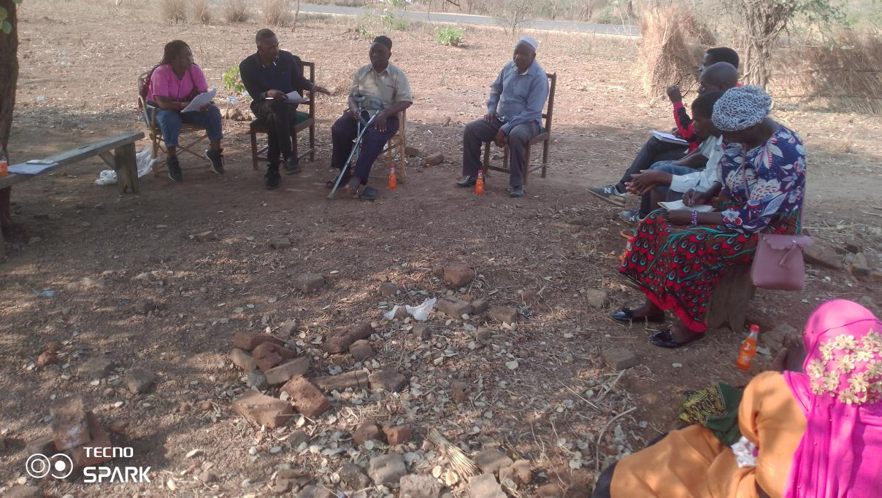
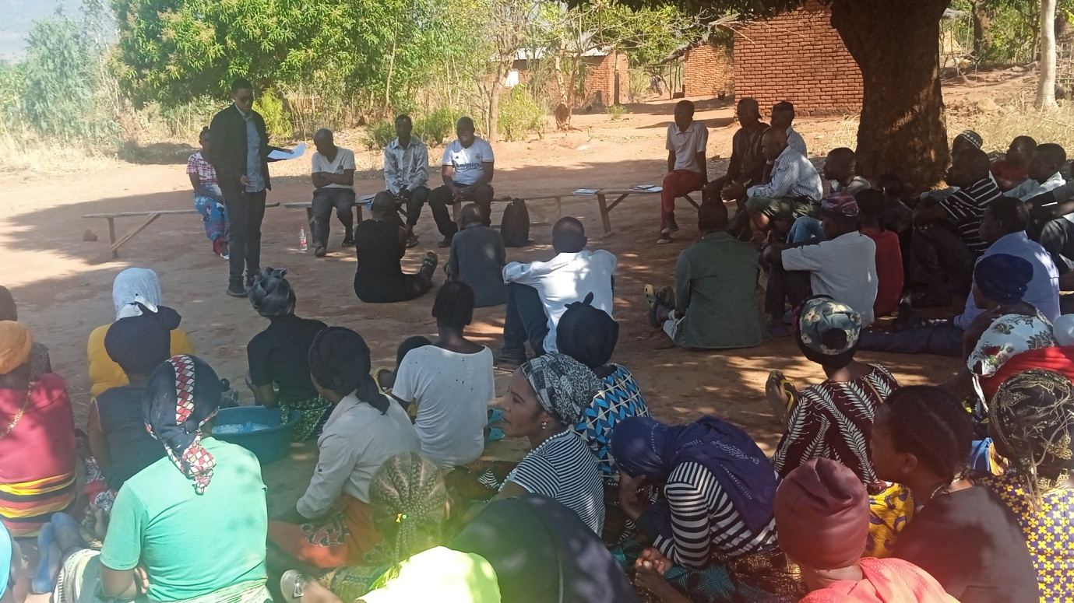

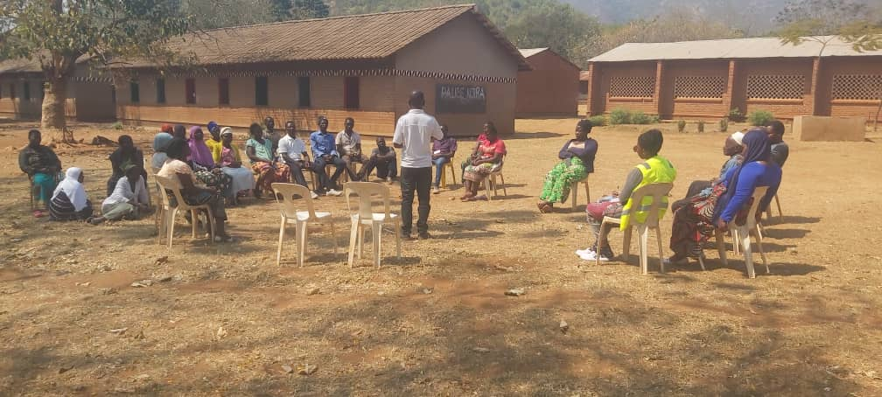
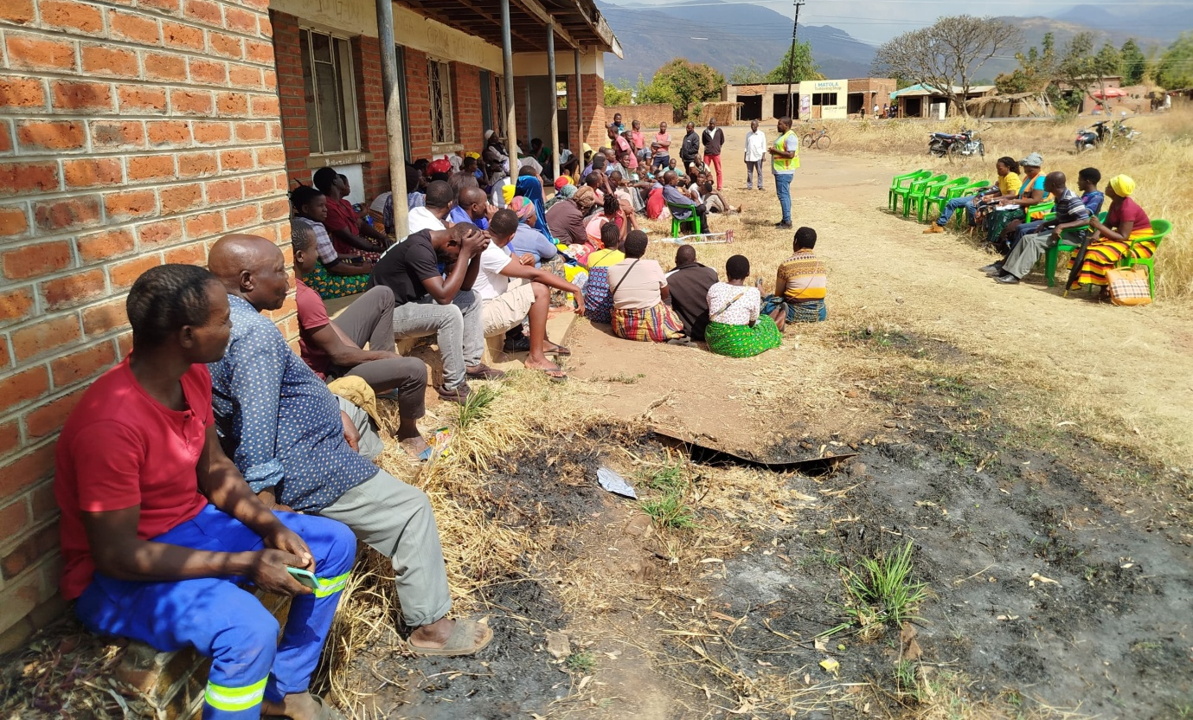
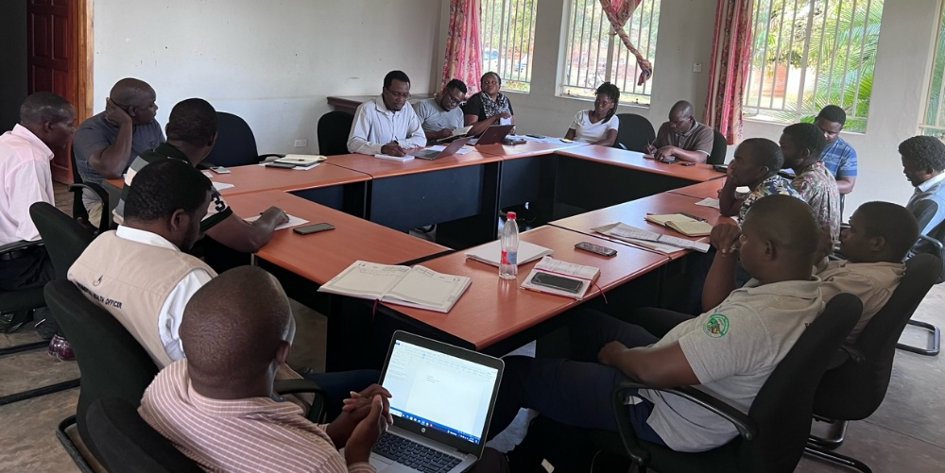
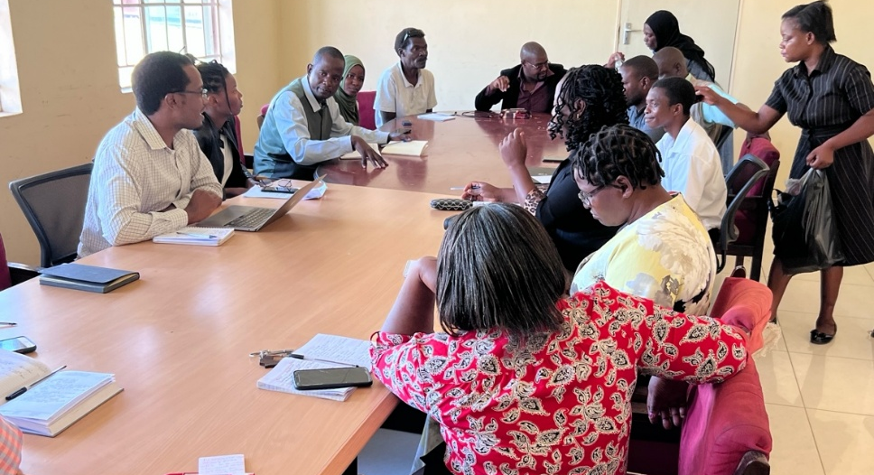

Attendance Register
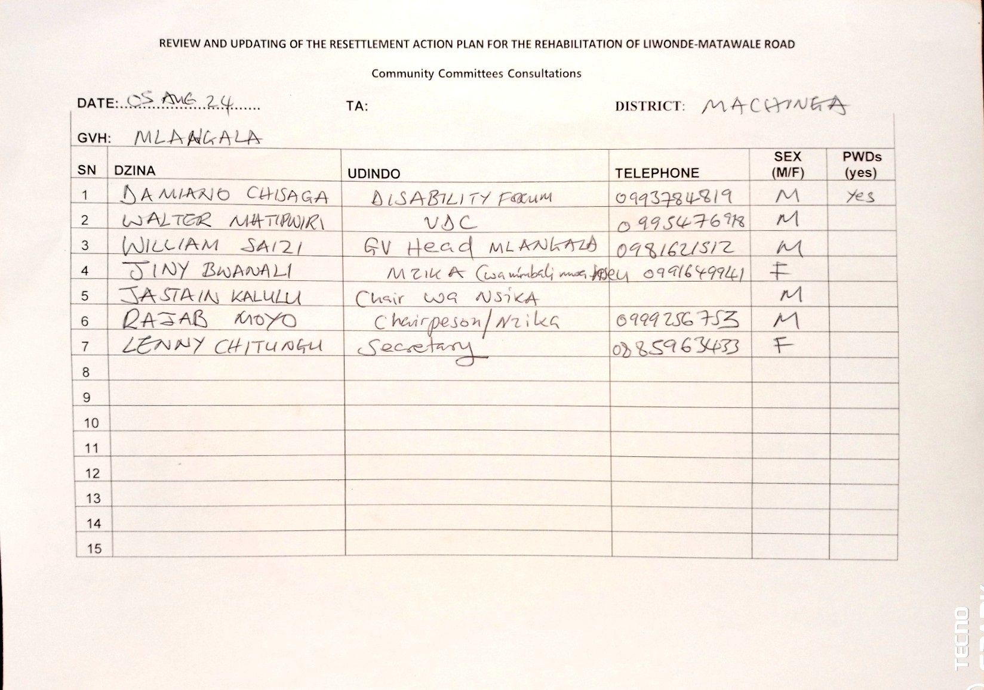
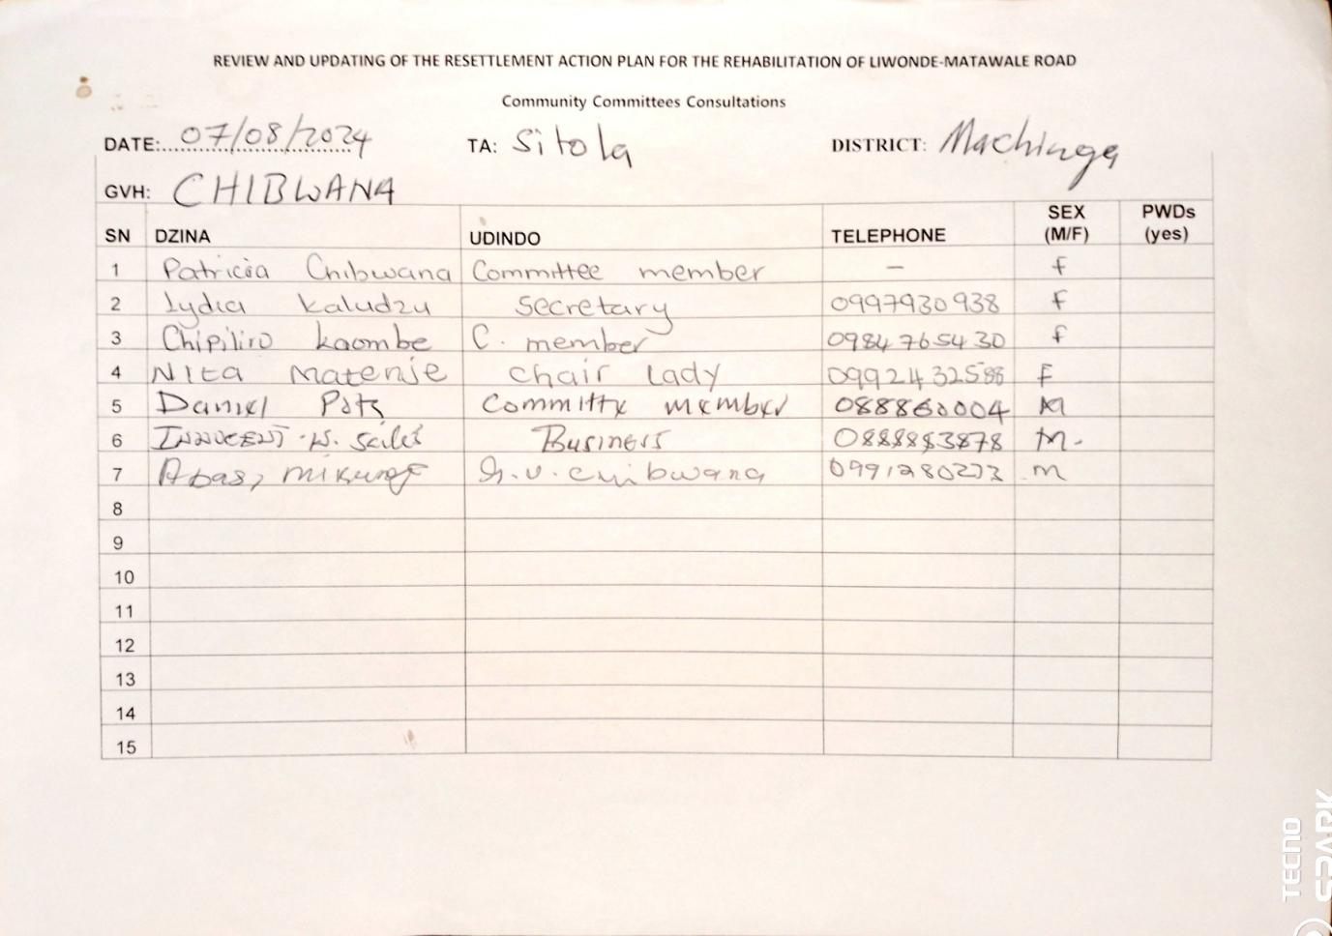

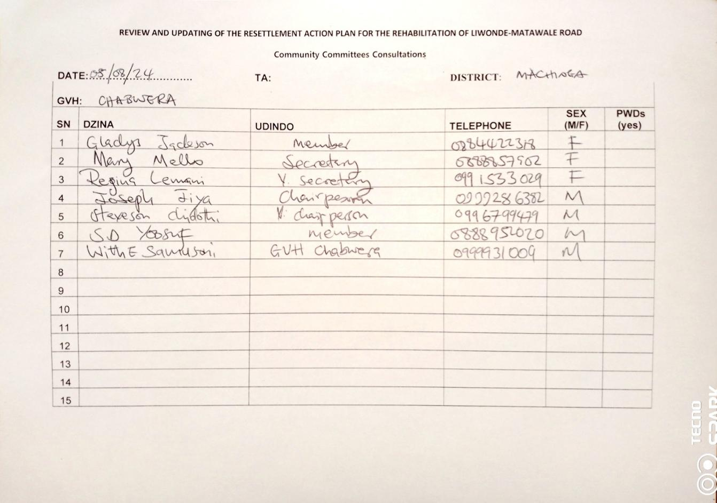

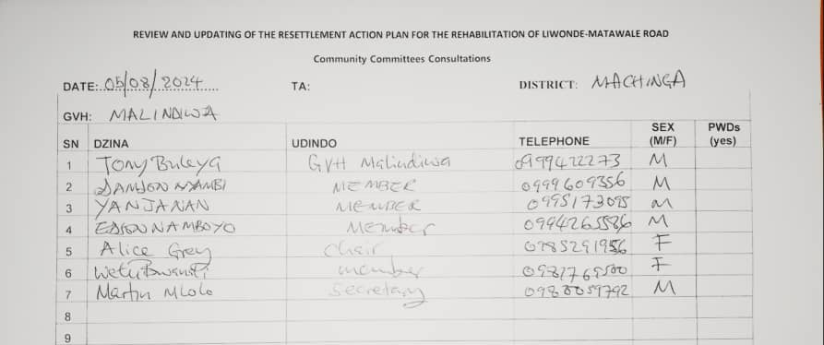

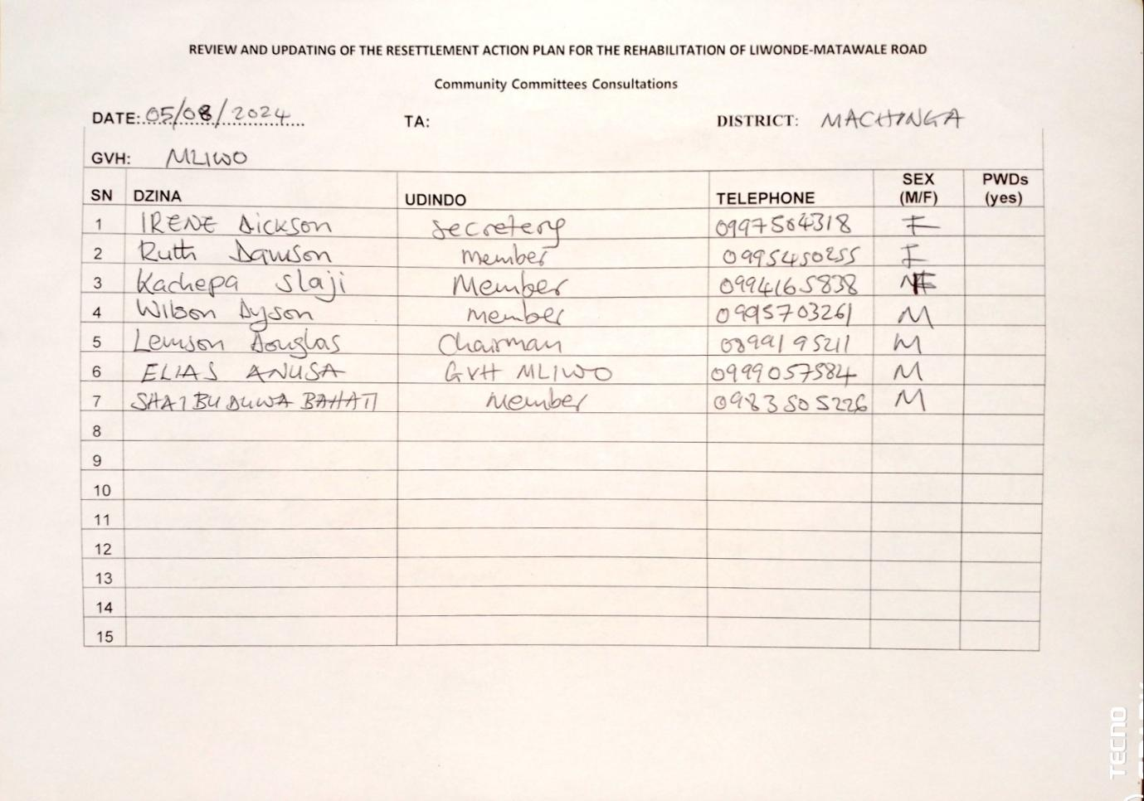

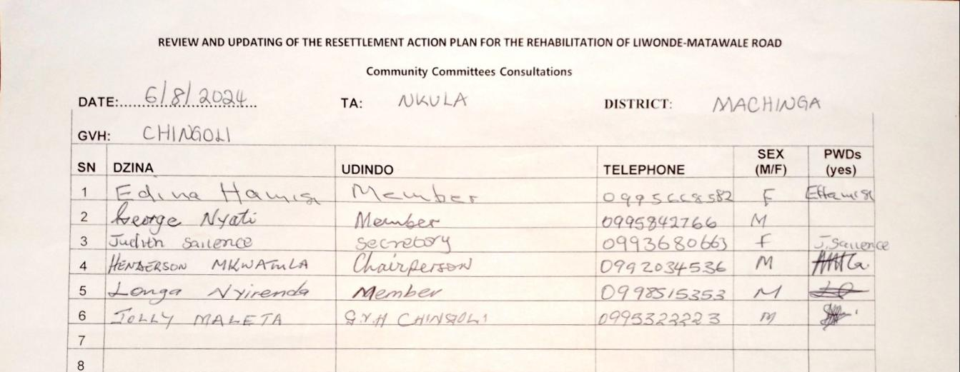

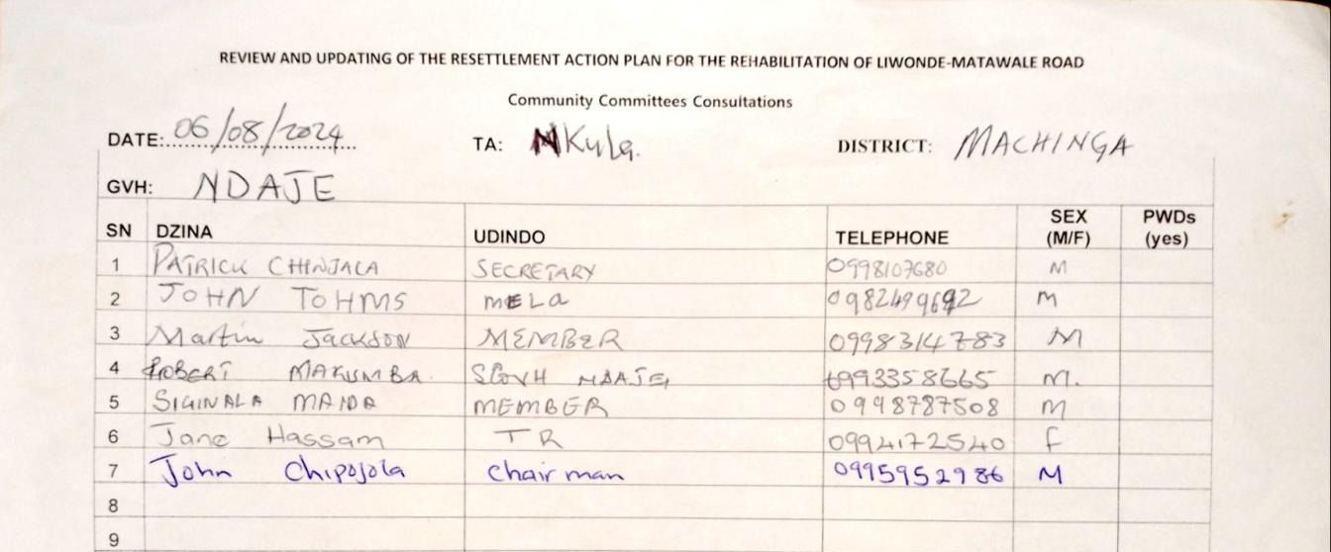

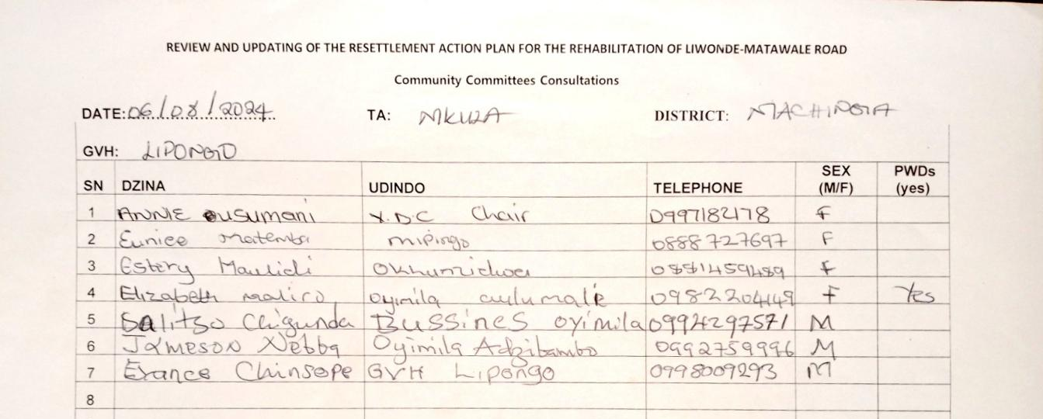

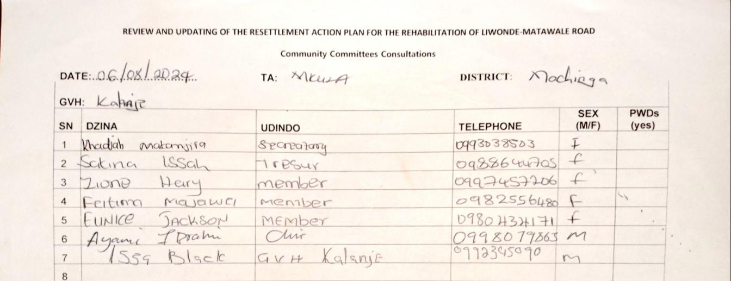

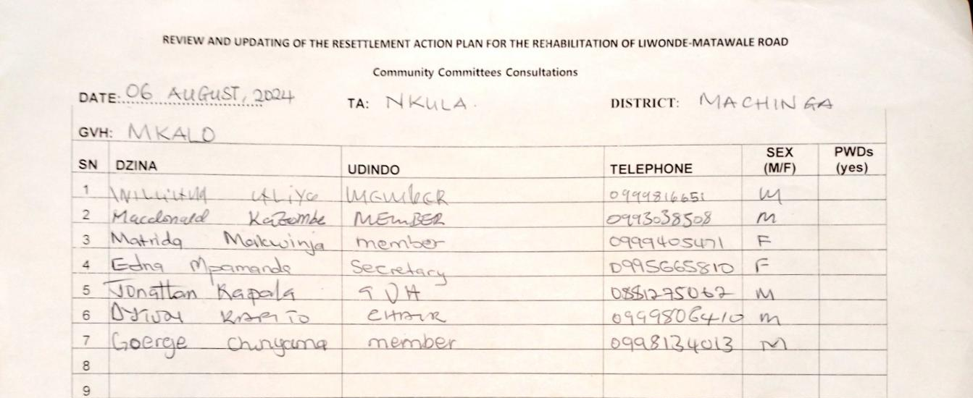

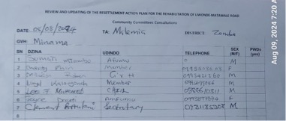

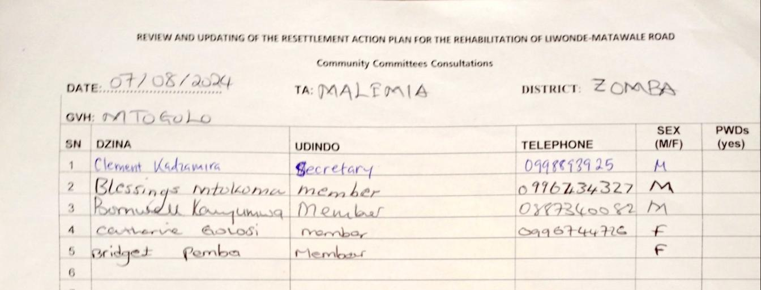

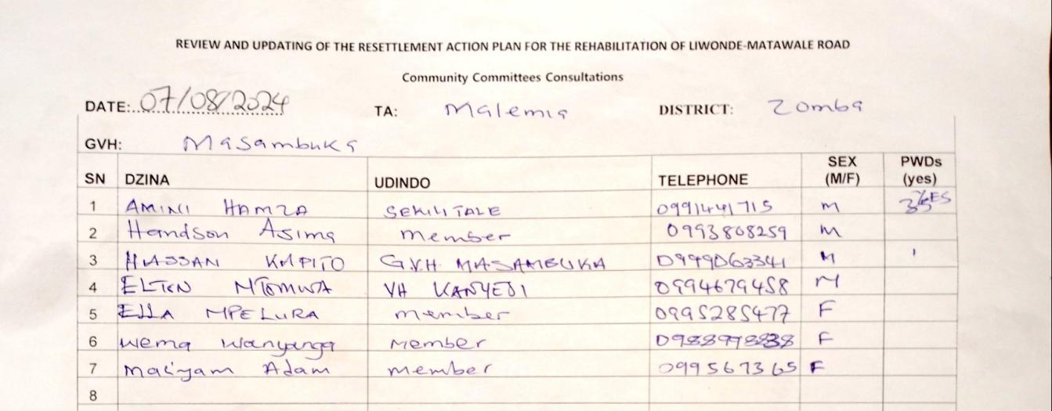

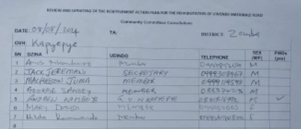

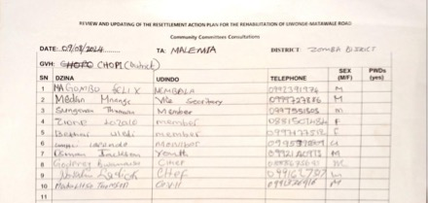

Annex E: STAKEHOLDER CONSULTATIONS WITH GOVERNMENT DEPARTMENTS, AGENCIES AND UTILITY AND SERVICE COMPANIES

Shared separately.

This amount excludes actual relocation cost for ESCOM infrastructure. The amount can be reduced or increased based on that difference but also on verification of actual affected infrastructure
This amount excludes actual relocation cost for ESCOM infrastructure, which has been tentatively costed at MK 938,580,392.85. The amount can be reduced or increased based on that difference but also on verification of actual affected infrastructure

